Ob-La-Di, Ob-La-Da (Paul McCartney & John Lennon, 1968) (C)
Ob-La-Di, Ob-La-Da by The Beatles (in Bb)

Intro | C C C G7 | C | C | C | C |  C G G7 C  Desmond has a barrow in the market place. Molly is the singer in a band.  C7 F  Desmond says to Molly, "Girl, I like your face"  C G7 C  And Molly says this as she takes him by the hand  Chorus  C Em Am C G7 C  Ob-la-di, ob-la-da, life goes on, bra, La la how that life goes on.  C Em Am C G7 C  Ob-la-di, ob-la-da, life goes on, bra, La la how that life goes on.  C G  Desmond takes a trolley to the jeweller's store  G7 C  Buys a twenty carat golden ring  C7 F  Takes it back to Molly waiting at the door,  C G7 C  And as he gives it to her she begins to sing. Chorus  Bridge  F C Csus2 C C7  __ In a couple of years they have built a home sweet home  F C G7  __ With a couple of kids running in the yard of Desmond and Molly Jones.  C G  Happy ever after in the market place,  G7 C  Desmond lets the children lend a hand  C7 F  Molly stays at home and does her pretty face  C G7 C  And in the evening she still sings it with the band, yeah! Chorus Bridge  C G G7 C  Happy ever after in the market place, Molly lets the children lend a hand  C7 F  Desmond stays at home and does his pretty face  C G7 C  And in the evening she’s a singer with the band, yeah! Chorus  Outro  G7 C  And if you want some fun, sing ob-la-di-bla-da! | 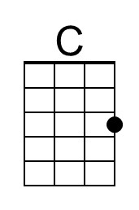 | 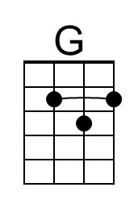
 | 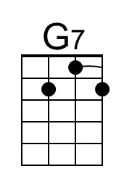 | 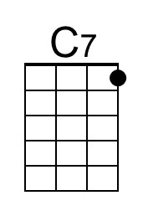
 | 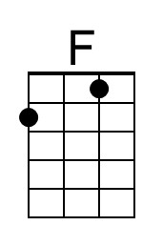 | 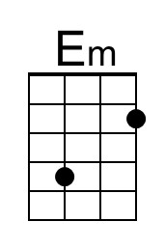
 | 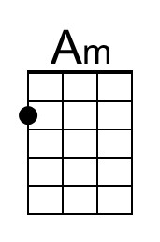 | 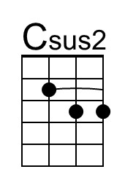
 | Bari
 | 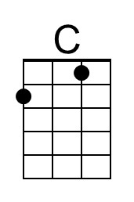 | 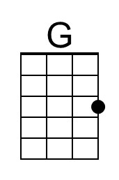
 | 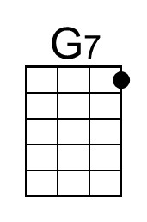 | 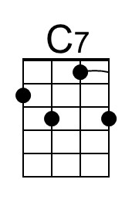
 | 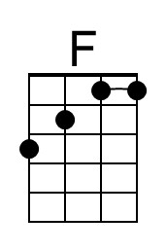 | 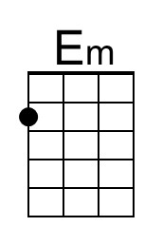
 | 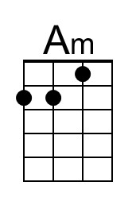 | 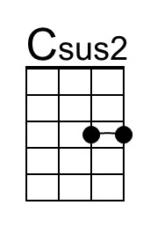

Ob-La-Di, Ob-La-Da (Paul McCartney & John Lennon, 1968) (G)
Ob-La-Di, Ob-La-Da by The Beatles (in Bb)

Intro | G G G D7 | G | G | G | G |  G D D7 G  Desmond has a barrow in the market place. Molly is the singer in a band.  G7 C  Desmond says to Molly, "Girl, I like your face"  G D7 G  And Molly says this as she takes him by the hand  Chorus  G Dm Em G D7 G  Ob-la-di, ob-la-da, life goes on, bra, La la how that life goes on.  G Dm Em G D7 G  Ob-la-di, ob-la-da, life goes on, bra, La la how that life goes on.  G D  Desmond takes a trolley to the jeweller's store  D7 G  Buys a twenty carat golden ring  G7 C  Takes it back to Molly waiting at the door,  G D7 G  And as he gives it to her she begins to sing. Chorus  Bridge  C G Gsus2 G G7  __ In a couple of years they have built a home sweet home  C G D7  __ With a couple of kids running in the yard of Desmond and Molly Jones.  G D  Happy ever after in the market place,  D7 G  Desmond lets the children lend a hand  G7 C  Molly stays at home and does her pretty face  G D7 G  And in the evening she still sings it with the band, yeah! Chorus Bridge  G D D7 G  Happy ever after in the market place, Molly lets the children lend a hand  G7 C  Desmond stays at home and does his pretty face  G D7 G  And in the evening she’s a singer with the band, yeah! Chorus  Outro  D7 G  And if you want some fun, sing ob-la-di-bla-da! |  | 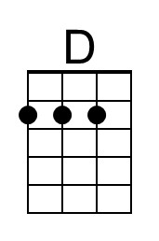
 | 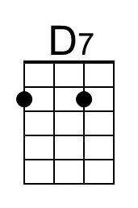
 |  | 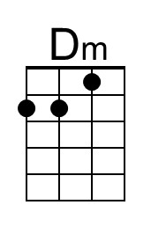
 |  | 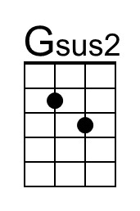
 | Bari
 |  | 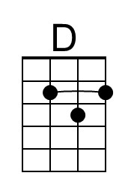
 | 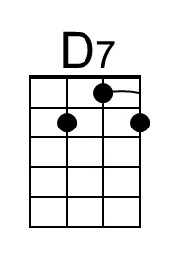
 |  | 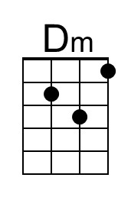
 |  | 