
Octaves Roasting On An Open Fire
C119 C
A parody by Kathy Dupuy & David Rakowski (1984) & Friends
Tune: "The Christmas Song" – Octaves Roasting On An Open Fire by Dave Swenson
Intro Last two lines of first verse  C Dm Em - Am  Octaves roasting on an open fire,  C C7 F - E7  Major sixths nipping at your nose,  Am Fm C B7  Major seconds being sung by a choir,  Em A7 Dm G  Chro-matic alterations of the scale.  C Dm Em - Am  Diatonic scale. A turkey and some mistletoe.  C C7 F - E7  Major sixths make the season bright.  Am Fm C B7  Major seconds with their eyes all a-glow  Em Am F G7 C  Will drop a perfect fifth to-night.*  Bridge  Gm - C Gm C  There's minor sevenths on their way.  Gm C F  They've loaded lots of minor seconds on their sleigh.  Fm Eb  And every minor sixth will want to spy  Am D7 F G7  To see the supertonic prolonged over five.  C Dm Em - Am  And octave offering this simple phrase  C C7 F - E7  To major sixths one to ninety-two.  Am Fm C B7  Al-though it's been said many times, many ways,  F C G7 C  Meet the Flintstones. __ To you.  Repeat from Bridge  Am Fm C B7  Al-though it's been said many times, many ways,  F C F C  Meet the Flintstones, Meet the Flintstones,  F C G7 C  Meet the Flintstones. __ To you.  * Or: "Will hear a pretty tritone tonight"  “Will drop diminished fifths . . . tonight.” | 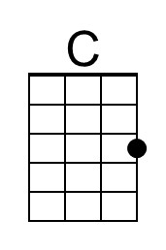 | 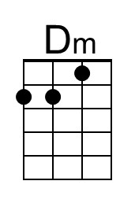 | 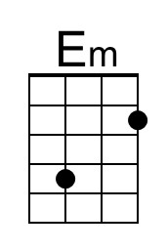 | 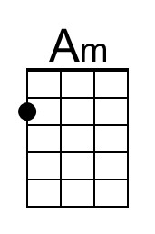
 | 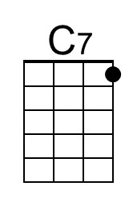 | 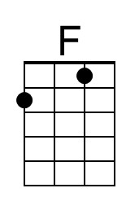 | 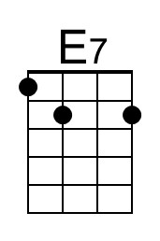 | 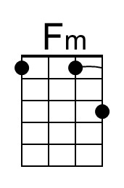
 | 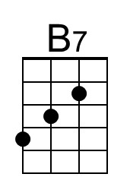 | 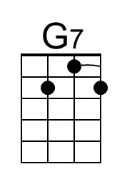 | 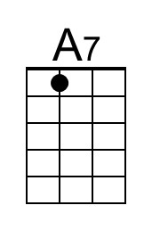 | 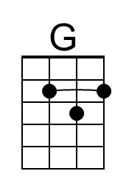
 | 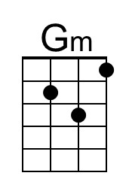 | 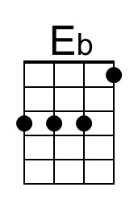 | 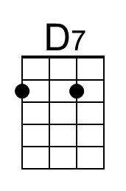
 | 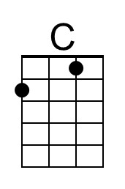 | 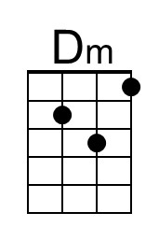 | 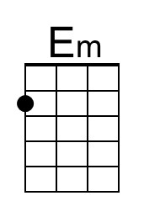 | 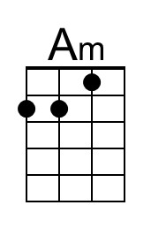
 | 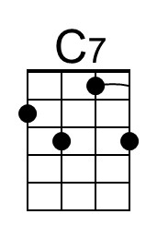 | 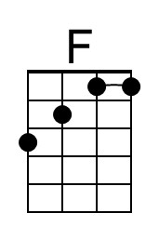 | 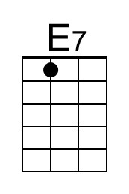 | 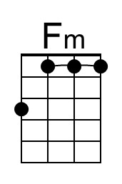
 | 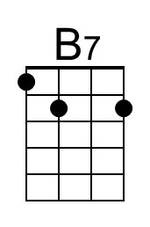 | 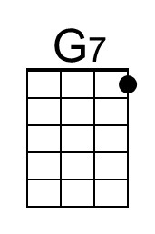 | 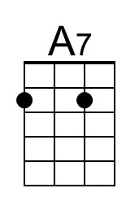 | 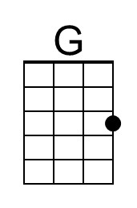
 | 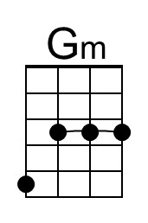 | 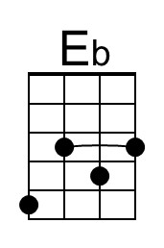 | 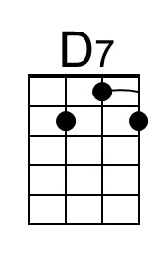

Octaves Roasting On An Open Fire
C118 G
A parody by Kathy Dupuy & David Rakowski (1984) & Friends
Tune: "The Christmas Song" – Octaves Roasting On An Open Fire by Dave Swenson
Intro Last two lines of first verse  G Am Bm - Em  Octaves roasting on an open fire,  G G7 C - B7  Major sixths nipping at your nose,  Em Cm G F#7  Major seconds being sung by a choir,  Bm E7 Am D  Chro-matic alterations of the scale.  G Am Bm - Em  Diatonic scale. A turkey and some mistletoe.  G G7 C - B7  Major sixths make the season bright.  Em Cm G F#7  Major seconds with their eyes all a-glow  Bm Em C D7 G  Will drop a perfect fifth to-night.*  Bridge  Dm - G Dm G  There's minor sevenths on their way.  Dm G C  They've loaded lots of minor seconds on their sleigh.  Cm A#  And every minor sixth will want to spy  Em A7 C D7  To see the supertonic prolonged over five.  G Am Bm - Em  And octave offering this simple phrase  G G7 C - B7  To major sixths one to ninety-two.  Em Cm G F#7  Al-though it's been said many times, many ways,  C G D7 G  Meet the Flintstones. __ To you.  Repeat from Bridge  Em Cm G F#7  Al-though it's been said many times, many ways,  F C F C  Meet the Flintstones, Meet the Flintstones,  C G D7 G  Meet the Flintstones. __ To you.  * Or: "Will hear a pretty tritone tonight"  “Will drop diminished fifths . . . tonight.” |  |  | 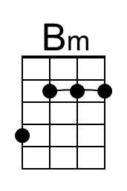
 |  |  |  | 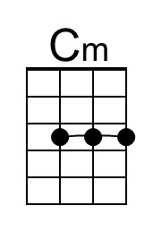
 | 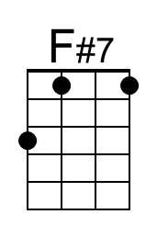 |  |  | 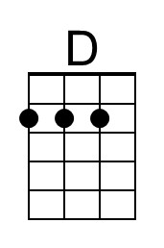
 |  | 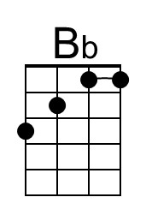
 |  |  | 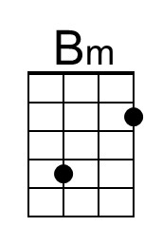
 |  |  |  | 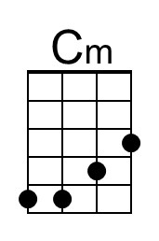
 | 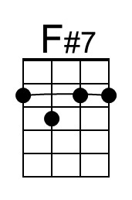 |  |  | 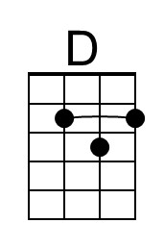
 |  | 