Octopus’s Garden (Ringo Starr, 1968-69) (C)
Octopus’ Garden by The Beatles (E)
4/4 – 92 BPM
Intro C | Am | F | G | (2x)

C Am F G | G7 |
_ I'd like to be __ under the sea, in an octopus's garden in the shade.
C Am F G | G7 |
_ He'd let us in, __ knows where we've been in his octopus's garden in the shade.
Am Am7 | F G | ↓ ↓ ↓ ↓
I'd ask my friends to come and see ___ _ an octopus's garden with me.
C Am F G7 C | C |
_ I'd like to be __ under the sea in an octopus's garden in the shade

C Am F G | G7 |
_ We would be warm __ below the storm in our little hideaway beneath the waves.
C Am F G | G7 |
_ Resting our head __ on the sea bed in an octopus's garden near a cave.
Am Am7 | F G | ↓ ↓ ↓ ↓
We would sing and dance around ___ _ because we know we can't be found.
C Am F G7 C | C |
_ I'd like to be __ under the sea in an octopus's garden in the shade

C Am F G | G7 |
_ We would shout __ and swim about the coral that lies beneath the waves.
(Lies beneath the ocean waves)
C Am F G | G7 |
_ Oh, what joy, __ for every girl and boy, knowing they're happy and they're safe.
(Happy and they're safe)
Am Am7 | F G | ↓ ↓ ↓ ↓
We would be so happy you and me; ___ _ no one there to tell us what to do.
C Am F G7 Am
_ I'd like to be __ under the sea in an octopus's garden with you, (Hold)
F G Am F G C | G7 | C
In an octopus's garden with you, in an octopus's garden with you.

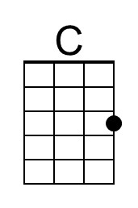 | 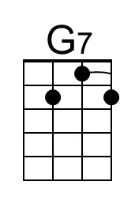 | 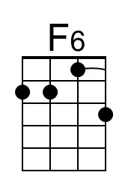 | 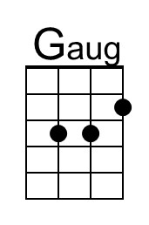 | 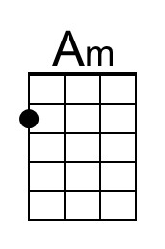 | 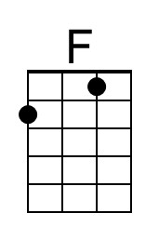 | 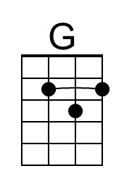 | 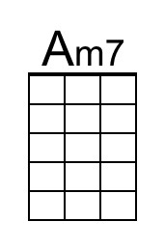 | 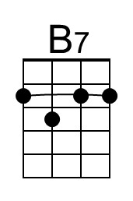
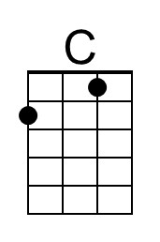 | 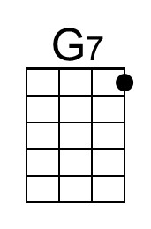 | 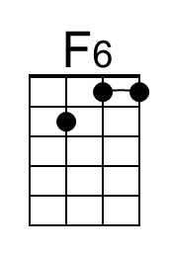 | 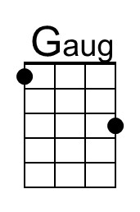 | 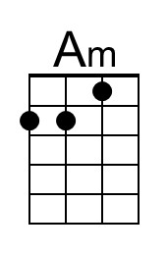 | 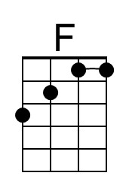 | 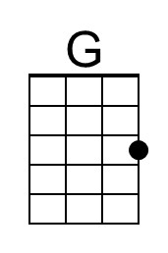 | 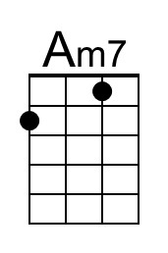 | 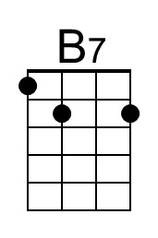

Octopus’s Garden (Ringo Starr, 1968-69) (D)
Octopus’ Garden by The Beatles (E)
4/4 – 92 BPM
Intro D | Bm | G | A | (2x)

D Bm G A | A7 |
_ I'd like to be __ under the sea, in an octopus's garden in the shade.
D Bm G A | A7 |
_ He'd let us in, __ knows where we've been in his octopus's garden in the shade.
Bm Bm7 | G A | ↓ ↓ ↓ ↓
I'd ask my friends to come and see ___ _ an octopus's garden with me.
D Bm G A7 D | D |
_ I'd like to be __ under the sea in an octopus's garden in the shade

D Bm G A | A7 |
_ We would be warm __ below the storm in our little hideaway beneath the waves.
D Bm G A | A7 |
_ Resting our head __ on the sea bed in an octopus's garden near a cave.
Bm Bm7 | G A | ↓ ↓ ↓ ↓
We would sing and dance around ___ _ because we know we can't be found.
D Bm G A7 D | D |
_ I'd like to be __ under the sea in an octopus's garden in the shade

D Bm G A | A7 |
_ We would shout __ and swim about the coral that lies beneath the waves.
(Lies beneath the ocean waves)
D Bm G A | A7 |
_ Oh, what joy, __ for every girl and boy, knowing they're happy and they're safe.
(Happy and they're safe)
Bm Bm7 | G A | ↓ ↓ ↓ ↓
We would be so happy you and me; ___ _ no one there to tell us what to do.
D Bm G A7 Bm
_ I'd like to be __ under the sea in an octopus's garden with you, (Hold)
G A Bm G A D | A7 | D
In an octopus's garden with you, in an octopus's garden with you.

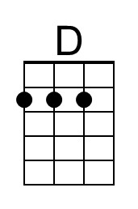 | 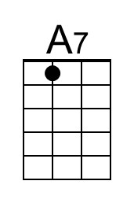 | 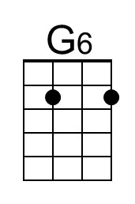 | 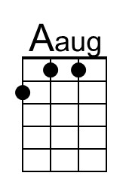 | 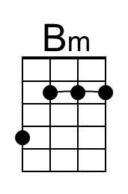 |  | 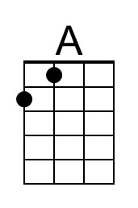 | 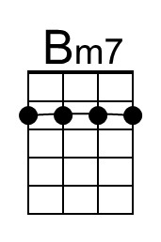 | 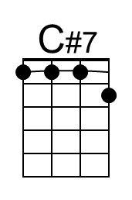
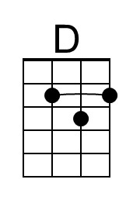 | 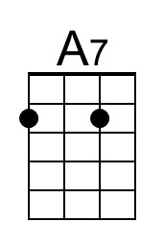 | 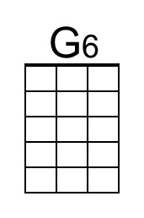 | 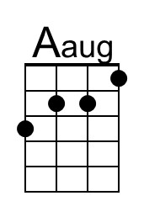 | 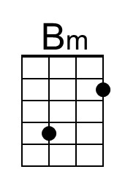 |  | 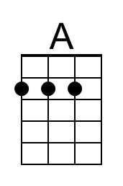 | 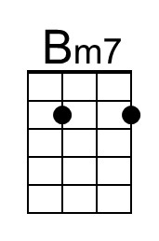 | 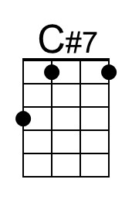

Octopus’s Garden (Ringo Starr, 1968-69) (E)
Octopus’ Garden by The Beatles (E)
4/4 – 92 BPM
Intro E | C#m | A | B | (2x)

E C#m A B | B7 |
_ I'd like to be __ under the sea, in an octopus's garden in the shade.
E C#m A B | B7 |
_ He'd let us in, __ knows where we've been in his octopus's garden in the shade.
C#m C#m7 | A B | ↓ ↓ ↓ ↓
I'd ask my friends to come and see ___ _ an octopus's garden with me.
E C#m A B7 E | E |
_ I'd like to be __ under the sea in an octopus's garden in the shade

E C#m A B | B7 |
_ We would be warm __ below the storm in our little hideaway beneath the waves.
E C#m A B | B7 |
_ Resting our head __ on the sea bed in an octopus's garden near a cave.
C#m C#m7 | A B | ↓ ↓ ↓ ↓
We would sing and dance around ___ _ because we know we can't be found.
E C#m A B7 E | E |
_ I'd like to be __ under the sea in an octopus's garden in the shade

E C#m A B | B7 |
_ We would shout __ and swim about the coral that lies beneath the waves.
(Lies beneath the ocean waves)
E C#m A B | B7 |
_ Oh, what joy, __ for every girl and boy, knowing they're happy and they're safe.
(Happy and they're safe)
C#m C#m7 | A B | ↓ ↓ ↓ ↓
We would be so happy you and me; ___ _ no one there to tell us what to do.
E C#m A B7 C#m
_ I'd like to be __ under the sea in an octopus's garden with you, (Hold)
A B C#m A B E | B7 | E
In an octopus's garden with you, in an octopus's garden with you.

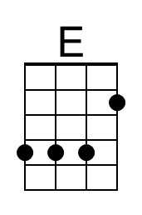 |  | 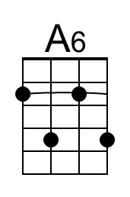 | 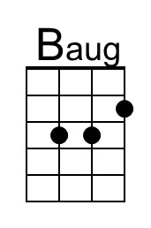 | 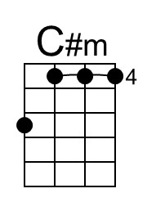 |  |  | 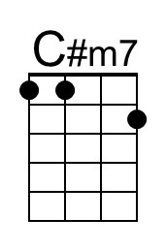 | 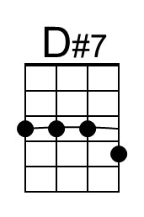
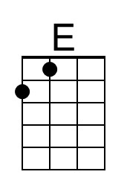 |  | 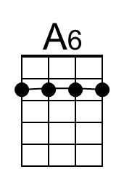 | 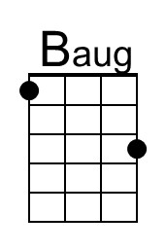 | 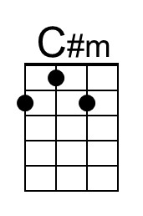 |  | 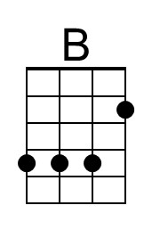 | 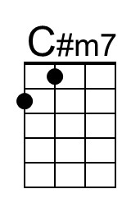 | 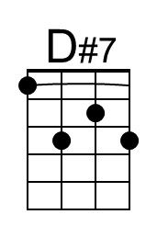

Octopus’s Garden (Ringo Starr, 1968-69) (G)
Octopus’ Garden by The Beatles (E)
4/4 – 92 BPM
Intro G | Em | C | D | (2x)

G Em C D | D7 |
_ I'd like to be __ under the sea, in an octopus's garden in the shade.
G Em C D | D7 |
_ He'd let us in, __ knows where we've been in his octopus's garden in the shade.
Em Em7 | C D | ↓ ↓ ↓ ↓
I'd ask my friends to come and see ___ _ an octopus's garden with me.
G Em C D7 G | G |
_ I'd like to be __ under the sea in an octopus's garden in the shade

G Em C D | D7 |
_ We would be warm __ below the storm in our little hideaway beneath the waves.
G Em C D | D7 |
_ Resting our head __ on the sea bed in an octopus's garden near a cave.
Em Em7 | C D | ↓ ↓ ↓ ↓
We would sing and dance around ___ _ because we know we can't be found.
G Em C D7 G | G |
_ I'd like to be __ under the sea in an octopus's garden in the shade

G Em C D | D7 |
_ We would shout __ and swim about the coral that lies beneath the waves.
(Lies beneath the ocean waves)
G Em C D | D7 |
_ Oh, what joy, __ for every girl and boy, knowing they're happy and they're safe.
(Happy and they're safe)
Em Em7 | C D | ↓ ↓ ↓ ↓
We would be so happy you and me; ___ _ no one there to tell us what to do.
G Em C D7 Em
_ I'd like to be __ under the sea in an octopus's garden with you, (Hold)
C D Em C D G | D7 | G
In an octopus's garden with you, in an octopus's garden with you.

 | 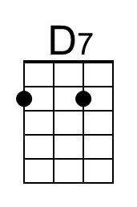 | 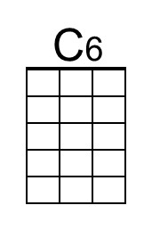 | 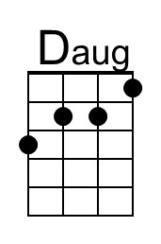 | 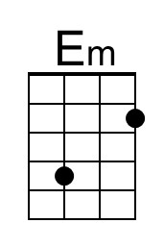 |  |  | 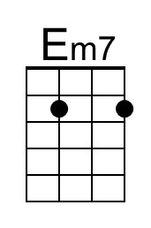 | 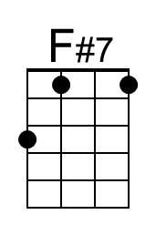
 | 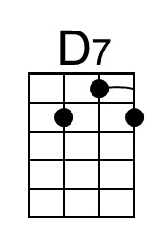 | 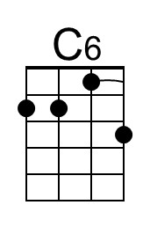 | 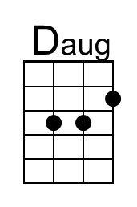 | 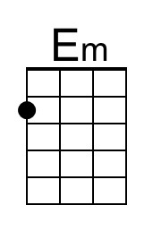 |  |  | 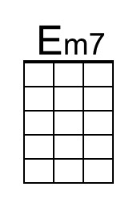 | 