Oh, What A Beautiful Mornin' (Rodgers and Hammerstein, 1943) (C)
Oh, What a Beautiful Mornin’ by Gordon MacRae from Oklahoma! (1955 Film)

C G C  There's a bright golden haze on the meadow!  C G C  There's a bright golden haze on the meadow!  C F  The corn is as high as an elephant's eye  G  And it looks like it's climbin' clear up to the sky!  Chorus  C F C G  Oh, what a beautiful mornin'! Oh, what a beautiful day!  C F C G7 C  I've got a beautiful feelin', everything's goin' my way!  C G C  All the cattle are standin' like statues.  C G C  All the cattle are standing like statues.  F  They don't turn their heads as they see me ride by,  G  But a little brown maverick is winkin' her eye! Chorus  C G C  All the sounds of the earth are like music!  C G C  All the sounds of the earth are like music!  F  The breeze is so busy, it don't miss a tree,  G  And an old weepin' willow is laughin' at me! Chorus  Outro  F C  Oh, what a beautiful day. | 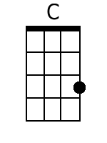 | 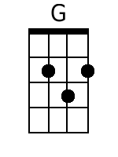
 | 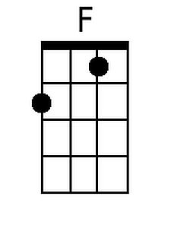 | 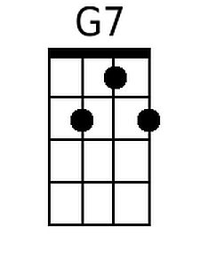
 | Baritone
 | 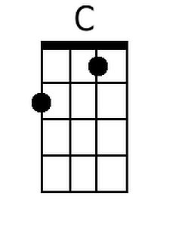 | 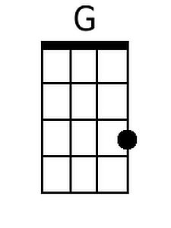
 | 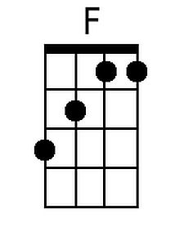 | 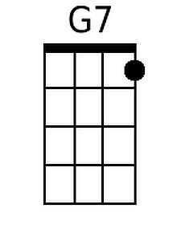

Oh, What A Beautiful Mornin' (Rodgers and Hammerstein, 1943) (G)
Oh, What a Beautiful Mornin’ by Gordon MacRae from Oklahoma! (1955 Film)

G D G  There's a bright golden haze on the meadow!  G D G  There's a bright golden haze on the meadow!  G C  The corn is as high as an elephant's eye  D  And it looks like it's climbin' clear up to the sky!  Chorus  G C G D  Oh, what a beautiful mornin'! Oh, what a beautiful day!  G C G D7 G  I've got a beautiful feelin', everything's goin' my way!  G D G  All the cattle are standin' like statues.  G D G  All the cattle are standing like statues.  C  They don't turn their heads as they see me ride by,  D  But a little brown maverick is winkin' her eye! Chorus  G D G  All the sounds of the earth are like music!  G D G  All the sounds of the earth are like music!  C  The breeze is so busy, it don't miss a tree,  D  And an old weepin' willow is laughin' at me! Chorus  Outro  F C  Oh, what a beautiful day. |  | 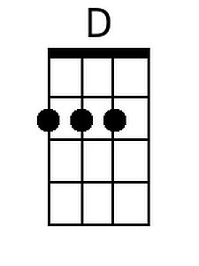
 |  | 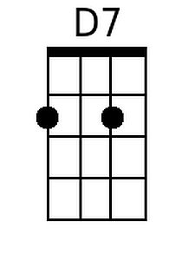
 | Baritone
 |  | 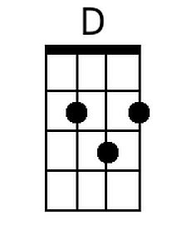
 |  | 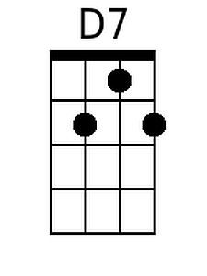

Oh, What A Beautiful Mornin' (Rodgers and Hammerstein, 1943) (NN)
Oh, What a Beautiful Mornin’ by Gordon MacRae from Oklahoma! (1955 Film)

1 5 1  There's a bright golden haze on the meadow!  1 5 1  There's a bright golden haze on the meadow!  1 4  The corn is as high as an elephant's eye  5  And it looks like it's climbin' clear up to the sky!  Chorus  1 4 1 5  Oh, what a beautiful mornin'! Oh, what a beautiful day!  1 4 1 5(7) 1  I've got a beautiful feelin', everything's goin' my way!  1 5 1  All the cattle are standin' like statues.  1 5 1  All the cattle are standing like statues.  4  They don't turn their heads as they see me ride by,  5  But a little brown maverick is winkin' her eye! Chorus  1 5 1  All the sounds of the earth are like music!  1 5 1  All the sounds of the earth are like music!  4  The breeze is so busy, it don't miss a tree,  5  And an old weepin' willow is laughin' at me! Chorus  Outro  4 1  Oh, what a beautiful day. | 1 | 5 | 4 | 5(7)
 | A | E | D | E7
 | Bb | F | Eb | F7
 | C | G | F | G7
 | D | A | G | A7
 | Eb | Bb | Ab | Eb7
 | F | C | Bb | C7
 | G | D | C | D7

