Oklahoma (Rogers and Hammerstein)
Title song from the R&H musical "Oklahoma!"

[Intro 1]  A D  They couldn't pick a better time to start in life  Bm A G Bm G A  It ain't too early and it ain't too late  D  Startin' as a farmer with a brand new wife  Bm A G Bm G A D  Soon be livin' in a brand new state  G A D G A D  Brand new state! Gonna treat you great!  [Intro 2]  G  Gonna give you barley, carrots and pertaters  D  Pasture fer the cattle, spinach and termayters  G  Flowers on the prarie where the June bugs zoom  D  Plenty of air and plenty of room  G  Plenty of room to swing a rope!  D  Plenty of heart and plenty of hope |  |  |  |  |  |  | 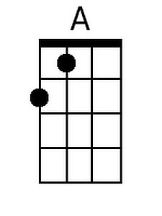 | 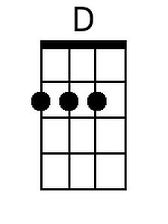
 |  |  |  |  |  |  | 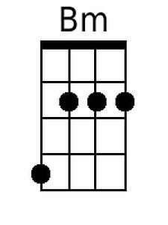 | 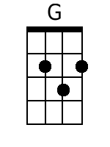
 |  |  |  |  |  |  | 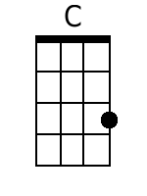 | 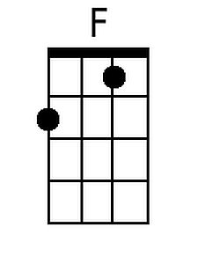
 |  |  |  |  |  |  | 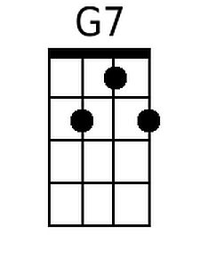 | 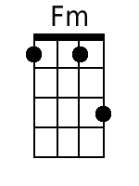
 |  |  |  |  |  |  | 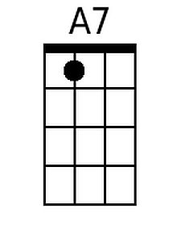 | 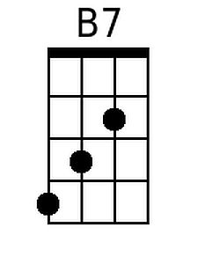
 |  |  |  |  |  |  | 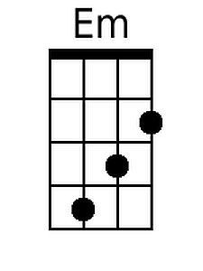
Baritone
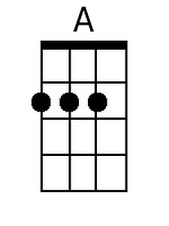 | 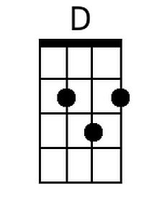 | 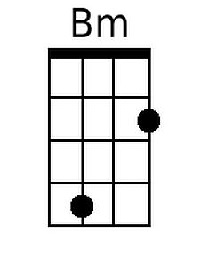 | 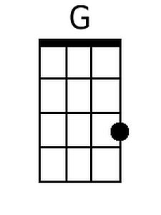 | 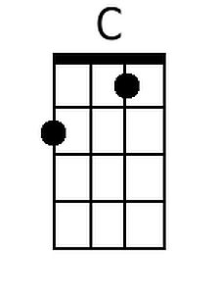 | 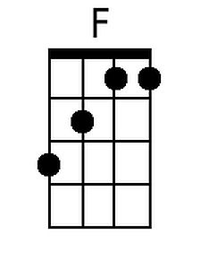
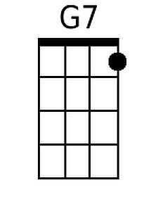 | 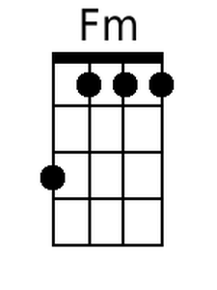 | 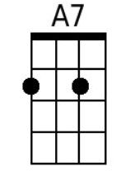 | 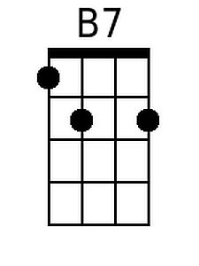 | 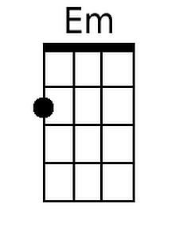

Oklahoma (C) – Page 2
[Verse 1]
C F C G7
Ohh-Ohh-Oke-lahoma, where the wind comes sweepin' down the plain
C F Fm
And the wavin' wheat, can sure smell sweet
C A7 D7 G7
When the wind comes right behind the rain.

[Verse 2]
C F C G7
Ohh-Ohh-Oke-lahoma, ev'ry night my honey lamb and I
C F Fm
Sit a-lone and talk, and watch a hawk
C G7 C
Makin' lazy circles in the sky.

[Chorus]
F C G D7 G7
We know we belong to the land, and the land we be-long to is grand!
C F C D
And when we say, Yeeow! A-yip-i-o-e-ay!
D C F D7
We're only sayin' “You're doin' fine, Okla-ho-ma!”
C G C
Okla-ho-ma, O.K.

Repeat from Verse 1.

[Segue]
C C C C C C D D D D Em Em
Ok – la – ho - ma, Ok – la – ho - ma, Ok – la – ho – ma,
Em Em F F F F G G G G C C
Ok – la – ho - ma, Ok – la – ho - ma, Ok – la – ho – ma! Chorus

[Outro]
C D Em F G C
L. A. H. O. M. A.
F# G A D C
Ok – la – ho - ma! Yeeow!

