**Ol’ 55 (Tom Waits)**

**C Em7 Am / F G C G7**

**C**

Well my time went so quickly,

**Em7**

I went lickety splitly

**F G C G7**

Out to my old fifty-five

**C Em7**

As I pulled away slowly, feelin so Holy,

**F G G7**

God knows I was feelin alive

**Chorus:**

**C Em7 F G7**



C

And now the sun's comin up

**C Em7 F G7**

I'm ridin' with Lady Luck

**C Em7 F G7**

Freeway cars and trucks

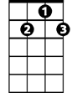

G7

**Dm G C Am**



G

Stars beginning to fade

**Dm G C Am**

And I lead the parade

**Dm G7 Am**

Just a-wishin' I'd stayed a little longer

**D7**

Lord, let me tell you

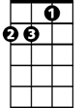

Am

**F G7**

**BARITONE**



F

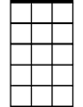

Em7

C



The feelin's gettin' stronger

**C Em7**

Six in the morning gave me no warning

**F G C G7**

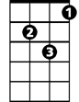

Dm

I had to be on my way

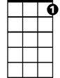

G7



G

**C**

Now the cars are all passin' me,

**Em7**

Trucks are all flashin' me

**F G G7**

I'm headin' home from your place

**(Chorus)**

**(Repeat First Verse)**

**C Em7 F G7**

And now the sun's comin up

**C Em7 F G7**

I'm ridin' with Lady Luck

**C Em7 F G7**

Freeway cars and trucks

**C Em7 F G7**

Freeway cars and trucks

**C Em7 F G7**

I'm ridin' with Lady Luck



Dm

Em7

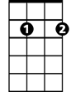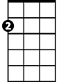

Am

F

