Ol' Man River (Jerome Kern & Oscar Hammerstein II, 1927) (C)

C F  There's an old man called the Missis-sippi  C G7  That's the old man that I wants to be  Am Dm  What does he care if the world's got troubles  Am Dm G7 C  What does he care if the land ain't free  C F C F  Ol' Man River, that Ol' Man River,  C F C F  He don't say nothin', but he must know somethin',  G G7 G G7 C F C F  He just keeps rollin', he keeps on rollin' a-long.  C F C F  He don't plant tatters, and he don't plant cotton,  C Em Am B7  And them what plants em, are soon for-gotten  G Dm G F C F C  But Ol' Man River, just keeps rollin' a-long.  Em Am Em Am  You and me, we sweat and strain,  Em Am Em Am  Body all achin' and racked with pain.  Em B7 Em B7  Tote that barge and lift that bail,  Em B7 Em Dm G  You get a little drunk and you lands in jail.  C F C F  I gets weary, and sick of trying,  C Dm Am D7  I'm tired of livin', but I'm scared of dyin',  C Am Dm G7 C F C  But Ol' Man River, he just keeps rollin' a-long. | 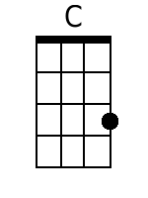 | 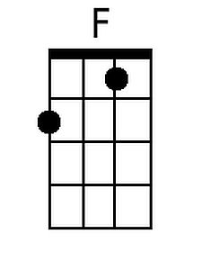 | 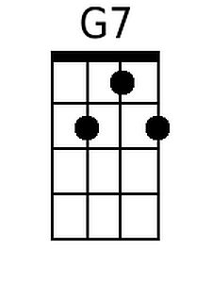
 | 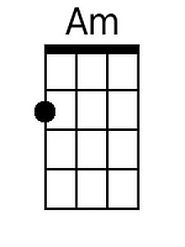 | 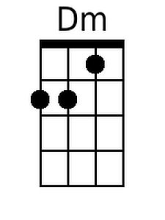 | 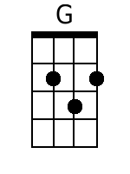
 | 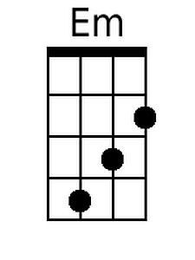 | 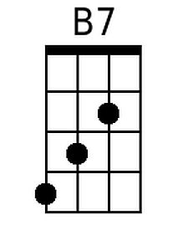 | 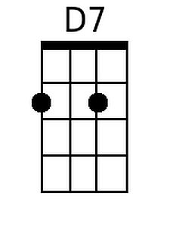
 | Baritone
 | 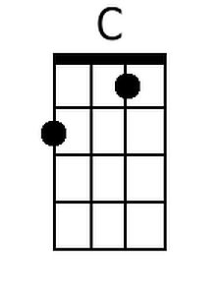 | 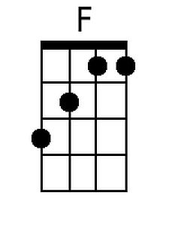 | 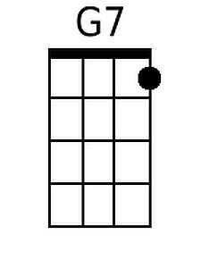
 | 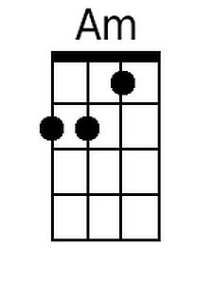 | 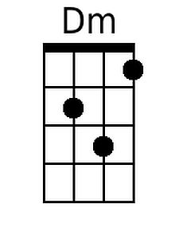 | 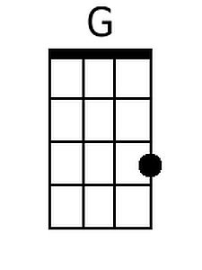
 | 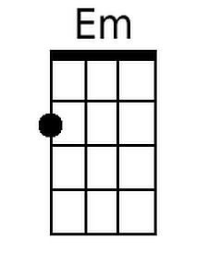 | 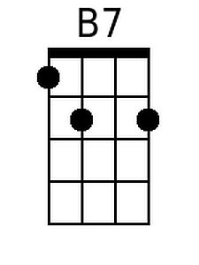 | 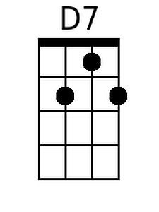

Ol' Man River (Jerome Kern & Oscar Hammerstein II, 1927) (G)

G C
There's an old man called the Missis-sippi
G D7
That's the old man that I wants to be
Em Am
What does he care if the world's got troubles
Em Am D7 G
What does he care if the land ain't free

G C G C
Ol' Man River, that Ol' Man River,
G C G C
He don't say nothin', but he must know somethin',
D D7 D D7 G C G C
He just keeps rollin', he keeps on rollin' a-long.

G C G C
He don't plant tatters, and he don't plant cotton,
G Bm Em F#7
And them what plants em, are soon for-gotten
D Am D C G C G
But Ol' Man River, just keeps rollin' a-long.

Bm Em Bm Em
You and me, we sweat and strain,
Bm Em Bm Em
Body all achin' and racked with pain.
Bm F#7 Bm F#7
Tote that barge and lift that bail,
Bm F#7 Bm Am D
You get a little drunk and you lands in jail.

G C G C
I gets weary, and sick of trying,
G Am Em A7
I'm tired of livin', but I'm scared of dyin',
G Em Am D7 G C G
But Ol' Man River, he just keeps rollin' a-long.

 |  |  | 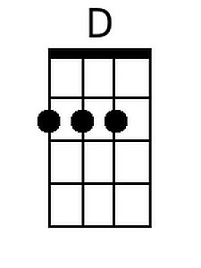
 | 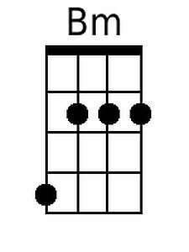 | 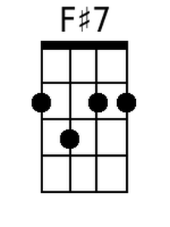 | 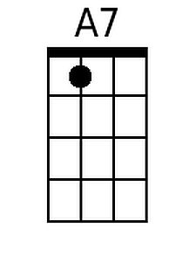
 | Baritone
 |  |  | 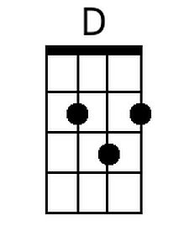
 | 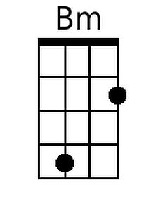 |  | 