**Old Joe's Place (Christopher Guest/Michael Mckean/Harry Shearer)**

**BARITONE**

**C F**

When-ever I'm out a-wandering,

**C F**

Chasing a rainbow dream.

**C Am**

I often stop and think a-bout,

**D7 G**

A place I've never seen.

**Am Em**

Where friendly folks can gather,

**Am G G7**

And raise the rafters high.

**C Am**

With songs and tales of yester-year,

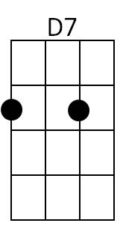 **F G C**

Un-til they say good-bye.

**(n.c.) F C**

Well... There's a puppy in the parlor,

**F C**

And a skillet on the stove,

**F C G C**

And a smelly old blanket, that a Navajo wove.

**F C**

There's a chicken on the table,

**F C**

But you got to say grace.

**F C**

There's always something cooking

**G C F C G C**

At Old Joe's Place.

**C F**

Now folks come by round evening time,

**C F**

Soon as the sun goes down.

**C Am**

Some drop in from right next door,

**D7 G**

And some from out of town. Pick it!

**Am Em / Am G G7 / C Am / F G C**

**(n.c.) F C**

Well... There's a puppy in the parlor,

**F C**

And a skillet on the stove,

**F C G C**

And a smelly old blanket, that a Navajo wove

**F C**

There's popcorn in the popper,

**F C**

And a porker in the pot.

**F C**

There's pie in the pantry,

**G C**

And the coffee's always hot.

**F C**

C



There's a chicken on the table,

**F C**

But you got to say grace.

**F C**

There's always something cooking

**G C F C G C**

At Old Joe's Place.



F

.

**C F**

Now they don't allow no frowns inside;

**C F**

Leave them by the door.

**C Am**

There's apple brandy by the keg,

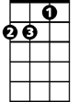

Am

**D7 G**

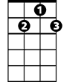

D7

And sawdust on the floor.

**Am Em**

So if you've got a hankerin',

**Am G G7**

I'll tell you where to go.

**C Am**

Just look for the busted neon sign,

**F (n.c.)**



G

That flashes... “EA_ A_ _OE’s”

**(n.c.) F C**

Well... There's a puppy in the parlor,

**F C**

And a skillet on the stove,

**F C G C**

And a smelly old blanket, that a Navajo wove

**F C**

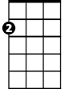

Em

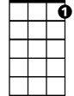

G7

There's popcorn in the popper,

**F C**

And a porker in the pot.

**F C**

There's pie in the pantry,

**G C**

And the coffee's always hot.

**F C**

There's sausage in the morning,

**F C**

And a party every night,

**F C G C**

There's a nurse on duty, if you don't feel right.

**F C**

There's a chicken on the table,

**F C** **(deep breath, “whew”)**

But you got to say grace.

**F C**

There's always something cooking

**G C F C G C**

At Old Joe's Place.