**On The Beach At Waikiki (G. H. Stover / Henry Kailimai) Key C**

**C**

Honi ka ua wiki wiki

**A7 D7**

Sweet brown maiden said to me

**G7**

As she gave me language lessons

**C F7 C G7**

On the beach at Waikiki

*Honi ka ua wiki wiki = we kiss quickly*

*Honi (kiss) Ka ua (we) wiki wiki (quick / fast)*

**C**

Honi ka ua wiki wiki

**A7 D7**

She then said and smiled in glee

**G7**

But she would not translate for me

**C F7 C G7**

On the beach at Waikiki

**C**

Honi ka ua wiki wiki

**A7 D7**

She repeated playfully

**G7**

Oh those lips were so inviting

**C F7 C G7**

On the beach at Waikiki

**C**

Honi ka ua wiki wiki

**A7 D7**

She was surely teasing me

**G7**

So I caught that maid and kissed her

**C F7 C G7**

On the beach at Waikiki

**C**

Honi ka ua wiki wiki

**A7 D7**

You have learned it perfectly

**G7**

Don't forget what I have taught you

**C F7 C**

Said the maid at Waikiki

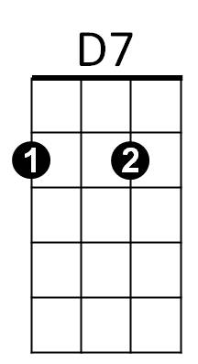

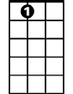

A7



C

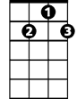

G7

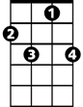

F7

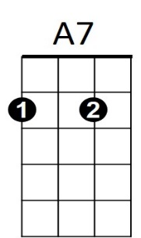

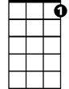

G7

**BARITONE**

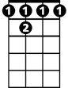

F 7



D7

C



**On The Beach At Waikiki (G. H. Stover / Henry Kailimai) Key G**

**G**

Honi ka ua wiki wiki

**E7 A7**

Sweet brown maiden said to me

**D7**

As she gave me language lessons

**G C7 G D7**

On the beach at Waikiki

**G**

Honi ka ua wiki wiki

**E7 A7**

She then said and smiled in glee

**D7**

But she would not translate for me

**G C7 G D7**

On the beach at Waikiki

**G**

Honi ka ua wiki wiki

**E7 A7**

She repeated playfully

**D7**

Oh those lips were so inviting

**G C7 G D7**

On the beach at Waikiki

**G**

Honi ka ua wiki wiki

**E7 A7**

She was surely teasing me

**D7**

So I caught that maid and kissed her

**G C7 G D7**

On the beach at Waikiki

**G**

Honi ka ua wiki wiki

**E7 A7**

You have learned it perfectly

**D7**

Don't forget what I have taught you

**G C7 G**

Said the maid at Waikiki



A7



G

E7

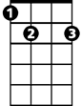

*Honi ka ua wiki wiki = we kiss quickly*

*Honi (kiss) Ka ua (we) wiki wiki (quick / fast)*





C7

**BARITONE**





G



E7



C7



D7