**On the Sunny Side of the Mountain**

**(Bobby Gregory / Harry C Mcaulife)**

**Key C**

**C F**

Now don't forget me little darling while I'm growing old and gray



C

**G7 C**

Just a little thought before I’m going far away

**F**

Cause I'll be waiting on the hillside where the wild red roses grow

**G7 C**

On the sunny side of the mountain where the rippling waters flow

F



**C F**

Now don't forget about the days we courted many years ago

**G7 C**

Don't forget all those promises you made me and so

**F**

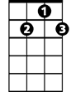

G7

I'll be waiting on the hillside when the day you will call

**G7 C**

On the sunny side of the mountain where the rippling waters fall

**C F**

Please tell me darling, in your letter do you ever think of me

**G7 C**

Please answer ... little darling tell me where you can be

**F**

It’s been so long since I’ve seen you but your love still lingers on

**G7 C**

Don't forget me little darling though our love affair is gone

**(repeat first verse)**

**BARITONE**

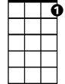

G7



F

C



**On the Sunny Side of the Mountain**

**(Bobby Gregory / Harry C Mcaulife)**

**Key G**

**D G**

Now don't forget me little darling while I'm growing old and gray

**A7 D**

Just a little thought before I’m going far away

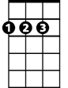

D

**G**

Cause I'll be waiting on the hillside where the wild red roses grow

**A7 D**

On the sunny side of the mountain where the rippling waters flow



G

**D G**

Now don't forget about the days we courted many years ago

**A7 D**

Don't forget all those promises you made me and so

**G**

I'll be waiting on the hillside when the day you will call

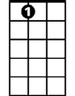

A7

**A7 D**

On the sunny side of the mountain where the rippling waters fall

**D G**

Please tell me darling, in your letter do you ever think of me

**A7 D**

Please answer ... little darling tell me where you can be

**G**

It’s been so long since I’ve seen you but your love still lingers on

**A7 D**

Don't forget me little darling though our love affair is gone

**(repeat first verse)**

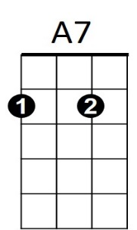



G



D

**BARITONE**

**On the Sunny Side of the Mountain**

**(Bobby Gregory / Harry C Mcaulife)**

**Key G**

**G C**

Now don't forget me little darling while I'm growing old and gray

**D7 G**

Just a little thought before I’m going far away



G

**C**

Cause I'll be waiting on the hillside where the wild red roses grow

**D7 G**

On the sunny side of the mountain where the rippling waters flow



C

**G C**

Now don't forget about the days we courted many years ago

**D7 G**

Don't forget all those promises you made me and so

**C**

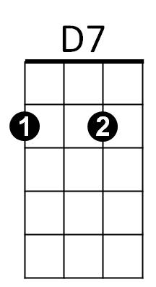I'll be waiting on the hillside when the day you will call

**D7 G**

On the sunny side of the mountain where the rippling waters fall

**G C**

Please tell me darling, in your letter do you ever think of me

**D7 G**

Please answer ... little darling tell me where you can be

**C**

It’s been so long since I’ve seen you but your love still lingers on

**D7 G**

Don't forget me little darling though our love affair is gone

**(repeat first verse)**

**BARITONE**



D7

C



G