One Horse Open Sleigh
C89 C
(James Lord Pierpont, 1857) – The Original Version of "Jingle Bells" – Version 2

Intro (last 2 lines of verse)  Dm C G7 C G7  C  1. Dashing thro' the snow,  C7 F  In a one horse open sleigh,  Dm G7 C  O'er the hills we go, laughing all the way;  (C) C7 F  Bells on bob tail ring, making spirits bright,  Dm C  Oh what sport to ride and sing  G7 C  A sleighing song to night.  Chorus  G7 C  Oh, Jingle bells, Jingle bells,  - C7  Jingle all the way.  F C  Oh! what joy it is to ride  D7 G - G7  In a one horse open sleigh.  C  Jingle bells, Jingle bells,  - C7  Jingle all the way.  F C  Oh! what joy it is to ride  G7 C - G7  In a one horse open sleigh. | C C7 F  2. A day or two ago, I tho't I'd take a ride,  Dm G7  And soon Miss Fannie Bright,  C  Was seated by my side.  (C)  The horse was lean and lank,  C7 F  Mis-fortune seem'd his lot,  Dm C G7 C  He got into a drifted bank and we? We got up-sot. Chorus  C C7 F  3. A day or two ago, the story I must tell,  Dm G7 C  I went out on the snow and on my back I fell;  (C) C7 F  A gent was riding by, in a one horse open sleigh,  Dm C  He laughed as there I sprawling lie,  G7 C  But quickly drove a-way. Chorus  C  4. Now the ground is white,  C7 F  Go it while you're young,  Dm G7 C  Take the girls to-night and sing this sleighing song;  (C) C7 F  Just get a bob tailed bay, two forty as his speed,  Dm C  Hitch him to an open sleigh  G7 C  And crack, you'll take the lead. Chorus

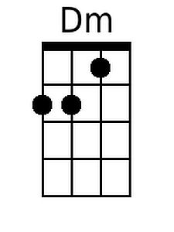 | 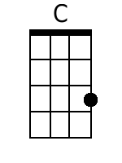 | 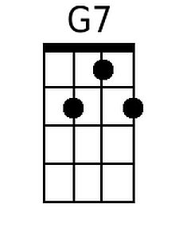 | 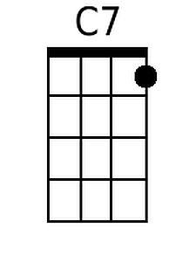 | 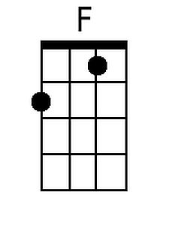 | 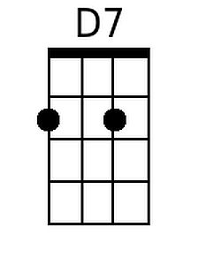 | 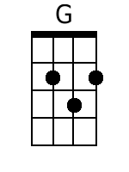
Baritone | 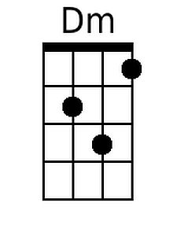 | 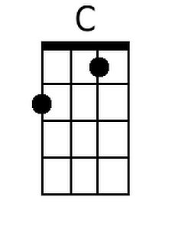 | 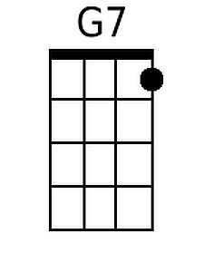 | 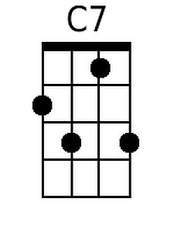 | 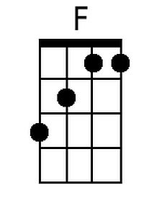 | 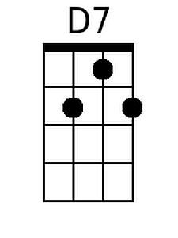 | 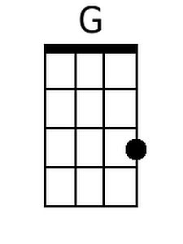

One Horse Open Sleigh
C89 D
(James Lord Pierpont, 1857) – The Original Version of "Jingle Bells" – Version 2

Intro (last 2 lines of verse)  Em D A7 D A7  D  1. Dashing thro' the snow,  D7 G  In a one horse open sleigh,  Em A7 D  O'er the hills we go, laughing all the way;  (D) D7 G  Bells on bob tail ring, making spirits bright,  Em D  Oh what sport to ride and sing  A7 D  A sleighing song to night.  Chorus  A7 D  Oh, Jingle bells, Jingle bells,  - D7  Jingle all the way.  G D  Oh! what joy it is to ride  E7 A - A7  In a one horse open sleigh.  D  Jingle bells, Jingle bells,  - D7  Jingle all the way.  G D  Oh! what joy it is to ride  A7 D - A7  In a one horse open sleigh. | D D7 G  2. A day or two ago, I tho't I'd take a ride,  Em A7  And soon Miss Fannie Bright,  D  Was seated by my side.  (D)  The horse was lean and lank,  D7 G  Mis-fortune seem'd his lot,  Em D A7 D  He got into a drifted bank and we? We got up-sot. Chorus  D D7 G  3. A day or two ago, the story I must tell,  Em A7 D  I went out on the snow and on my back I fell;  (D) D7 G  A gent was riding by, in a one horse open sleigh,  Em D  He laughed as there I sprawling lie,  A7 D  But quickly drove a-way. Chorus  D  4. Now the ground is white,  D7 G  Go it while you're young,  Em A7 D  Take the girls to-night and sing this sleighing song;  (D) D7 G  Just get a bob tailed bay, two forty as his speed,  Em D  Hitch him to an open sleigh  A7 D  And crack, you'll take the lead. Chorus

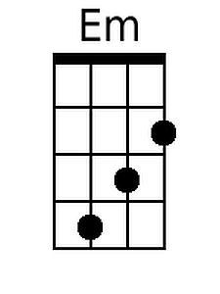 | 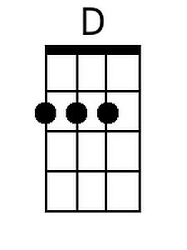 | 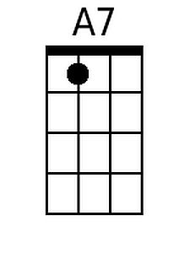 |  |  | 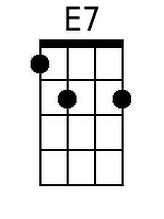 | 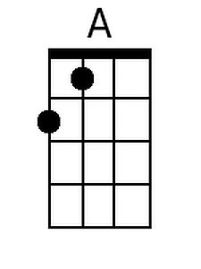
Baritone | 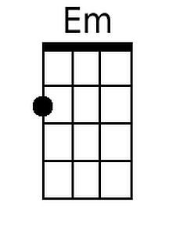 | 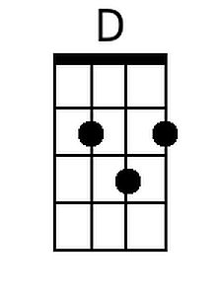 | 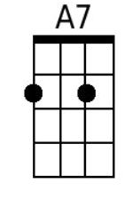 |  |  | 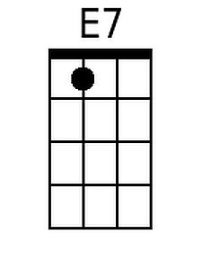 | 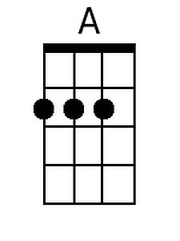

One Horse Open Sleigh
C89 G
(James Lord Pierpont, 1857) – The Original Version of "Jingle Bells" – Version 2

Intro (last 2 lines of verse)  Am G D7 G D7  G  1. Dashing thro' the snow,  G7 C  In a one horse open sleigh,  Am D7 G  O'er the hills we go, laughing all the way;  (G) G7 C  Bells on bob tail ring, making spirits bright,  Am G  Oh what sport to ride and sing  D7 G  A sleighing song to night.  Chorus  D7 G  Oh, Jingle bells, Jingle bells,  - G7  Jingle all the way.  C G  Oh! what joy it is to ride  A7 D - D7  In a one horse open sleigh.  G  Jingle bells, Jingle bells,  - G7  Jingle all the way.  C G  Oh! what joy it is to ride  D7 G - D7  In a one horse open sleigh. | G G7 C  2. A day or two ago, I tho't I'd take a ride,  Am D7  And soon Miss Fannie Bright,  G  Was seated by my side.  (G)  The horse was lean and lank,  G7 C  Mis-fortune seem'd his lot,  Am G D7 G  He got into a drifted bank and we? We got up-sot. Chorus  G G7 C  3. A day or two ago, the story I must tell,  Am D7 G  I went out on the snow and on my back I fell;  (G) G7 C  A gent was riding by, in a one horse open sleigh,  Am G  He laughed as there I sprawling lie,  D7 G  But quickly drove a-way. Chorus  G  4. Now the ground is white,  G7 C  Go it while you're young,  Am D7 G  Take the girls to-night and sing this sleighing song;  (G) G7 C  Just get a bob tailed bay, two forty as his speed,  Am G  Hitch him to an open sleigh  D7 G  And crack, you'll take the lead. Chorus

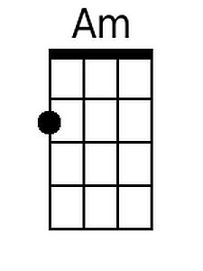
Baritone | 