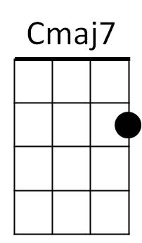**Our House (Graham Nash / David Crosby)**



C

**C Cmaj7 Am C F**

I'll light the fire, you place the flowers in the vase

**C F**

That you bought today

**C Cmaj7 Am C**

Staring at the fire for hours and hours

F

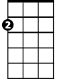

Am

**F C F G F G C Cmaj7**

While I listen to you play your love songs all night long for me

**Am C F G#**

Only for me



G

**C Cmaj7 Am C**

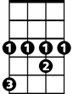

G#

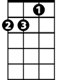

Dm

Come to me now and rest your head for just five minutes

**F C F**

Every - thing is done

**C Cmaj7 Am C**

Such a cozy room the windows are illuminated

**F C F G F G C Cmaj7**

**BARITONE**

By the evening sunshine through them fiery gems for you



F

C



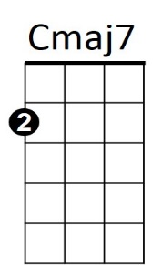**Am C F G#**



Am

Only for you

**CHORUS:**

**C Cmaj7 Am C**

Our house, is a very, very, very fine house



G

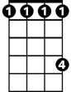

G#

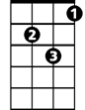

Dm

**F C**

With two cats in the yard

**F C**

Life used to be so hard

**F C F Dm F**

Now everything is easy 'cause of you …. and - I

**C Cmaj7 Am C F C F G**

Lala Ladadada Ladadada Ladadadada Dadadada Dadadada Dadadada Dadadada

**C Cmaj7 Am C F G#**

Lala Ladadada Ladadada Ladadadada Dadadada Dadada dada

**(CHORUS)**

**(slowly) C Cmaj7 Am C F**

I'll light the fire While you place the flowers in the vase

**G# C**

That you bought toda - -a – a—ay

**Our House (Graham Nash / David Crosby)**

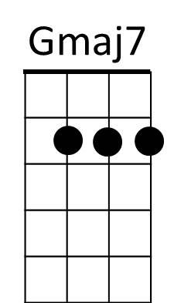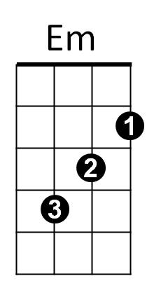



G

**G Gmaj7 Em G C**

I'll light the fire, you place the flowers in the vase

**G C**

That you bought today

**G Gmaj7 Em G**

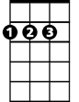

D



C

Staring at the fire for hours and hours

**C G C D C D G Gmaj7**

While I listen to you play your love songs all night long for me

**Em G C Eb**

Only for me

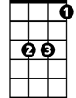

Eb

**G Gmaj7 Em G**



Am

Come to me now and rest your head for just five minutes

**C G C**

Every - thing is done

**G Gmaj7 Em G**

Such a cozy room the windows are illuminated

**C G C D C D G Gmaj7**

**BARITONE**

By the evening sunshine through them fiery gems for you

**Em G C Eb**

C



Em



G

Only for you

**CHORUS:**

**G Gmaj7 Em G**

Our house, is a very, very, very fine house



D



Eb



Am

**C G**

With two cats in the yard

**C G**

Life used to be so hard

**C G C Am C**

Now everything is easy 'cause of you …. and - I

**G Gmaj7 Em G C G C D**

Lala Ladadada Ladadada Ladadadada Dadadada Dadadada Dadadada Dadadada

**G Gmaj7 Em G C D#**

Lala Ladadada Ladadada Ladadadada Dadadada Dadada dada

**(CHORUS)**

**(slowly) G Gmaj7 Em G C**

I'll light the fire While you place the flowers in the vase

**Eb G**

That you bought toda - -a – a—ay