
Over The River And Through The Wood
C76 C
“The New-England Boy's Song About Thanksgiving Day”
Over the River and Through the Wood at The Hymns and Carols of Christmas
Words: Lydia Maria Child, "The New-England Boy's Song About Thanksgiving Day" in Flowers for Children, Part II (New York: C. S. Francis & Co., Boston: J. H. Francis, 1844, 1854), pp. 25-28.

C F C  Over the river, and through the wood, to Grandfather's house we go;  Dm7 G7 C Am  The horse knows the way to carry the sleigh  D7 G - G7  Through the white and drifted snow.  C F C  Over the river, and through the wood, to Grandfather's house a-way!  F B7 C Am C G7 C G7  We would not stop tor doll or top, for 't is Thanks-giving Day.  C F C  Over the river, and through the wood, oh, how the wind does blow!  Dm7 G7 C Am D7 G - G7  It stings the toes, and bites the nose, as over the ground we go.  C F C  Over the river, and through the wood, with a clear blue winter sky,  F B7 C Am C G7 C G7  The dogs do bark, and children hark, as we go jingling by.  C F C  Over the river, and through the wood, to have a first-rate play —  Dm7 G7 C Am D7 G - G7  Hear the bells ring “Ting a ling ding.” Hurra for Thanksgiving day!  C F C  Over the river, and through the wood — No matter for winds that blow;  F B7 C Am C G7 C G7  Or if we get the sleigh up-set in-to a bank of snow. |  |  |  |  |  |  |  | 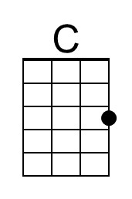 | 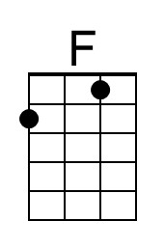
 |  |  |  |  |  |  |  | 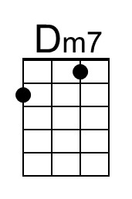 | 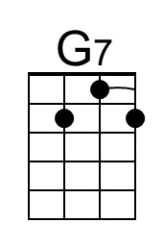
 |  |  |  |  |  |  |  | 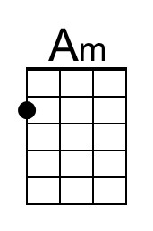 | 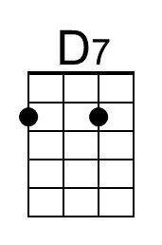
 |  |  |  |  |  |  |  | 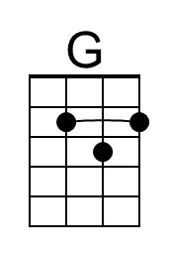 | 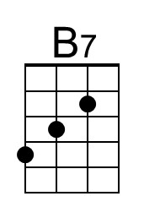
Baritone
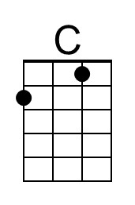 | 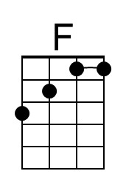 | 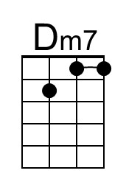 | 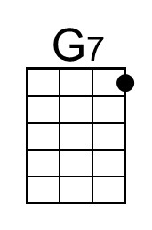 | 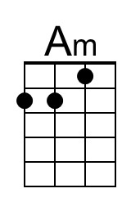 | 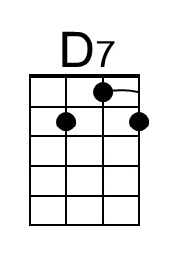 | 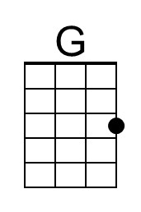 | 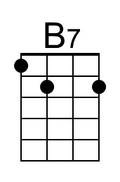

Over The River And Through The Wood (C) - Page 2

C F C
Over the river, and through the wood, to see little John and Ann;
Dm7 G7 C Am D7 G - G7
We will kiss them all, and play snow-ball, and stay as long as we can.
C F C
Over the river, and through the wood, trot fast my dapple gray!
F B7 C Am C G7 C G7
Spring over the ground, like a hunting-hound, for 'tis Thanksgiving day!

C F C
Over the river, and through the wood, and straight through the barnyard gate;
Dm7 G7 C Am D7 G - G7
We seem to go extremely slow, it is so hard to wait.
C F C
Over the river, and through the wood — Old Jowler hears our bells;
F B7 C Am C G7 C G7
He shakes his paw, with a loud bow-wow, and thus the news he tells.

C F C
Over the river, and through the wood — when Grandmother sees us come,
Dm7 G7 C Am D7 G - G7
She will say, Oh dear, “the children are here, bring a pie for every one.”
C F C
Over the river, and through the wood — now Grandmothers cap I spy!
F B7 C Am C G7 C G7
Hurra for the fun! Is the pudding done? Hurra for the pumpkin pie!

Over The River And Through The Wood
C76 G
“The New-England Boy's Song About Thanksgiving Day”
Over the River and Through the Wood at The Hymns and Carols of Christmas
Words: Lydia Maria Child, "The New-England Boy's Song About Thanksgiving Day" in Flowers for Children, Part II (New York: C. S. Francis & Co., Boston: J. H. Francis, 1844, 1854), pp. 25-28.

G C G
Over the river, and through the wood, to Grandfather's house we go;
Am7 D7 G Em
The horse knows the way to carry the sleigh
A7 D - D7
Through the white and drifted snow.
G C G
Over the river, and through the wood, to Grandfather's house a-way!
C F#7 G Em G D7 G D7
We would not stop tor doll or top, for 't is Thanks-giving Day.

G C G
Over the river, and through the wood, oh, how the wind does blow!
Am7 D7 G Em A7 D - D7
It stings the toes, and bites the nose, as over the ground we go.
G C G
Over the river, and through the wood, with a clear blue winter sky,
C F#7 G Em G D7 G D7
The dogs do bark, and children hark, as we go jingling by.

G C G
Over the river, and through the wood, to have a first-rate play —
Am7 D7 G Em A7 D - D7
Hear the bells ring “Ting a ling ding.” Hurra for Thanksgiving day!
G C G
Over the river, and through the wood — No matter for winds that blow;
C F#7 G Em G D7 G D7
Or if we get the sleigh up-set in-to a bank of snow.

 |  |  |  |  |  |  |  | 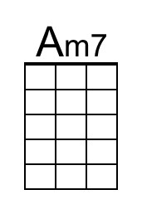
 |  |  |  |  |  |  |  | 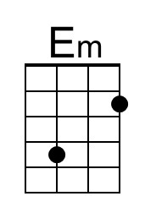 | 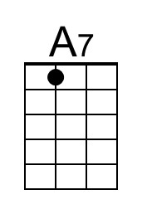
 |  |  |  |  |  |  |  | 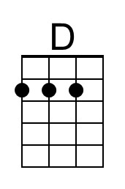 | 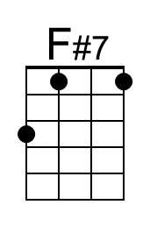
Baritone
 |  | 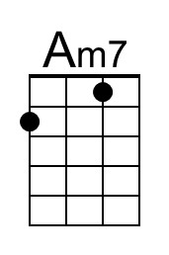 |  | 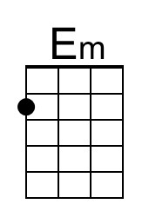 | 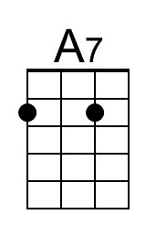 | 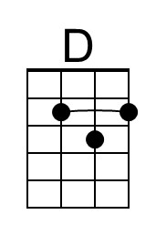 | 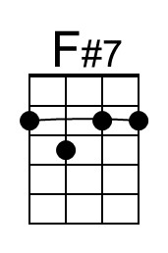

Over The River And Through The Wood (C) - Page 2

G C G
Over the river, and through the wood, to see little John and Ann;
Am7 D7 G Em A7 D - D7
We will kiss them all, and play snow-ball, and stay as long as we can.
G C G
Over the river, and through the wood, trot fast my dapple gray!
C F#7 G Em G D7 G D7
Spring over the ground, like a hunting-hound, for 'tis Thanksgiving day!

G C G
Over the river, and through the wood, and straight through the barnyard gate;
Am7 D7 G Em A7 D - D7
We seem to go extremely slow, it is so hard to wait.
G C G
Over the river, and through the wood — Old Jowler hears our bells;
C F#7 G Em G D7 G D7
He shakes his paw, with a loud bow-wow, and thus the news he tells.

G C G
Over the river, and through the wood — when Grandmother sees us come,
Am7 D7 G Em A7 D - D7
She will say, Oh dear, “the children are here, bring a pie for every one.”
G C G
Over the river, and through the wood — now Grandmothers cap I spy!
C F#7 G Em G D7 G D7
Hurra for the fun! Is the pudding done? Hurra for the pumpkin pie!

