Over the River and Through the Woods (C)
Over the River and Through the Woods at The Hymns and Carols of Christmas
Based on the poem by Lydia Maria Child, "The New-England Boy's Song About Thanksgiving Day" in Flowers for Children, Part II (New York: C. S. Francis & Co., Boston: J. H. Francis, 1844, 1854), pp. 25-28.

C F C  Over the river and through the woods to Grandmother's house we go  Dm7 G7 C Am  The horse knows the way to carry the sleigh  D7 G - G7  Through white and drifted snow  C F C  Over the river and through the woods oh, how the wind does blow  F (B7) C Am C G7 C G7  It stings the toes and bites the nose as over the ground we go.  C F C  Over the river and through the woods, to have a full day of play.  Dm7 G7 C Am D7 G - G7  Oh, hear the bells ringing “ting-a-ling-ling,” for it is Christmas Day.  C F C  Over the river and through the woods, trot fast my dapple gray;  F (B7) C Am C G7 C G7  Spring o'er the ground just like a hound, for this is Christmas Day.  C  Over the river and through the woods and  F C  Straight through the barnyard gate.  Dm7 G7 C Am D7 G - G7  It seems that we go so dreadfully slow; it is so hard to wait.  C F C  Over the river and through the woods, now Grandma's cap I spy.  F (B7) C Am C G7 C G7 C  Hur-rah for fun; the pudding's done; Hur-rah for the pumpkin pie. |  |  |  |  |  |  |  | 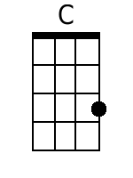 | 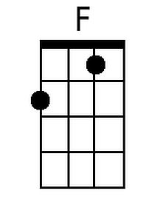
 |  |  |  |  |  |  |  | 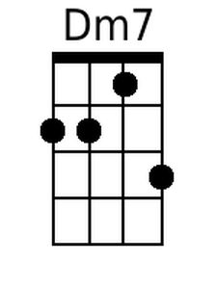 | 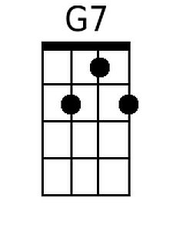
 |  |  |  |  |  |  |  | 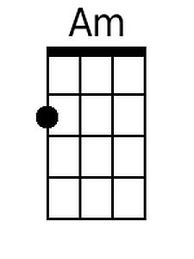 | 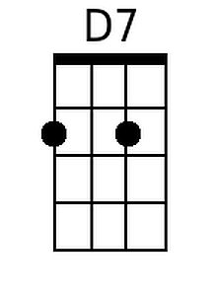
 |  |  |  |  |  |  |  | 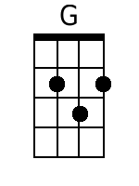 | 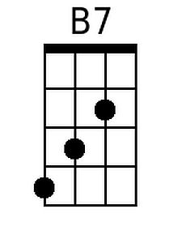
Baritone
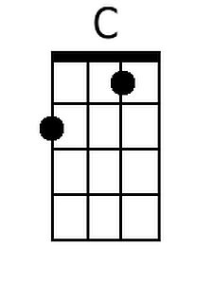 | 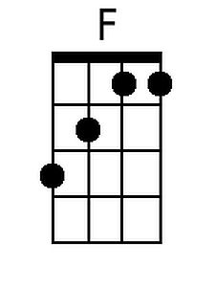 | 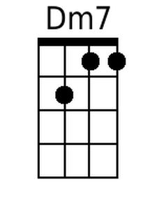 | 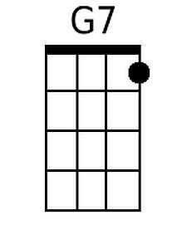 | 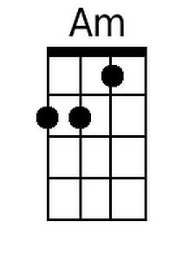 | 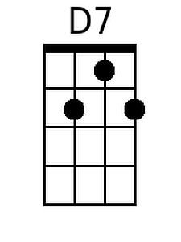 | 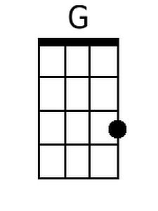 | 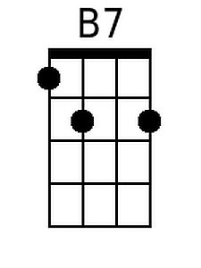

Over the River and Through the Woods (G)
Over the River and Through the Woods at The Hymns and Carols of Christmas
Based on the poem by Lydia Maria Child, "The New-England Boy's Song About Thanksgiving Day" in Flowers for Children, Part II (New York: C. S. Francis & Co., Boston: J. H. Francis, 1844, 1854), pp. 25-28.

G C G
Over the river and through the woods to Grandmother's house we go
Am7 D7 G Em
The horse knows the way to carry the sleigh
A7 D - D7
Through white and drifted snow
G C G
Over the river and through the woods oh, how the wind does blow
C (F#7) G Em G D7 G D7
It stings the toes and bites the nose as over the ground we go.

G C G
Over the river and through the woods, to have a full day of play.
Am7 D7 G Em A7 D - D7
Oh, hear the bells ringing "ting-a-ling-ling," for it is Christmas Day.
G C G
Over the river and through the woods, trot fast my dapple gray;
C (F#7) G Em G D7 G D7
Spring o'er the ground just like a hound, for this is Christmas Day.

G
Over the river and through the woods and
C G
Straight through the barnyard gate.
Am7 D7 G Em A7 D - D7
It seems that we go so dreadfully slow; it is so hard to wait.
G C G
Over the river and through the woods, now Grandma's cap I spy.
C (F#7) G Em G D7 G D7 G
Hur-rah for fun; the pudding's done; Hur-rah for the pumpkin pie.

 |  |  |  |  |  |  |  | 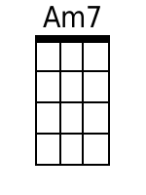
 |  |  |  |  |  |  |  | 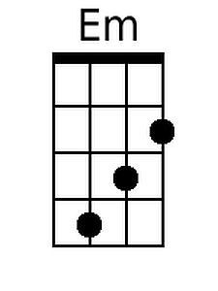 | 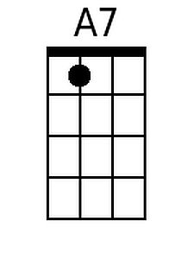
 |  |  |  |  |  |  |  | 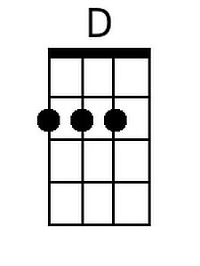 | 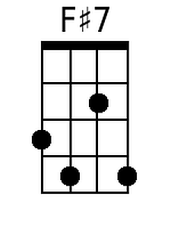
Baritone
 |  | 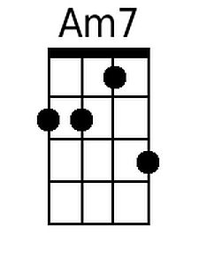 |  | 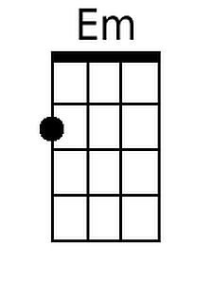 | 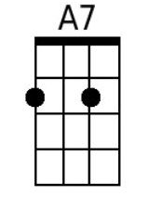 | 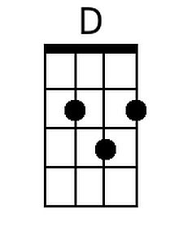 | 