Over the River and Through the Woods
C77 C
Over the River and Through the Woods at The Hymns and Carols of Christmas
Based on the poem by Lydia Maria Child, "The New-England Boy's Song About Thanksgiving Day" in Flowers for Children, Part II (New York: C. S. Francis & Co., Boston: J. H. Francis, 1844, 1854), pp. 25-28.

C F C  Over the river and through the woods to Grandmother's house we go  Dm7 G7 C Am  The horse knows the way to carry the sleigh  D7 G - G7  Through white and drifted snow  C F C  Over the river and through the woods oh, how the wind does blow  F (B7) C Am C G7 C G7  It stings the toes and bites the nose as over the ground we go.  C F C  Over the river and through the woods, to have a full day of play.  Dm7 G7 C Am D7 G - G7  Oh, hear the bells ringing “ting-a-ling-ling,” for it is Christmas Day.  C F C  Over the river and through the woods, trot fast my dapple gray;  F (B7) C Am C G7 C G7  Spring o'er the ground just like a hound, for this is Christmas Day.  C  Over the river and through the woods and  F C  Straight through the barnyard gate.  Dm7 G7 C Am D7 G - G7  It seems that we go so dreadfully slow; it is so hard to wait.  C F C  Over the river and through the woods, now Grandma's cap I spy.  F (B7) C Am C G7 C G7 C  Hur-rah for fun; the pudding's done; Hur-rah for the pumpkin pie. |  |  |  |  |  |  | 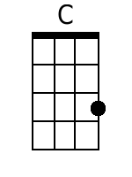 | 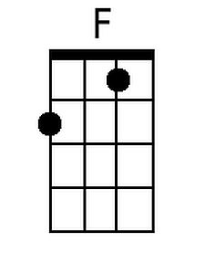
 |  |  |  |  |  |  | 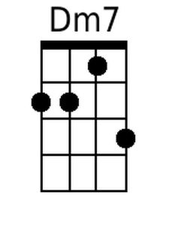 | 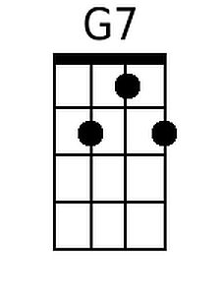
 |  |  |  |  |  |  | 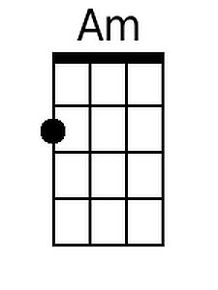 | 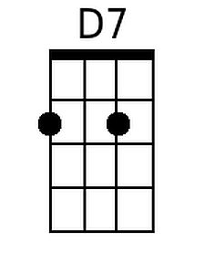
 |  |  |  |  |  |  | 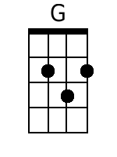 | 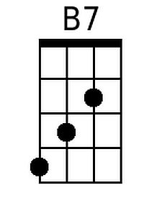
Baritone | 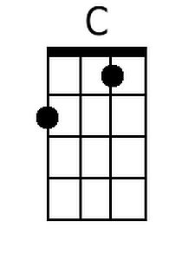 | 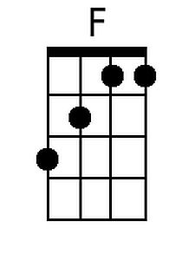 | 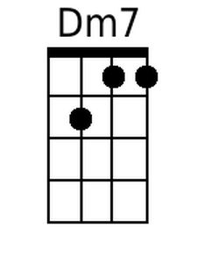 | 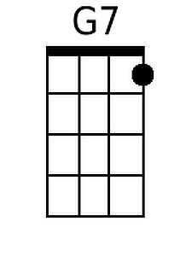 | 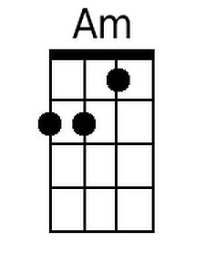 | 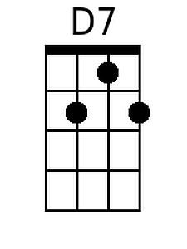 | 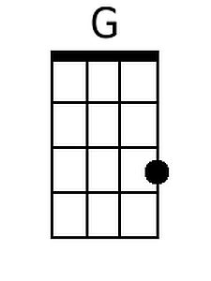 | 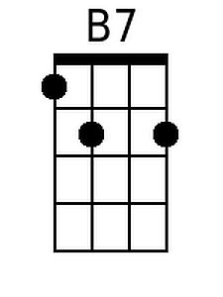

Over the River and Through the Woods
C77 G
Over the River and Through the Woods at The Hymns and Carols of Christmas
Based on the poem by Lydia Maria Child, "The New-England Boy's Song About Thanksgiving Day" in Flowers for Children, Part II (New York: C. S. Francis & Co., Boston: J. H. Francis, 1844, 1854), pp. 25-28.

G C G
Over the river and through the woods to Grandmother's house we go
Am7 D7 G Em
The horse knows the way to carry the sleigh
A7 D - D7
Through white and drifted snow
G C G
Over the river and through the woods oh, how the wind does blow
C (F#7) G Em G D7 G D7
It stings the toes and bites the nose as over the ground we go.

G C G
Over the river and through the woods, to have a full day of play.
Am7 D7 G Em A7 D - D7
Oh, hear the bells ringing "ting-a-ling-ling," for it is Christmas Day.
G C G
Over the river and through the woods, trot fast my dapple gray;
C (F#7) G Em G D7 G D7
Spring o'er the ground just like a hound, for this is Christmas Day.

G
Over the river and through the woods and
C G
Straight through the barnyard gate.
Am7 D7 G Em A7 D - D7
It seems that we go so dreadfully slow; it is so hard to wait.
G C G
Over the river and through the woods, now Grandma's cap I spy.
C (F#7) G Em G D7 G D7 G
Hur-rah for fun; the pudding's done; Hur-rah for the pumpkin pie.

 |  |  |  |  |  |  | 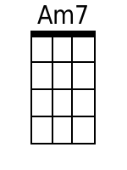
 |  |  |  |  |  |  | 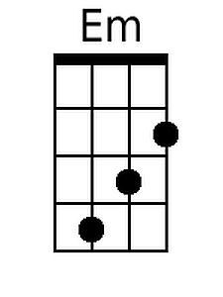 | 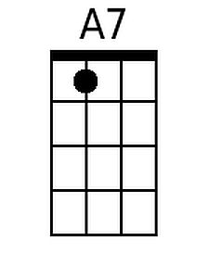
 |  |  |  |  |  |  | 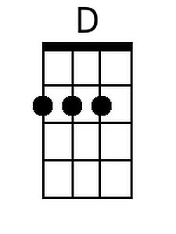 | 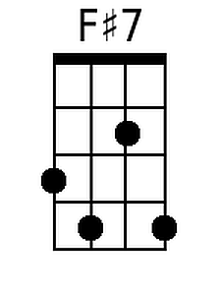
Baritone |  |  | 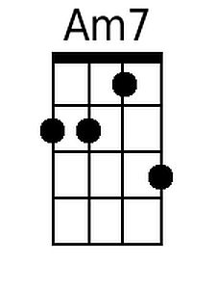 |  | 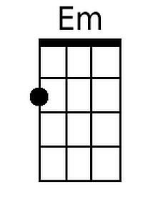 | 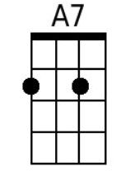 | 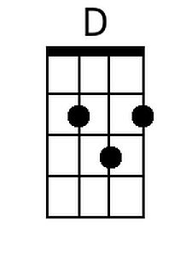 | 