**Panama Red (P. Rowan) Key C**



C



G

F

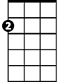

Am

E7

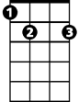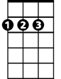

D

**Intro: G C**

**Chorus:**

**Am G**

Panama Red, Panama Red,

**F D G**

He'll steal your woman then he'll rob your head.

**Am G**

Panama Red, Panama Red,

**E7 F**

On his white horse Mescalito, he comes breezin' thru town.

**G C**

Bet your woman is up in bed with ol' Panama Red.

**C**

The judge don't know when Red's in town,

**F**

He keeps well hidden under ground.

**G C**

Everybody's actin' lazy, fallin' out or hangin' round.

**C F**

My woman said, Hey Pedro, you're actin' crazy like a clown.

**G C**

Nobody feels like workin' Panama Red is back in town.

**(Chorus)**

**C F**

Everybody's lookin' out for him ‘cause they know Red satisfies.

**G C**

Little girls like to listen to him sing and tell sweet lies.

**C F**

But when things get too confusin' honey, you're better off in bed.

**G C**

I'll be searchin' all the joints in town for Panama Red.

**BARITONE**

**(Chorus) 3x to fade**

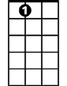

E7



D



F

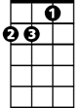

Am

C



G

**Panama Red (P. Rowan) Key F**

**Intro C F**



C

F



**BARITONE**

**Chorus:**

**Dm C**

Panama Red, Panama Red,

**Bb G C**



G



Dm

He'll steal your woman then he'll rob your head.

**Dm C**

Panama Red, Panama Red,

**A7 Bb**

On his white horse Mescalito, he comes breezin' thru town.

**C F**



Bb



A7

Bet your woman is up in bed with ol' Panama Red.

**F**

The judge don't know when Red's in town,

**Bb**

He keeps well hidden underground.

**C F**

Everybody's actin' lazy, fallin' out or hangin' round.

**F Bb**

My woman said, Hey Pedro, you're actin' crazy like a clown.

**C F**

Nobody feels like workin' Panama Red is back in town.

**(Chorus)**

**F Bb**

Everybody's lookin' out for him ‘cause they know Red satisfies.

**C F**

Little girls like to listen to him sing and tell sweet lies.

**F Bb**

But when things get too confusin' honey, you're better off in bed.

**C F**

I'll be searchin' all the joints in town for Panama Red.

**(Chorus) 3x to fade**

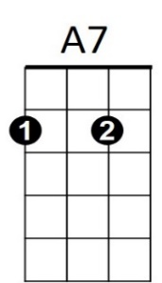



F

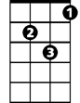

Dm



G

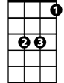

Bb

C



**Panama Red (P. Rowan)**

**Intro D G**



G



D

**Chorus:**

**Em D**

Panama Red, Panama Red,

**C A D**

He'll steal your woman then he'll rob your head.



C

Em

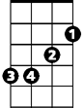

**Em D**

Panama Red, Panama Red,

**B7 C**

On his white horse Mescalito, he comes breezin' thru town.

**D G**

Bet your woman is up in bed with ol' Panama Red.

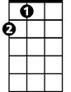

A

**G**

The judge don't know when Red's in town,

**C**

He keeps well hidden underground.

**D G**

Everybody's actin' lazy, fallin' out or hangin' round.

**G C**

My woman said, Hey Pedro, you're actin' crazy like a clown.

**D G**

Nobody feels like workin' Panama Red is back in town.

**(Chorus)**

**G C**

Everybody's lookin' out for him ‘cause they know Red satisfies.

**D G**

Little girls like to listen to him sing and tell sweet lies.

**G C**

But when things get too confusin' honey, you're better off in bed.

**D G**

I'll be searchin' all the joints in town for Panama Red.

**BARITONE**

**(Chorus) 3x to fade**



D



G



Em

C



B7



A