H22-C
Pearly Shells
Songwriters: Leon Pober / Webley Edwards – Performed by Ran Conniff & The Singers

GCEA  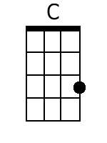  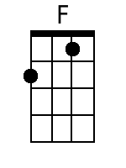  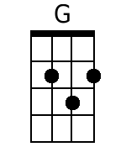  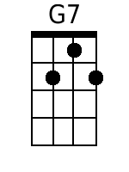  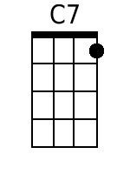  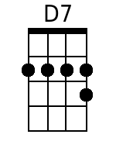 | Chorus:  C  Pearly Shells (pearly shells)  From the ocean (from the ocean)  F  Shining in the sun (shining in the sun)  G G7  Covering the shore (covering the shore)  C C7  When I see them (when I see them)  F  My heart tells me that I love you  C G7 C F C  More than all those little pearly shells.  Verse  G7  For every grain of sand upon the beach  C  I've got a kiss for you  G7  And I've got more left over for each star  D7 G7  That twinkles in the blue.  Bridge (Optional)  C  Pü pü (a‘o ‘Ewa)  I ka nu‘a (nä känaka)  F  E naue mai (a e ‘ike)  G G7  I ka mea hou (po ka ‘äina)  C  Ahe ‘äina (ua kaulana)  F  Mai nä küpu’ una mai  C G7 C  Alahula Pu‘uloa ke ala hehe no Ka‘ahu pahau,  C G7 C  Alahula Pu‘uloa ke ala hele no Ka‘ahu pahau.  Repeat From Beginning, Then:  C G7 C F  More than all those little pearly shells! | Bari  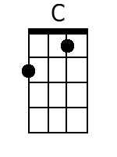  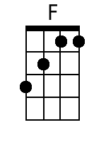  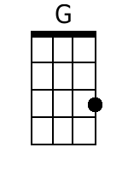  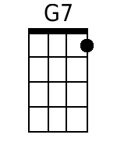  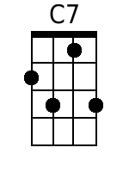  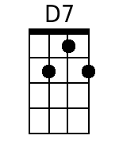

H22-G
Pearly Shells
Songwriters: Leon Pober / Webley Edwards – Performed by Ran Conniff & The Singers

GCEA  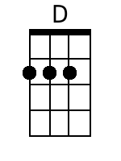  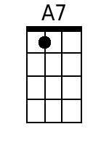 | Chorus:  G  Pearly Shells (pearly shells)  From the ocean (from the ocean)  C  Shining in the sun (shining in the sun)  D D7  Covering the shore (covering the shore)  G G7  When I see them (when I see them)  C  My heart tells me that I love you  G D7 G C G  More than all those little pearly shells.  Verse  D7  For every grain of sand upon the beach  G  I've got a kiss for you  D7  And I've got more left over for each star  A7 D7  That twinkles in the blue.  Bridge (Optional)  G  Pü pü (a‘o ‘Ewa)  I ka nu‘a (nä känaka)  C  E naue mai (a e ‘ike)  D D7  I ka mea hou (po ka ‘äina)  G  Ahe ‘äina (ua kaulana)  C  Mai nä küpu’ una mai  G D7 G  Alahula Pu‘uloa ke ala hehe no Ka‘ahu pahau,  G D7 G  Alahula Pu‘uloa ke ala hele no Ka‘ahu pahau.  Repeat From Beginning, Then:  G D7 G C  More than all those little pearly shells! | Bari  