Pencil Thin Mustache (Jimmy Buffett) (C)

Intro C E7 | A7 A7 | D7 G7 | C G7 |  C E7 A7  Now they make new movies in old black and  D7 G7 white  With happy endings, where nobody fights  C E7 A7  So if you find your-self in that nostalgic rage  D7 G7  Honey, jump right up and show your age...  Chorus  C E7 A7  I wish I had a pencil thin mustache  D7 G7 C  The “Boston Blackie” kind  C E7 A7  A two-toned Ricky Ri-cardo jacket  D7 G7  And an autographed picture of Andy Devine  C C7  I remember bein' buck toothed and skinny  F Ab7  Writin' fan letters to Sky's niece Penny  C E7 A7  Oh I wish I had a pencil thin mustache  D7 G7 C  Then I could solve some mysteries too  Dm A7 Dm A7  Oh it's Bandstand, Disneyland, growin' up  Dm A7 Dm fast  Drinkin' on a fake I.D  Em B7 Em B7  And Ramar of the jungle was everyone's  Bawana  D7 G7  But only jazz musicians were smokin'  marijuana  C E7 A7  Yeah, I wish I had a pencil thin mustache  D7 G7 C  Then I could solve some mysteries too. |  |  |  | Instrumental C E7 | A7 A7 | D7 G7 | C G7  C E7 | A7 D7 | G7 C  (Thin, thin, pencil thin mustache)  Dm A7 Dm A7  Then it's flat top, dirty bop, coppin' a feel  Dm A7 Dm A7  Grubbin' on the livin' room floor (so sore)  Em B7  They send you off to college,  Em B7  Try to gain a little knowledge  D7 G7  But all you want to do is learn how to score  C E7 A7  Yeah, but now I'm gettin' old, and I don't wear  D7 G7 underwear  I don't go to church and I don't cut my hair  C E7 A7  But I can go to movies and see it all there  D7 G7 C  Just the way that it used to be. That’s why  Chorus  C C7  Oh, I could be anyone I wanted to be  F Ab7  Maybe suave Errol Flynn or the Sheik of  C E7 A7 Araby  If I only had a pencil-thin mustache  D7 G7 C  Then I could do some cruisin' too  Outro  C  Yeah, Brylcreem, a little dab'll do yah,  D7 G7 C G7 C  Oh, I could do some cruisin' too. |  |  |  |  | 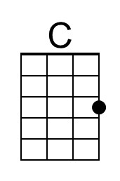 | 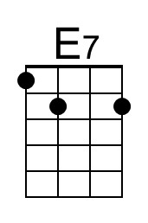
 |  |  |  |  |  |  |  |  | 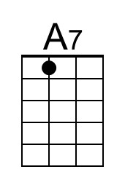 | 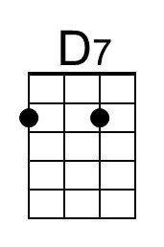
 |  |  |  |  |  |  |  |  | 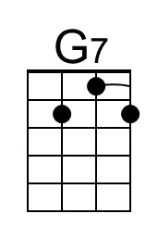 | 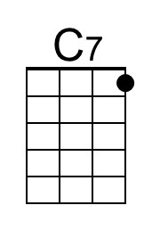
 |  |  |  |  |  |  |  |  | 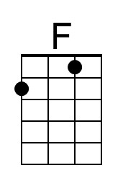 | 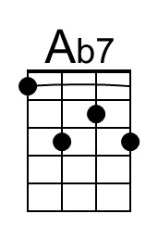
 |  |  |  |  |  |  |  |  | 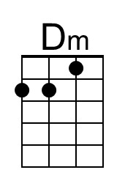 | 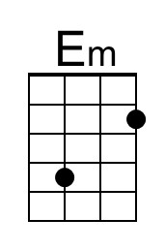
 |  |  |  |  |  |  |  |  | 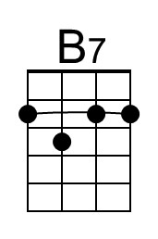
 |  | Bari | 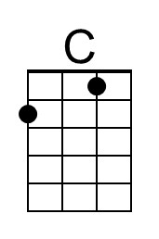 |  | 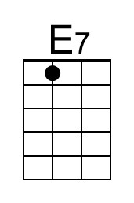 | 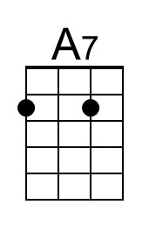 | 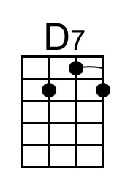 | 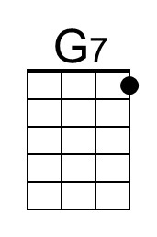 |  | 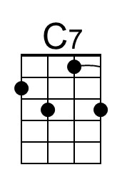
 |  |  | 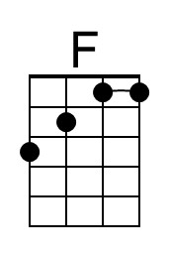 |  | 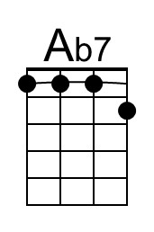 | 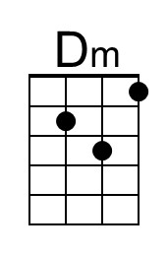 | 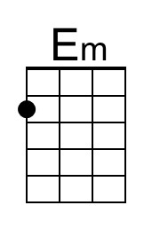 | 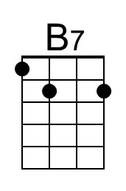

Pencil Thin Mustache (Jimmy Buffett) (F)

Intro F A7 | D7 D7 | G7 C7 | F C7 |  F A7 D7  Now they make new movies in old black and  G7 C7 white  With happy endings, where nobody fights  F A7 D7  So if you find your-self in that nostalgic rage  G7 C7  Honey, jump right up and show your age...  Chorus  F A7 D7  I wish I had a pencil thin mustache  G7 C7 F  The "Boston Blackie" kind  F A7 D7  A two-toned Ricky Ri-cardo jacket  G7 C7  And an autographed picture of Andy Devine  F F7  I remember bein' buck toothed and skinny  Bb C#7  Writin' fan letters to Sky's niece Penny  F A7 D7  Oh I wish I had a pencil thin mustache  G7 C7 F  Then I could solve some mysteries too  Gm D7 Gm D7  Oh it's Bandstand, Disneyland, growin' up fast  Gm D7 Gm  Drinkin' on a fake I.D  Am E7 Am E7  And Ramar of the jungle was everyone's  G7 C7 Bawana  But only jazz musicians were smokin'  marijuana  F A7 D7  Yeah, I wish I had a pencil thin mustache  G7 C7 F  Then I could solve some mysteries too. |  |  |  | F A7 | D7 D7 | G7 C7 | F C7 |  F A7 | D7 G7 | C7 F  (Thin, thin, pencil thin mustache)  Gm D7 Gm D7  Then it's flat top, dirty bop, coppin' a feel  Gm D7 Gm D7  Grubbin' on the livin' room floor (so sore)  Am E7  They send you off to college,  Am E7  Try to gain a little knowledge  G7 C7  But all you want to do is learn how to score  F A7 D7  Yeah, but now I'm gettin' old, and I don't wear  underwear  G7 C7  I don't go to church and I don't cut my hair  F A7 D7  But I can go to movies and see it all there  G7 C7 F  Just the way that it used to be. That's why. Chorus  F F7  Oh, I could be anyone I wanted to be  Bb C#7  Maybe suave Errol Flynn or the Sheik of  F A7 D7 Araby  If I only had a pencil-thin mustache  G7 C7 F  Then I could do some cruisin' too  F  Yeah, Brylcreem, a little dab'll do yah,  G7 C7 F C7 F  Oh, I could do some cruisin' too.
 |  |  |  |  |  |  |  |  | 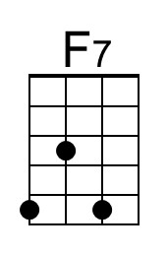
 |  |  |  |  |  |  |  | 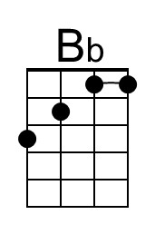 | 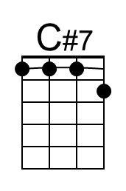
 |  |  |  |  |  |  |  | 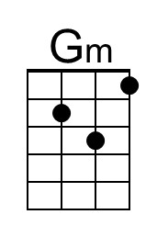 | 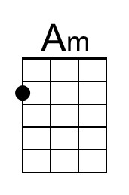
 |  | Bari |  |  |  |  |  |  | 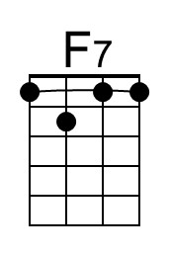
 |  |  | 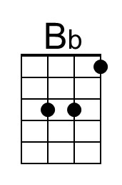 |  | 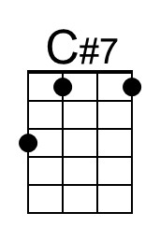 | 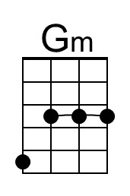 | 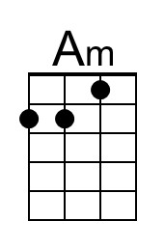

Pencil Thin Mustache (Jimmy Buffett) (G)

Intro G B7 | E7 E7 | A7 D7 | G D7 |  G B7 E7  Now they make new movies in old black and white  A7 D7  With happy endings, where nobody fights  G B7 E7  So if you find your-self in that nostalgic rage  A7 D7  Honey, jump right up and show your age...  Chorus  G B7 E7  I wish I had a pencil thin mustache  A7 D7 G  The "Boston Blackie" kind  G B7 E7  A two-toned Ricky Ri-cardo jacket  A7 D7  And an autographed picture of Andy Devine  G G7  I remember bein' buck toothed and skinny  C Eb7  Writin' fan letters to Sky's niece Penny  G B7 E7  Oh I wish I had a pencil thin mustache  A7 D7 G  Then I could solve some mysteries too  Am E7 Am E7  Oh it's Bandstand, Disneyland, growin' up fast  Am E7 Am  Drinkin' on a fake I.D  Bm F#7 Bm F#7  And Ramar of the jungle was everyone's  A7 D7 Bawana  But only jazz musicians were smokin'  marijuana  G B7 E7  Yeah, I wish I had a pencil thin mustache  A7 D7 G  Then I could solve some mysteries too. |  |  |  | Instrumental G B7 | E7 E7 | A7 D7 | G D7  G B7 | E7 A7 | D7 G  (Thin, thin, pencil thin mustache)  Am E7 Am E7  Then it's flat top, dirty bop, coppin' a feel  Am E7 Am E7  Grubbin' on the livin' room floor (so sore)  Bm F#7  They send you off to college,  Bm F#7  Try to gain a little knowledge  A7 D7  But all you want to do is learn how to score  G B7 E7  Yeah, but now I'm gettin' old, and I don't wear  A7 D7 underwear  I don't go to church and I don't cut my hair  G B7 E7  But I can go to movies and see it all there  A7 D7 G  Just the way that it used to be. That's why Chorus  G G7  Oh, I could be anyone I wanted to be  C Eb7  Maybe suave Errol Flynn or the Sheik of  G B7 E7 Araby  If I only had a pencil-thin mustache  A7 D7 G  Then I could do some cruisin' too  Outro  G  Yeah, Brylcreem, a little dab'll do yah,  A7 D7 G D7 G  Oh, I could do some cruisin' too. |  |  |  | 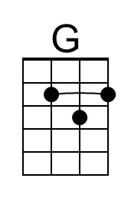
 |  |  |  |  |  |  |  |  |  | 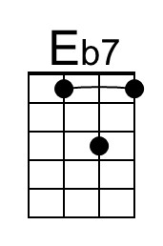
 |  |  |  |  |  |  |  |  |  | 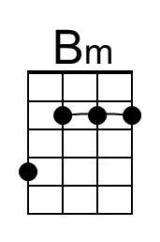
 |  |  |  |  |  |  |  | 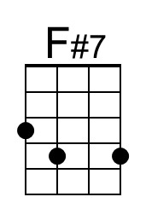
 |  |  | Bari | 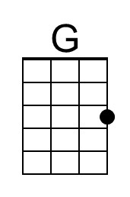
 |  |  |  |  | 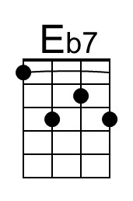 |  | 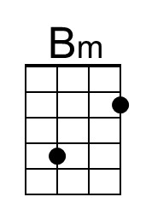 |  | 