**Intro: Melody for last two lines of chorus**

**C E7 A7**

E7

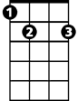

C

Now they make new movies in old black and white

**D7 G7**

With happy endings, where nobody fights

**C E7 A7**

So if you find yourself in that nostalgic rage

**D7 G7**

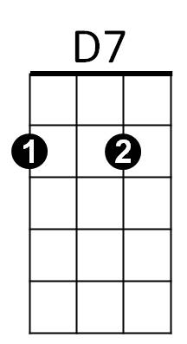Honey, jump right up and show your age

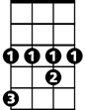

G#

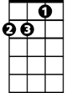

Dm

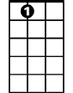

A7

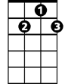

G7

**Chorus:**

**C E7 A7**

I wish I had a pencil thin mustache

**D7 G7 C**

The "Boston Blackie" kind

**C E7 A7**

A two toned Ricky Ricardo jacket

F

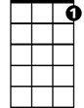

C7

**D7 G7**

And an autographed picture of Andy Devine

**C C7**

Oh I remember bein' buck-toothed and skinny

**F G#**

Writin' fan letters to Sky's niece Penny

**C E7 A7**

Em

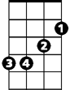

Oh I wish I had a pencil thin mustache

**D7 G7 C**

Then I could solve some mysteries too

**Dm A7 Dm A7**

Oh it's Bandstand, Disneyland, growin' up fast

**Dm A7 Dm**

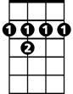

B7

Drinkin' on a fake I.D.

**Em B7 Em B7**

And Rama of the jungle was everyone's Bawana

**D7 G7**

But only jazz musicians were smokin' marijuana

**C E7 A7**

Yeah, I wish I had a pencil thin mustache

**D7 G7 C**

Then I could solve some mysteries too

**Instrumental bridge first two lines of verse**

**Dm A7 Dm A7**

But then it's flat top, dirty bop, coppin' a feel

**BARITONE**

**Dm A7 Dm**

Grubbin' on the livin' room floor (so sore)

**Em B7 Em B7**

Yeah, they send you off to college, try to gain a little knowledge,

**D7 G7**

C



E7

But all you want to do is learn how to score

**C E7 A7**

Yeah, but now I'm gettin' old, don't wear underwear

**D7 G7**

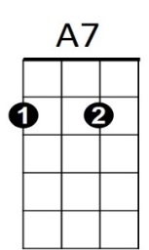I don't go to church and I don't cut my hair



D7



G7

**C E7 A7**

But I can go to movies and see it all there

**D7 G7 C**

Just the way that it used to be

**C E7 A7**



F

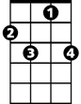

C7

That's why I wish I had a pencil thin mustache

**D7 G7 C**

The "Boston Blackie" kind,

**C E7 A7**

A two-toned Ricky Ricardo jacket

**D7 G7**

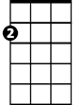

Em

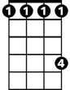

G#

And an autographed picture of Andy Devine

**C C7**

Oh, I could be anyone I wanted to be

**F G#**

Maybe suave Errol Flynn or a Sheik of Araby

**C E7 A7**

If I only had a pencil thin mustache

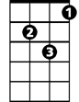

Dm

B7



**D7 G7 C**

Then I could do some cruisin' too

**C**

Yeah, Bryl-cream, a little dab'll do yah

**D7 G7 C**

Oh, I could do some cruisin' too