**People are Strange (Jim Morrison)**

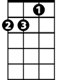

Dm

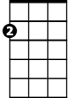

Am

**Am**

People are strange

**Dm Am**

When you’re a Stranger

**Dm Am E7 Am**

Faces look ugly when you’re alone

E7

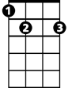

C

**Am**

Women seem wicked

**Dm Am**

When you’re unwanted

**Dm Am E7 Am**

Streets are uneven when you’re down

**Refrain:**

**BARITONE**

**Am E7**

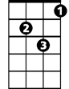

Dm



Am

When you’re strange

**C E7**

Faces come out in the rain

When you’re strange

**C E7**

No one remembers your name

C

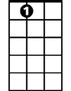

E7

When you’re strange, when you’re strange

**(Repeat entire song)**

**(Refrain)**

**E7**  **(hold last chord at end)**

When you’re strange........