**People (Jule Styne / Bob Merrill)**

**G Am**

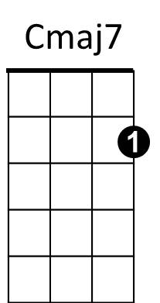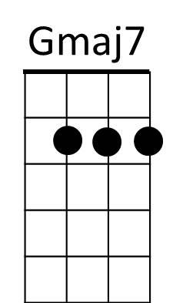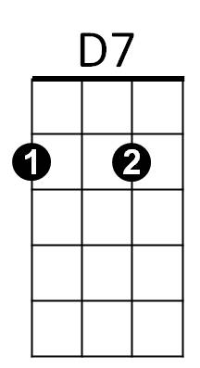**G Am G Am D**

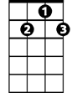

G7

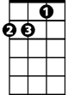

Dm

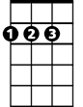

D



G

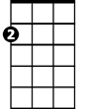

Am

Em

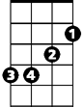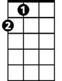

A

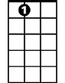

A7



C

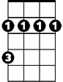

Bm

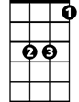

Eb

People People who need people

**Gmaj7 B7**

Are the luckiest people in the world

**Em A7**

We're children, needing other children

**Em A D**

And yet letting a grown-up pride

**Em D**

Hide all the need inside

**Em A D D7**

Acting more like children - than children

**G Am G Am**

Lovers, Are very special people

**D G Gmaj7 Dm**

They're the luckiest people in the world

**G C Bm G**

With one person, one very special person

**C Cmaj7**

A feeling deep in your soul

**G A**

Says you were half now you're whole

**G Em**

No more hunger and thirst

**Am G G7**

**BARITONE**

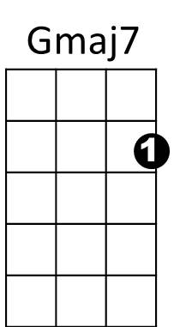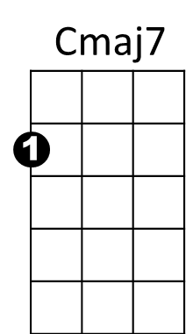But first be a person who needs people

Bm



D

C

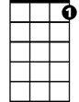

G7

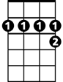

A7



A



D7



Am

B7

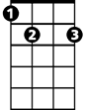

G



Em

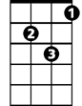

Dm

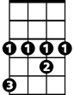

Eb

**C Am**

People who need people

**G Am G G7**

Are the luckiest people in the world

**C Bm G**

With one person, one very special person

**C Cmaj7**

A feeling deep in your soul

**G A**

Says you were half now you're whole

**G Em**

No more hunger and thirst

**Am G G7**

But first be a person who needs people

**C Eb**

People who need people

**G Am Eb G**

Are the luckiest people - in the world