Piano Man
Billy Joel (1973) – At YouTube: Piano Man

GCEA  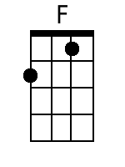  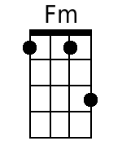  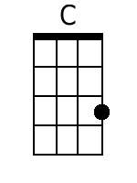  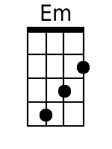  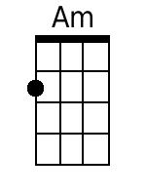  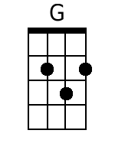  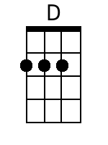  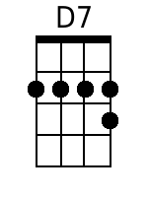  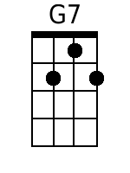 | Intro: F - Fm - - -  + Instrumental = Verse 1  + C - F - C - F (2x)  C Em Am - G  1. It's nine o'clock on a Saturday,  F Am D - G  The regular crowd shuffles in.  C - Em Am - G  There's an old man sitting next to me,  F G C  Makin' love to his tonic and gin.  [Instrumental] C - Em - Am - G - F - G - C - F  C Em Am - G  2. He says, Son, can you play me a memory?  F Am D - G  I'm not really sure how it goes.  C Em Am - G  But it's sad and it's sweet and I knew it complete,  F G C  when I wore a younger man's clothes.  Am C D - Am  La la la, de de da,  D - D7 G - G7 - G - G7  La la, de de da, da da.  Chorus  C Em Am - G  Sing us a song, you're the piano man,  F Am D - G  sing us a song to-night.  C Em Am - G  Well, we're all in the mood for a melody,  F G C  and you've got us feeling al-right.  [Instrumental]  C - Em - Am - G - F - G  C - F - C - F (2x)  C Em Am - G  3. Now John at the bar is a friend of mine,  F Am D - G  He gets me my drinks for free.  C Em Am G  And he's quick with a joke or to light up your smoke,  F G C - F  But there's some place that he'd rather be.  C Em Am - G  4. He says, Bill, I be-lieve this is killing me,  F Am D - G  As the smile ran away from his face.  C Em Am - G  Well, I'm sure that I could be a movie star,  F G C  If I could get out of this place.  Am C D - Am  La la la, de de da,  D - D7 G - G7 - G - G7  La la, de de da, da da.  C Em Am - G  5. Now Paul is a real estate novelist,  F Am D - G  Who never had time for a wife.  C Em Am G  And he's talking with Davy who's still in the navy,  F G C  And probably will be for life.  [Instrumental] C - Em - Am - G - F - G - C - F  C Em Am - G  6. And the waitress is practicing politics,  F Am D - G  As the businessman slowly gets stoned.  C Em Am - G  Yes, they're sharing a drink they call loneliness,  F G C  But it's better than drinking alone.  [Instrumental]  Am - D7 - Am - D7 - Am - D7  G - G7 - G - G7  Chorus  [Instrumental]  C - Em - Am - G - F - G  C - F - C - F (2x)  C Em Am - G  7. It's a pretty good crowd for a Saturday  F Am D - G  and the manager gives me a smile,  C Em Am G  'cause he knows that it's me they've been coming to see  F G C - F  to for-get about life for a while.  C Em Am - G  8. And the piano, it sounds like a carnival,  F Am D - G  and the microphone smells like a beer,  C Em Am G  and they sit at the bar and put bread in my jar,  F G C  and say, Man, what are you doing here?  Am C D - Am  La la la, de de da,  D - D7 G - G7 - G - G7  La la, de de da, da da.  Chorus  [Instrumental]  C - Em - Am - G - F - G  C - F - C - F (2x) - C | Bari  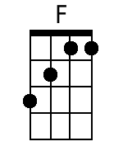  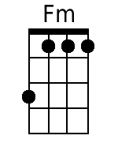  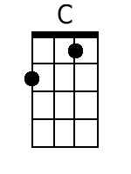  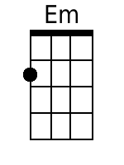  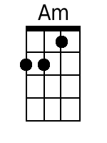  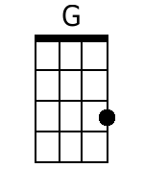  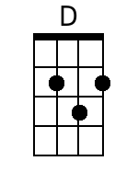  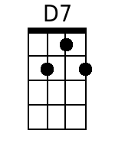  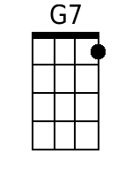

Piano Man
Billy Joel (1973) – At YouTube: Piano Man

GCEA  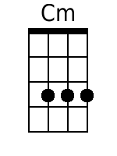  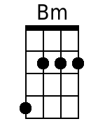  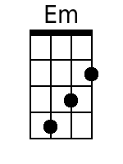  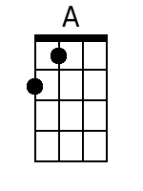  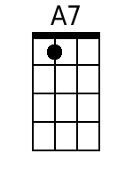 | Intro:  C - Cm - - -  + Instrumental = verse 1  + G - C - G - C (2x)  G Bm Em - D  1. It's nine o'clock on a Saturday,  C Em A - D  The regular crowd shuffles in.  G - Bm Em - D  There's an old man sitting next to me,  C D G  Makin' love to his tonic and gin.  [Instrumental] G - Bm - Em - D - C - D - G - C  G Bm Em - D  2. He says, Son, can you play me a memory?  C Em A - D  I'm not really sure how it goes.  G Bm Em - D  But it's sad and it's sweet and I knew it complete,  C D G  when I wore a younger man's clothes.  Em G A - Em  La la la, de de da,  A - A7 D - D7 - D - D7  La la, de de da, da da.  Chorus  G Bm Em - D  Sing us a song, you're the piano man,  C Em A - D  sing us a song to-night.  G Bm Em - D  Well, we're all in the mood for a melody,  C D G  and you've got us feeling al-right.  [Instrumental]  G - Bm - Em - D - C - D  G - C - G - C (2x)  G Bm Em - D  3. Now John at the bar is a friend of mine,  C Em A - D  He gets me my drinks for free.  G Bm Em D  And he's quick with a joke or to light up your smoke,  C D G - C  But there's some place that he'd rather be.  G Bm Em - D  4. He says, Bill, I be-lieve this is killing me,  C Em A - D  As the smile ran away from his face.  G Bm Em - D  Well, I'm sure that I could be a movie star,  C D G  If I could get out of this place.  Em G A - Em  La la la, de de da,  A - A7 D - D7 - D - D7  La la, de de da, da da.  G Bm Em - D  5. Now Paul is a real estate novelist,  C Em A - D  Who never had time for a wife.  G Bm Em D  And he's talking with Davy who's still in the navy,  C D G  And probably will be for life.  [Instrumental] G - Bm - Em - D - C - D - G - C  G Bm Em - D  6. And the waitress is practicing politics,  C Em A - D  As the businessman slowly gets stoned.  G Bm Em - D  Yes, they're sharing a drink they call loneliness,  C D G  But it's better than drinking alone.  [Instrumental]  Em - A7 - Em - A7 - Em - A7  D - D7 - D - D7  Chorus  [Instrumental]  G - Bm - Em - D - C - D  G - C - G - C (2x)  G Bm Em - D  7. It's a pretty good crowd for a Saturday  C Em A - D  and the manager gives me a smile,  G Bm Em D  'cause he knows that it's me they've been coming to see  C D G - C  to for-get about life for a while.  G Bm Em - D  8. And the piano, it sounds like a carnival,  C Em A - D  and the microphone smells like a beer,  G Bm Em D  and they sit at the bar and put bread in my jar,  C D G  and say, Man, what are you doing here?  Em G A - Em  Oh, la la, de de da,  A - A7 D-D7-D-D7  la la, de de da, da da.  Chorus  [Instrumental]  G - Bm - Em - D - C - D  G - C - G - C (2x) - G | Bari  