**Piece of My Heart (Jerry Ragovoy / Bert Berns)**

F



C

**Intro C F G F (2X)**

**C F G F C F G**

Didn't I make you feel ~ li ke you were the only man.

**F C F G**

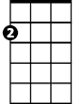

Am



G

And didn't I give you nearly everything that a woman possibly can.

**Am G**

But with all the love I give ya, it’s never enough

**Dm G**

Butl I'm gonna show you baby that a woman can be tough,

**F G** **F G F G F G**

So come on, come on, come on, come on

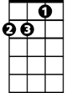

Dm

**Chorus:**

**C F G F G**

Take it! Take another little piece of my heart now baby

**C F G F G**

Break it! Break another little bit of my heart now baby

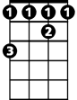

Gb

**C F G G Gb F**

Have it! Have another little piece of my heart now baby

**F Dm C C F G F**

You know you've got it, if it makes you feel good,

**C F G**

You're out on the street looking good

**F C F G**

And you know - deep down in your heart that ain't right

**F C F G F G**

And no - you never, never hear me when I cry at night.- who-oh

**Am G**

**BARITONE**

I tell myself that I can't stand the pain,



F



G

C



**Dm G**

But when you hold me in your arms, I say it again.

**F G F G F G F G**

So come on, come on, come on, come on

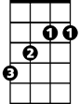

Gb

**(Chorus) 2x end with C**

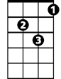

Dm



Am