**Yellow Bird**

**(Michel Mauléart Monton / Oswald Durand) (English lyrics by Alan and Marilyn Bergman)**

**C G7 C**



C

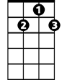

G7

F



Yellow bird, up high in banana tree.

**G7 C**

Yellow bird, you sit all alone like me.

**F C**

Did you lady friend leave the nest again?

**G7 C**

That is very sad, makes me feel so bad.

**F C**

You can fly away, in the sky away.

**G7 C**

You more lucky than me.

**F G7 C**

I also had a pretty girl, she’s not with me today.

**F**

They’re all the same those pretty girls.

**G7 C**

Take tenderness, then they fly away.

**C G7 C**

Yellow bird, up high in banana tree.

**G7 C**

Yellow bird, you sit all alone like me.

**F C**

Better fly away, in the sky away

C

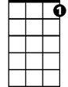

G7



F

**BARITONE**

**G7 C**

Picker coming soon, pick from night to noon

**F C**

Black and yellow you, like banana too

**G7 C**

They might pick you someday

**F G7**

Wish that I were a yellow bird, I’d fly away with you.

**F G7 C**

But I am not a yellow bird, so here I sit - nothing I can do.

**C**

Yell ow bird, yellow bird, yellow bird

**Stand By Me (Ben E. King)**

**INTRO: C Am F G C**



C



G

F

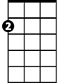

Am

**C**

When the night has come

**Am**

And the land is dark

**F G C**

And the moon is the only light we'll see

**Am**

No I won't be afraid, oh I won't be afraid

**F G C**

Just as long as you stand, stand by me

**CHORUS:**

**G C Am**

And darlin', darlin', stand by me, oh stand by me

**F G C**

**BARITONE**

Oh stand, Stand by me, stand by me



G



F

C

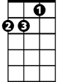

Am

**C**

If the sky that we look upon

**Am**

Should tumble and fall

**F G C**

Or the mountains should crumble to the sea

**Am**

I won't cry, I won't cry, no I won't shed a tear

**F G C**

Just as long as you stand, stand by me

**(CHORUS)**

**G**

Whenever you’re in trouble, won’t you

**C Am**

Stand by me, oh stand by me

**F G C**

Oh stand, Oh stand, stand by me

**F G C**

Oh stand, Oh stand, stand by me

**As Tears Go By - Rolling Stones**

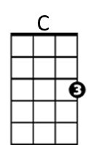**Intro: C D F G7**

F

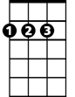

D

**C D F G7**

It is the evening of the da-ay

**C D F G7**

I sit and watch the children pla-ay

**F G7**



G7



Am

Smiling faces I can see

**C Am**

But not for me

**F G7**

I sit and watch as tears go by

**C D F G7**

My richness can't buy everythi-ing

**C D F G7**

I want to hear the children si-ing

**F G7**

All I hear is the sound

**C Am**

**BARITONE**

of rain falling on the ground

C



D

**F G7**

I sit and watch as tears go by

**C D F G7**

It is the evening of the da-ay

**C D F G7**



G7



F

I sit and watch the children pla-ay

**F G7**

Doing things I used to do

**C Am**

Thinking of you

**F G7**



Am

I sit and watch as tears go by

**OUTRO (2x)**

**C D F G7**

Hmm Hmm Hmm Hmm Hmm Hmm Hmm Hmm

**Black is Black (Anthony Hayes / Michelle Grainger / Steve Wadey)**

**Intro: Dm C (4x)**

**Dm C**



C



G



Dm

Black is black, I want my baby back

**Dm G G7 C**

It's gray, it's gray, since she went away, woh woh

**C Dm G C**

What can I do, 'cause I - I - I - I -I, I'm feelin' blue

F



D



G7

**Dm C**

If I had my way, she'd be back today

**Dm G G7 C**

But she don’t intend, to see me again, oh oh

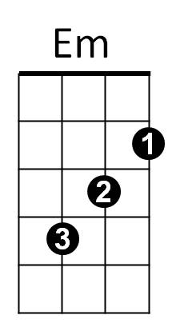**C Dm G C**

What can I do, 'cause I - I - I - I -I, I'm feelin' blue

**Reprise:**

**Dm Em**

I can't choose, it's too much to lose

**F**

When our love's too strong

**BARITONE**

**D**



G

C

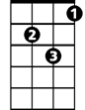

Dm

Whoooo- Maybe if she would come back to me,

**G Em G7 (PAUSE)**

Then it can't go wrong

**Dm C**

Bad is bad, that I feel so sad



G7



F



D

**Dm G G7 C**

It's time, it's time, that I found peace of mind, oh oh

**C Dm G C**

What can I do, 'cause I - I - I - I -I, I'm feelin' blue

**(Reprise)**



Em

**Dm C**

Black is black, I want my baby back

**Dm G G7 C**

It's gray, it's gray, since she went away, woh woh

**C Dm G C**

What can I do, 'cause I - I - I – I - I, I'm feelin' blue

**Dm G C C F G C**

'Cause I - I - I - I -I, I'm feelin' blue,

**Peggy Sue (Buddy Holly)**



C

**Intro: C F C G (2x)**

**C F C F C**

If you knew Peggy Sue, then you'd know why I feel blue

F



**F C F C**

About Peggy, my Peggy Sue

**G F C F C G**

Oh, well, I love you gal, yes, I love you Peggy Sue.

**C F C F C**



G

Peggy Sue, Peggy Sue, Oh how my heart yearns for you

**F C F C**

Oh, Pa-he-ggy, my Peggy Sue;

**G F C F C G**

Oh, well, I love you gal, yes, I love you, Peggy Sue.

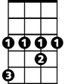

G#

**Reprise:**

**C G# C**

Peggy Sue, Peggy Sue, pretty, pretty, pretty, pretty, Peggy Sue,

**F C F C**

**BARITONE**

Oh, my Peggy, my Peggy Sue



F

C



**G F C F C G**

Oh, well, I love you gal, I need you, Peggy Sue.

**C F C F C**

I love you Peggy Sue, with a love so rare and true,



G

**F C F C**

Oh, Peggy, My Peggy Sue;

**G F C F C**

Oh, well, I love you gal, and I want you, Peggy Sue.



G#

**(Repeat from Reprise)**

**4**

**G F C F C**

Oh, well, I love you gal, yes, I want you, Peggy Sue.

**I Saw Her Standing There (John Lennon / Paul McCartney)**

**Intro: 1 – 2- 3 – FIRE! G**



G7



C



G

**G**

Well she was just seventeen

**C G**

You know what I mean

**G7 D D7**

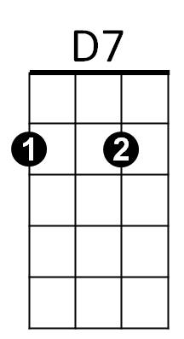And the way she looked was way beyond compare

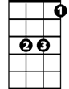

Eb



D

**G G7 C Eb**

So how could I dance with another, Oh,

**G D G**

When I saw her standing there

**C G**

Well she looked at me, and I, I could see

**G7 D D7**

That before too long, I'd fall in love with her

**G G7 C Eb**

She wouldn't dance with another Oh,

**G D G**

When I saw her standing there

**Chorus:**

**C C7**Well my heart went boom - When I crossed that room

**D C**

**BARITONE**

And I held her hand in mine

C



G7



G

**G**

Oh we danced through the night

**C G**

And we held each other tight

**G7 D D7**



D7



D



Eb

And before too long, I fell in love with her

**G G7 C Eb**

Now I'll never dance with another - Oh,

**G D G**

When I saw her standing there

**(Repeat from Chorus)**

**D G**

Oh, since I saw her standing there

**D G**

Yeah, well since I saw - her – stan-ding there