Please Mr. Postman – The Marvelettes (C)
(Georgia Dobbins, William Garrett, Freddie Gorman, Brian Holland & Robert Bateman, 1961)
Please Mr. Postman by The Marvelettes (1961) (D - 122)

Intro (Single Strum or Note) C  C Tacet Am Tacet  (Wait!) Oh yes, wait a minute Mr. Postman, (Wait!) Wait... Mr. Postman.  Chorus  C Am  __ Please Mr. Postman, look and see, __ Is there a letter in your bag for me?  F G  __ I've been waiting such a long time, __ since I heard from this boyfriend of mine.  C Am  __ There must be some word today,__ from my boyfriend so far away.  F G  __ Please Mr. Postman, look and see, __ Is there a letter, a letter for me?  C Am  __ I've been standing here waiting Mr. Postman, __ so, so patiently.  F G  __ For just a card, or just a letter, __ saying he's returning home to me. Chorus  C Am  __ So many days, you pass me by, __ You saw the tear standing in my eye.  F G  __ You wouldn't stop to make me feel better, __ by leaving me a card or a letter.  C Am  Please Mr. Postman, look and see, is there a letter, oh yeah, in your bag for me?  F G  You know it's been so long, since I heard from this boyfriend of mine.  C Am  You better wait a minute, wait a minute (oh yeah). You better wait a minute, please,  F  Please Mr. Postman. (Wait, Wait a minute, Mr. Postman),  G Tacet  Please check and see, just one more time for me.  Outro (2x) End on | D | A  C  You gotta wait a minute, wait a minute (oh yeah),  Am  Wait a minute, wait a minute, (Mr. Postman).  F  Please Mr. Postman. (Wait a minute, Mr. Postman),  G  Don’t pass me by, you see the tears in my eye. | 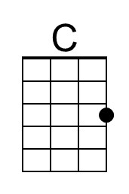
 | 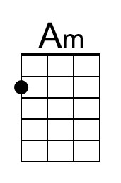
 | 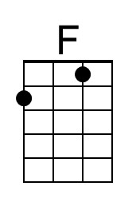
 | 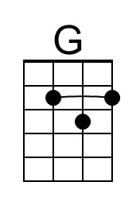
 | Bari
 | 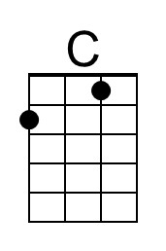
 | 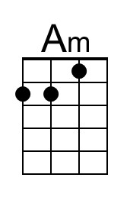
 | 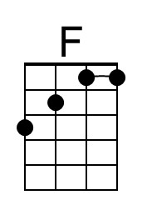
 | 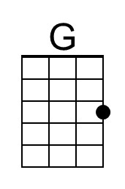

Please Mr. Postman – The Marvelettes (D)
(Georgia Dobbins, William Garrett, Freddie Gorman, Brian Holland & Robert Bateman, 1961)
Please Mr. Postman by The Marvelettes (1961) (D - 122)

Intro (Single Strum or Note) D  D Tacet Bm Tacet  (Wait!) Oh yes, wait a minute Mr. Postman, (Wait!) Wait... Mr. Postman.  Chorus  D Bm  __ Please Mr. Postman, look and see, __ Is there a letter in your bag for me?  G A  __ I've been waiting such a long time, __ since I heard from this boyfriend of mine.  D Bm  __ There must be some word today,__ from my boyfriend so far away.  G A  __ Please Mr. Postman, look and see, __ Is there a letter, a letter for me?  D Bm  __ I've been standing here waiting Mr. Postman, __ so, so patiently.  G A  __ For just a card, or just a letter, __ saying he's returning home to me. Chorus  D Bm  __ So many days, you pass me by, __ You saw the tear standing in my eye.  G A  __ You wouldn't stop to make me feel better, __ by leaving me a card or a letter.  D Bm  Please Mr. Postman, look and see, is there a letter, oh yeah, in your bag for me?  G A  You know it's been so long, since I heard from this boyfriend of mine.  D Bm  You better wait a minute, wait a minute (oh yeah). You better wait a minute, please,  G  Please Mr. Postman. (Wait, Wait a minute, Mr. Postman),  A Tacet  Please check and see, just one more time for me.  Outro (2x) End on | D | A  D  You gotta wait a minute, wait a minute (oh yeah),  Bm  Wait a minute, wait a minute, (Mr. Postman).  G  Please Mr. Postman. (Wait a minute, Mr. Postman),  A  Don’t pass me by, you see the tears in my eye. | 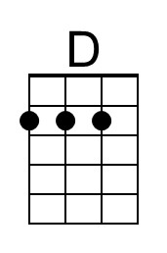
 | 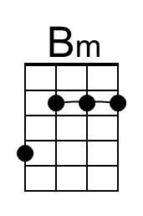
 | 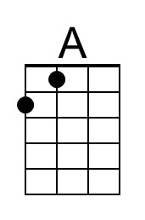
 | Bari
 | 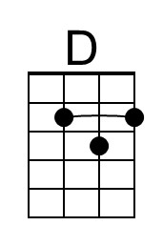
 | 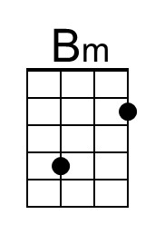
 | 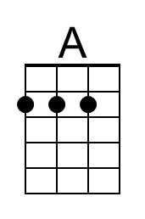

Please Mr. Postman – The Marvelettes (G)
(Georgia Dobbins, William Garrett, Freddie Gorman, Brian Holland & Robert Bateman, 1961)
Please Mr. Postman by The Marvelettes (1961) (D - 122)

Intro (Single Strum or Note) G

G Tacet Em Tacet
(Wait!) Oh yes, wait a minute Mr. Postman, (Wait!) Wait... Mr. Postman.

Chorus
G Em
__ Please Mr. Postman, look and see, __ Is there a letter in your bag for me?
C D
__ I've been waiting such a long time, __ since I heard from this boyfriend of mine.

G Em
__ There must be some word today,__ from my boyfriend so far away.
C D
__ Please Mr. Postman, look and see, __ Is there a letter, a letter for me?
G Em
__ I've been standing here waiting Mr. Postman, __ so, so patiently.
C D
__ For just a card, or just a letter, __ saying he's returning home to me. Chorus

G Em
__ So many days, you pass me by, __ You saw the tear standing in my eye.
C D
__ You wouldn't stop to make me feel better, __ by leaving me a card or a letter.

G Em
Please Mr. Postman, look and see, is there a letter, oh yeah, in your bag for me?
C D
You know it's been so long, since I heard from this boyfriend of mine.

G Em
You better wait a minute, wait a minute (oh yeah). You better wait a minute, please,
C
Please Mr. Postman. (Wait, Wait a minute, Mr. Postman),
D Tacet
Please check and see, just one more time for me.

Outro (2x) End on | D | A
G
You gotta wait a minute, wait a minute (oh yeah),
Em
Wait a minute, wait a minute, (Mr. Postman).
C
Please Mr. Postman. (Wait a minute, Mr. Postman),
D
Don’t pass me by, you see the tears in my eye.
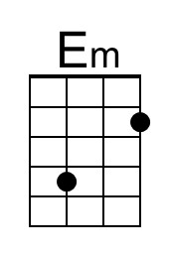
Bari
