Please Mr. Postman – The Beatles (A)
(Georgia Dobbins, William Garrett, Freddie Gorman, Brian Holland & Robert Bateman, 1961)
Please Mr. Postman by the Beatles (A – 123 BPM)

Intro (Single Strum or Note) A  A Tacet F#m Tacet  (Wait!) Oh yes, wait a minute Mr. Postman, (Wait!) Wait... Mr. Postman.  A F#m  __ Mr. Postman, look and see, __ Is there a letter in your bag for me? Chorus  D E  __ I've been waiting such a long time, __ since I heard from that gal of mine.  A F#m  __ There must be some word today,__ from my girlfriend so far away.  D E  __ Please Mr. Postman, look and see, __ Is there a letter, a letter for me?  A F#m  __ I've been standing here waiting Mr. Postman, __ so patiently.  D E  __ For just a card, or just a letter, __ saying she's returning home to me. Please  Chorus  A F#m  __ So many days, you pass me by, __ You see the tear standing in my eye.  D E  __ You didn't stop to make me feel better, __ by leaving me a card or a letter. Chorus  Outro  A F#m  You gotta wait a minute, wait a minute (oh yeah); Wait a minute, wait a minute (oh yeah),  D  You gotta wait a minute, wait a minute (oh yeah).  E Tacet  Check it and see, just one more time for me.  A F#m  You gotta wait a minute, wait a minute (oh yeah); Wait a minute, wait a minute (oh yeah),  D E Tacet  Mister Postman (oh yeah) Deliver the letter the sooner the better.  A F#m  You gotta wait a minute, wait a minute (oh yeah); Wait a minute, wait a minute (oh yeah),  D  You gotta wait a minute, wait a minute (oh yeah),  E | A  You gotta wait a minute, wait a minute (oh yeah) | 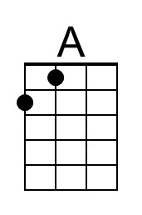
 | 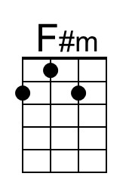
 | 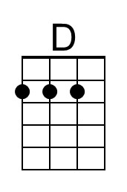
 | 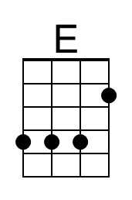
 | Bari
 | 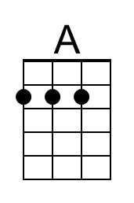
 | 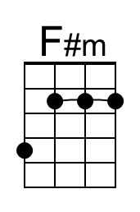
 | 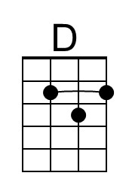
 | 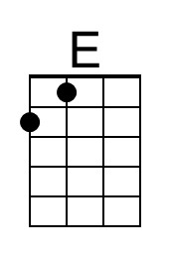

Please Mr. Postman – The Beatles (C)
(Georgia Dobbins, William Garrett, Freddie Gorman, Brian Holland & Robert Bateman, 1961)
Please Mr. Postman by the Beatles (A – 123 BPM)

Intro (Single Strum or Note) C  C Tacet Am Tacet  (Wait!) Oh yes, wait a minute Mr. Postman, (Wait!) Wait... Mr. Postman.  C Am  __ Mr. Postman, look and see, __ Is there a letter in your bag for me? Chorus  F G  __ I've been waiting such a long time, __ since I heard from that gal of mine.  C Am  __ There must be some word today,__ from my girlfriend so far away.  F G  __ Please Mr. Postman, look and see, __ Is there a letter, a letter for me?  C Am  __ I've been standing here waiting Mr. Postman, __ so patiently.  F G  __ For just a card, or just a letter, __ saying she's returning home to me. Please  Chorus  C Am  __ So many days, you pass me by, __ You see the tear standing in my eye.  F G  __ You didn't stop to make me feel better, __ by leaving me a card or a letter. Chorus  Outro  C Am  You gotta wait a minute, wait a minute (oh yeah); Wait a minute, wait a minute (oh yeah),  F  You gotta wait a minute, wait a minute (oh yeah).  G Tacet  Check it and see, just one more time for me.  C Am  You gotta wait a minute, wait a minute (oh yeah); Wait a minute, wait a minute (oh yeah),  F G Tacet  Mister Postman (oh yeah) Deliver the letter the sooner the better.  C Am  You gotta wait a minute, wait a minute (oh yeah); Wait a minute, wait a minute (oh yeah),  F  You gotta wait a minute, wait a minute (oh yeah),  G | C  You gotta wait a minute, wait a minute (oh yeah) | 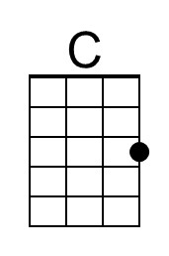
 | 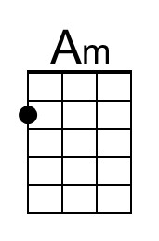
 | 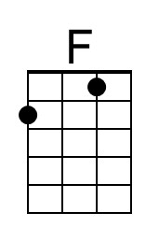
 | 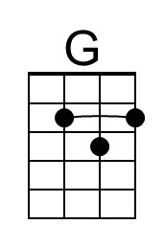
 | Bari
 | 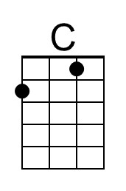
 | 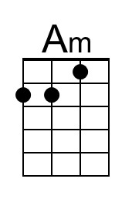
 | 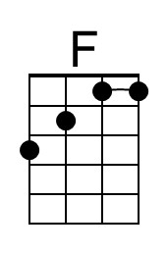
 | 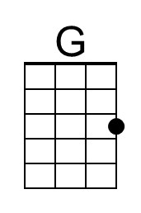

Please Mr. Postman – The Beatles (G)
(Georgia Dobbins, William Garrett, Freddie Gorman, Brian Holland & Robert Bateman, 1961)
Please Mr. Postman by the Beatles (A – 123 BPM)

Intro (Single Strum or Note) G

G Tacet Em Tacet
(Wait!) Oh yes, wait a minute Mr. Postman, (Wait!) Wait... Mr. Postman.

Chorus
G Em
__ Mr. Postman, look and see, __ Is there a letter in your bag for me?
C D
__ I've been waiting such a long time, __ since I heard from that gal of mine.

G Em
__ There must be some word today,__ from my girlfriend so far away.
C D
__ Please Mr. Postman, look and see, __ Is there a letter, a letter for me?
G Em
__ I've been standing here waiting Mr. Postman, __ so patiently.
C D
__ For just a card, or just a letter, __ saying she's returning home to me. Please
Chorus

G Em
__ So many days, you pass me by, __ You see the tear standing in my eye.
C D
__ You didn't stop to make me feel better, __ by leaving me a card or a letter. Chorus

Outro
G Em
You gotta wait a minute, wait a minute (oh yeah); Wait a minute, wait a minute (oh yeah),
C
You gotta wait a minute, wait a minute (oh yeah).
D Tacet
Check it and see, just one more time for me.

G Em
You gotta wait a minute, wait a minute (oh yeah); Wait a minute, wait a minute (oh yeah),
C D Tacet
Mister Postman (oh yeah) Deliver the letter the sooner the better.

G Em
You gotta wait a minute, wait a minute (oh yeah); Wait a minute, wait a minute (oh yeah),
C
You gotta wait a minute, wait a minute (oh yeah),
D | G
You gotta wait a minute, wait a minute (oh yeah)
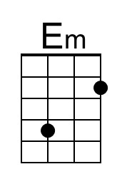
Bari
