**Please Please Me (Lennon / McCartney)**

**Intro: G**

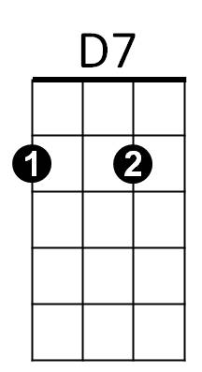**G C G Bb C D7**



C



G



Bb

Last night I said these words to my girl

**G C G**

I know you never even try girl

**Chorus:**

**C Am**

Come on (come on), come on (come on)

Em

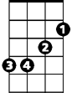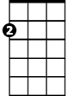

Am

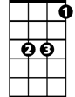

Eb

**Em C**

Come on (come on), come on (come on)

**G C**

Please please me, whoa yeah

**D7 G**

Like I please you

**G C G Bb C D7**

You don't need me to show the way girl

**G C G**

Why do I always have to say girl

**(Chorus)**

**Bridge:**

**C**

I don't want to sound complaining

**D7 G C G**

But you know there's always rain in my heart (in my heart)

**C**

I do all the pleasing with you



Em



G

C



Bb

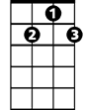

D7

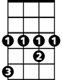

Eb

**BARITONE**

**D7 G**

It's so hard to reason with you

**C D7 G**

Oh yeah, why do you make me blue

**(First Verse)**

**(Chorus)**

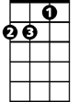

Am

**G C**

Please please me, whoa yeah

**D7 G**  **Eb D7 G**

Like I please you