Plenty To Be Thankful For (Irving Berlin, 1942) (C)
Plenty To Be Thankful For by Bing Crosby with Bob Crosby and His Orchestra (Bb @ 154)

Intro | C Am | Dm7 G7 | C Am | Dm7 G7 |  C Am Dm7 G7 C A7 | D7 G7 |  I've got plenty to be thankful for  C Am Dm7 G7 C  I haven't got great big yacht to sail from shore to shore.  Dm7 C Am Dm7 G7 C Am | Dm7 G7  Still, I've got plenty to be thankful for  C Am Dm7 G7 C A7 | D7 G7 |  I've got plenty to be thankful for  C Am Dm7 G7 C  No private car, no ca – vi – ar, No carpet on my floor.  Dm7 C Am Dm7 G7 C Dm7 | C  Still, I've got plenty to be thankful for.  Chorus  Dm7 G7 Dm7 G7  I've got eyes to see with,  C | C  Ears to hear with  Em Am Am7 D7  Arms to hug with, lips to kiss with  G Dm7 G7  __ Someone to adore  C Am Dm7 G7 C A7 | D7 G7 |  How could any - body ask for more?  C Am Dm7 G7  My needs are small, I buy 'em all  C  At the five and ten cent store  _______________________________________________  │ Dm7 C A7 Dm7 G7 C Am7 | Dm7 G7  │1. Oh, I've got plenty to be thankful for.  │ Repeat from Top  _______________________________________________  │ Dm7 C A7 Dm7 G7 C G7 | C  │2. Oh, I've got plenty to be thankful for. | 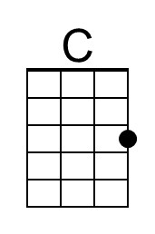 | 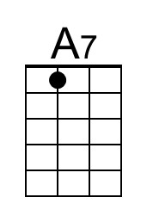 | 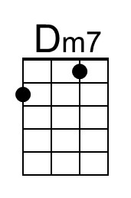
 | 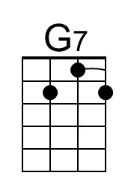 | 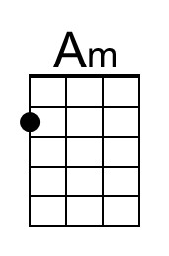 | 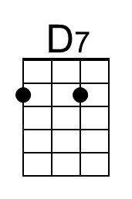
 | 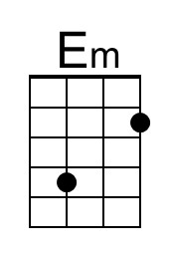 | 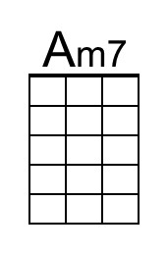 | 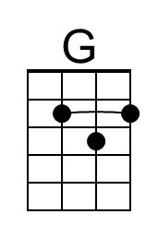
 | Baritone
 | 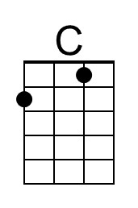 | 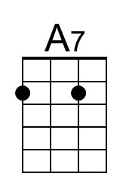 | 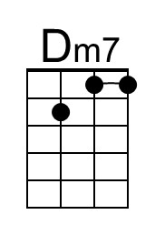
 | 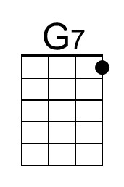 | 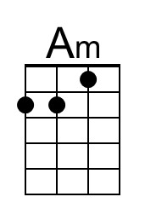 | 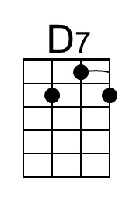
 | 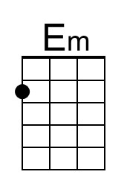 | 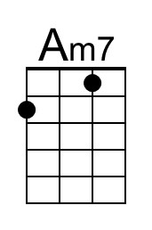 | 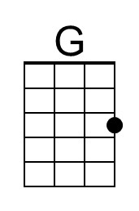

A common variant of the I vi IV V progression (“Ice Cream Changes”) – I vi ii V
Plenty To Be Thankful For (Irving Berlin, 1942) (G)
Plenty To Be Thankful For by Bing Crosby with Bob Crosby and His Orchestra (Bb @ 154)

Intro | G E7 | Am7 D7 | G Em7 | Am7 D7 |  G Em Am7 D7 G E7 | A7 D7 |  I've got plenty to be thankful for  G Em Am7 D7 G  I haven't got great big yacht to sail from shore to shore.  Am7 G Em Am7 D7 G Em | Am7 D7  Still, I've got plenty to be thankful for  G Em Am7 D7 G E7 | A7 D7 |  I've got plenty to be thankful for  G Em Am7 D7 G  No private car, no ca – vi – ar, No carpet on my floor.  Am7 G Em Am7 D7 G Am7 | G  Still, I've got plenty to be thankful for.  Chorus  Am7 D7 Am7 D7  I've got eyes to see with,  G | G  Ears to hear with  Bm Em Em7 A7  Arms to hug with, lips to kiss with  D Am7 D7  __ Someone to adore  G Em Am7 D7 G E7 | A7 D7 |  How could any - body ask for more?  G Em Am7 D7  My needs are small, I buy 'em all  G  At the five and ten cent store  _______________________________________________  │ Am7 G E7 Am7 D7 G Em7 | Am7 D7  │1. Oh, I've got plenty to be thankful for.  │ Repeat from Top  _______________________________________________  │ Am7 G E7 Am7 D7 G D7 | G  │2. Oh, I've got plenty to be thankful for. |  | 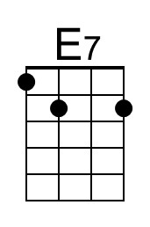
 | 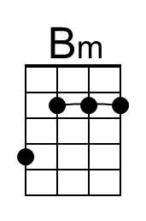 | 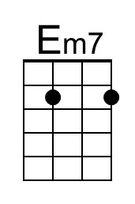 | 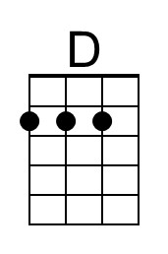
 | Baritone
 |  | 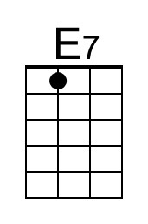
 | 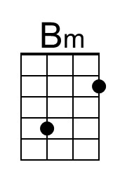 | 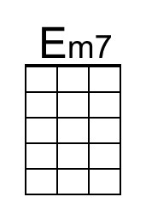 | 