Pretty Irish Girl (Lawrence Edward Watkin & Oliver Wallace, 1959) - Key G

G G7 C - C7  Have you ever seen the seagulls, a-flyin' o'er the heather?  G Em A7 D7  Or the crimson sails on Galway Bay the fishermen un-furl?  G G7 C - C7  Oh, the earth is filled with beauty, and it’s gathered all together  G Em A7 D7  In the form and face and dainty grace of a pretty Irish girl  Chorus  G D7 C G  Oh, she's my dear, my darlin' one, her eyes so sparklin' full of fun  C G A7 D7  No other, no other, can match the likes of her  G D7 C G  She's my dear, my darlin' one, my smilin' and beguilin' one  Am C A7 G (A7) D7 G  I love the ground she walks upon - my pretty I – r i s h girl  G G7 C - C7  Have you ever seen the morning, in Kerry and Killarney?  G Em A7 D7  When the dew is on the hayrick, and ev'ry drop a pearl ?  G G7 C - C7  When the geese are full of blarney, and the thrush is singing Gaelic  G Em A7 D7  And standing in the doorway is a pretty Irish Girl? Chorus  G G7 C - C7  When I'm parted from my darlin', my sighs would sail a schooner  G Em A7 D7  And when I cannot reach her, sure my tears would turn a mill  G G7 C - C7  Since she cannot be un-kind, to any helpless creature  G Em A7 D7  I think that I will marry me a pretty Irish girl! |  |  |  |  |  |  | 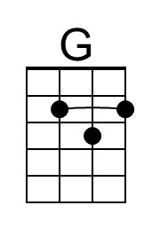
 |  |  |  |  |  |  | 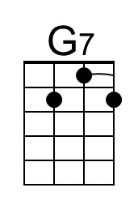
 |  |  |  |  |  |  | 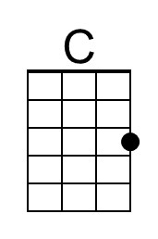
 |  |  |  |  |  |  | 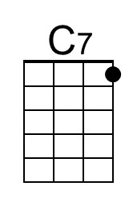
 |  |  |  |  |  |  | 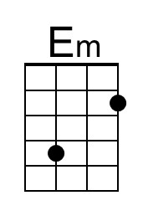
 |  |  |  |  |  |  | 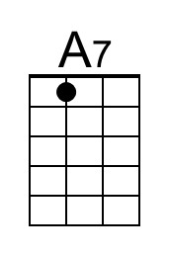
 |  |  |  |  |  |  | 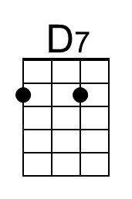
 |  |  |  |  |  |  | 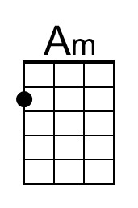
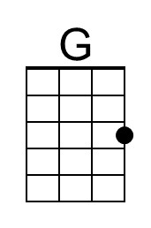 | 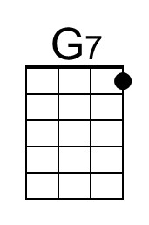 | 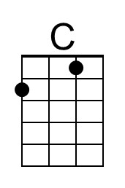 | 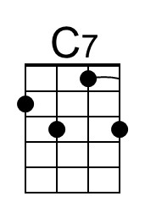 | 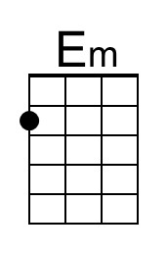 | 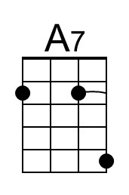 | 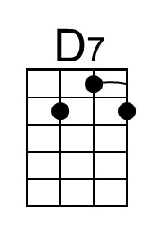 | 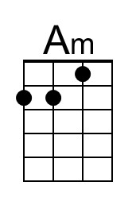

Pretty Irish Girl (Lawrence Edward Watkin & Oliver Wallace, 1959) - Key C

C C7 F - F7
Have you ever seen the seagulls, a-flyin' o'er the heather?
C Am D7 G7
Or the crimson sails on Galway Bay the fishermen un-furl?
C C7 F - F7
Oh, the earth is filled with beauty, and it’s gathered all together
C Am D7 G7
In the form and face and dainty grace of a pretty Irish girl.

Chorus
C G7 F C
Oh, she's my dear, my darlin' one, her eyes so sparklin' full of fun
F C D7 G7
No other, no other, can match the likes of her
C G7 F C
She's my dear, my darlin' one, my smilin' and beguilin' one
Dm F D7 C (D7) G7 C
I love the ground she walks upon - my pretty I – r i s h girl

C C7 F - F7
Have you ever seen the morning in Kerry and Killarney?
C Am D7 G7
When the dew is on the hayrick, and ev'ry drop a pearl?
C C7 F - F7
When the geese are full of blarney, and the thrush is singing Gaelic
C Am D7 G7
And standing in the doorway is a pretty Irish Girl. Chorus

C C7 F - F7
When I'm parted from my darlin', my sighs would sail a schooner
C Am D7 G7
And when I cannot reach her, sure my tears would turn a mill
C C7 F - F7
Since she cannot be un-kind, to any helpless creature
C Am D7 G7
I think that I will marry me a pretty Irish girl! Chorus

 |  |  |  |  |  |  | 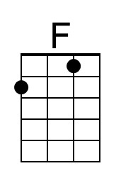
 |  |  |  |  |  |  | 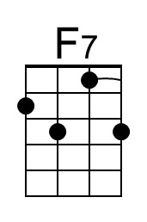
 |  |  |  |  |  |  | 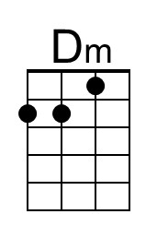
 |  | 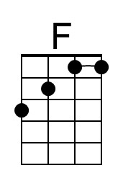 | 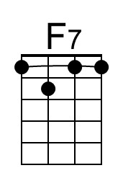 |  |  |  | 