Pretty Little Angel Eyes (Curtis Lee & Tommy Boyce, 1961) (C)
Pretty Little Angel Eyes by Curtis Lee & The Halos (1961) (E – 112 BPM)

Intro (4 Measures) C | Am | Dm | G  C Am  Pretty little angel eyes. Pretty little angel eyes.  F  Pretty little angel, pretty little angel,  G C Am Dm G C Am  Pretty little, pretty little, pretty little angel. Ooooo-oo, ooooo-oo, Ooooo-oo,  F G  Pretty, pretty, pretty little angel eyes...  C Am Dm G C Am Dm G  Angel eyes, I really love you so. Angel eyes, I'll never let you go  C Am Dm G C  Because I love you, my darlin' angel eyes  F G  Pretty, pretty, pretty little angel eyes.  C Am Dm G  Angel eyes, you are so good to me,  C Am Dm G  And when I'm in your arms, you be so heavenly  C Am Dm G C F C G  You know I love you, my darlin' angel eyes. Angel eyes, bom-bom-bom-bom  Bridge  F  I know you were sent from heaven above.  C  You rule my life with your wonderful love.  F  I know we'll be happy for eternity,  G  'Cause I know wow-wow-wow-wow-wow-wow  G7 | G7  That our love is really real.  Repeat Verse 1 |  |  |  |  |  |  |  | 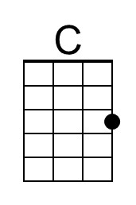
 |  |  |  |  |  |  |  | 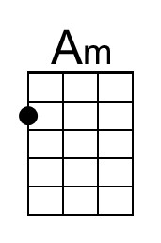
 |  |  |  |  |  |  |  | 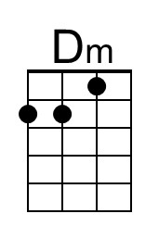
 |  |  |  |  |  |  |  | 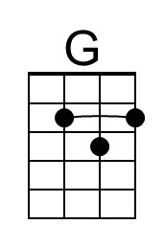
 |  |  |  |  |  |  |  | 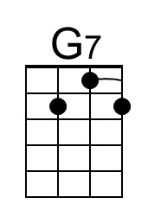
 |  |  |  |  |  |  |  | 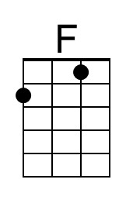
Bari | 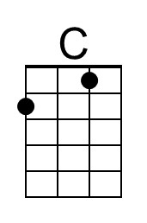 | 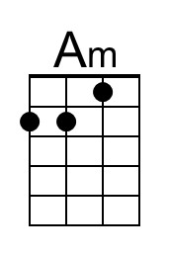 | 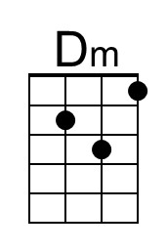 | 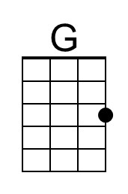 | 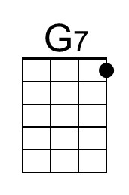 | 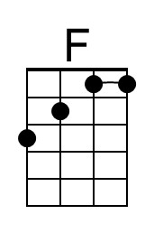
Pretty Little Angel Eyes (C) – Page 2

Instrumental (4 Measures) C | Am | Dm | G

C Am
Pretty little angel eyes. Pretty little angel eyes.
F
Pretty little angel, pretty little angel,
G
Pretty little, pretty little, pretty little angel.

Instrumental Verse

F G
Pretty, pretty, pretty little angel eyes.

C Am Dm G
Angel eyes, I really love you so.
C Am Dm G
Angel eyes, I'll never let you go
C Am Dm G C
Because I love you, my darlin' angel eyes

F G
Pretty, pretty, pretty little angel eyes.

Outro
C Am Dm G C Am Dm G
Ooooo-oo, Ooooo-oo, Ooooo-oo, Ooooo-oo,
C Am Dm G | C | G | C
Ooooo-oo, Ooooo-oo.

Pretty Little Angel Eyes (Curtis Lee & Tommy Boyce, 1961) (D)
Pretty Little Angel Eyes by Curtis Lee & The Halos (1961) (E – 112 BPM)

Intro (4 Measures) D | Bm | Em | A  D Bm  Pretty little angel eyes. Pretty little angel eyes.  G  Pretty little angel, pretty little angel,  A D Bm Em A D Bm  Pretty little, pretty little, pretty little angel. Ooooo-oo, ooooo-oo, Ooooo-oo,  G A  Pretty, pretty, pretty little angel eyes...  D Bm Em A D Bm Em A  Angel eyes, I really love you so. Angel eyes, I'll never let you go  D Bm Em A D  Because I love you, my darlin' angel eyes  G A  Pretty, pretty, pretty little angel eyes.  D Bm Em A  Angel eyes, you are so good to me,  D Bm Em A  And when I'm in your arms, you be so heavenly  D Bm Em A D G D A  You know I love you, my darlin' angel eyes. Angel eyes, bom-bom-bom-bom  Bridge  G  I know you were sent from heaven above.  D  You rule my life with your wonderful love.  G  I know we'll be happy for eternity,  A  'Cause I know wow-wow-wow-wow-wow-wow  A7 | A7  That our love is really real.  Repeat Verse 1 |  |  |  |  |  |  |  | 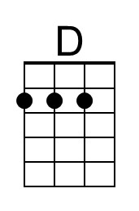
 |  |  |  |  |  |  |  | 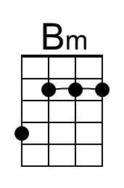
 |  |  |  |  |  |  |  | 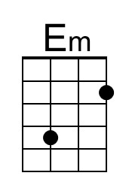
 |  |  |  |  |  |  |  | 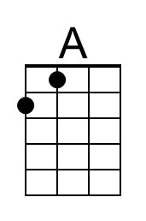
 |  |  |  |  |  |  |  | 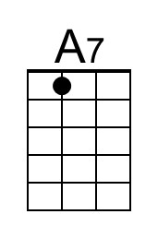
Bari | 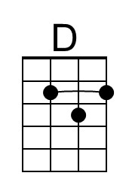 | 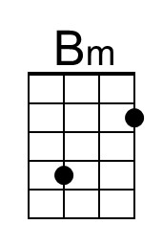 | 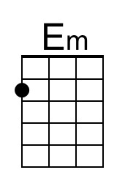 | 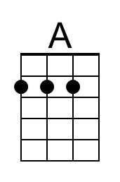 | 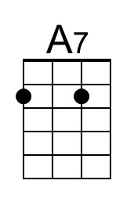

Pretty Little Angel Eyes (D) – Page 2

Instrumental (4 Measures) D | Bm | Em | A

D Bm
Pretty little angel eyes. Pretty little angel eyes.
G
Pretty little angel, pretty little angel,
A
Pretty little, pretty little, pretty little angel.

Instrumental Verse

G A
Pretty, pretty, pretty little angel eyes.

Repeat Verse 1

G A
Pretty, pretty, pretty little angel eyes.

Outro
D Bm Em A D Bm Em A
Ooooo-oo, Ooooo-oo, Ooooo-oo, Ooooo-oo,
D Bm Em A | D | A | D
Ooooo-oo, Ooooo-oo.

Pretty Little Angel Eyes by Sha Na Na (1973) (D - 114 BPM)

Pretty Little Angel Eyes (Curtis Lee & Tommy Boyce, 1961) (G)
Pretty Little Angel Eyes by Curtis Lee & The Halos (1961) (E – 112 BPM)

Intro (4 Measures) G | Em | Am | D

G Em
Pretty little angel eyes. Pretty little angel eyes.
Am
Pretty little angel, pretty little angel,
D G Em Am D G Em
Pretty little, pretty little, pretty little angel. Ooooo-oo, ooooo-oo, Ooooo-oo,
C D
Pretty, pretty, pretty little angel eyes...

G Em Am D G Em Am D
Angel eyes, I really love you so. Angel eyes, I'll never let you go
G Em Am D G
Because I love you, my darlin' angel eyes

C D
Pretty, pretty, pretty little angel eyes.

G Em Am D
Angel eyes, you are so good to me,
G Em Am D
And when I'm in your arms, you be so heavenly
G Em Am D G C G D
You know I love you, my darlin' angel eyes. Angel eyes, bom-bom-bom-bom

Bridge
C
I know you were sent from heaven above.
G
You rule my life with your wonderful love.
C
I know we'll be happy for eternity,
D
'Cause I know wow-wow-wow-wow-wow-wow
D7 | D7
That our love is really real.

Repeat Verse 1

 |  |  |  |  |  |  |  | 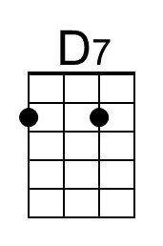
Bari |  |  |  |  | 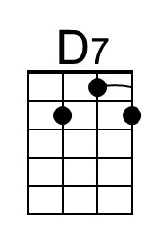

Pretty Little Angel Eyes (G) – Page 2

Instrumental (4 Measures) G | Em | Am | D

G Em C
Pretty little angel eyes. Pretty little angel eyes. Pretty little angel, pretty little angel,
C
Pretty little angel, pretty little angel,
D
Pretty little, pretty little, pretty little angel.

Instrumental Verse

C D
Pretty, pretty, pretty little angel eyes.

G Em Am D G Em Am D
Angel eyes, I really love you so. Angel eyes, I'll never let you go
G Em Am D G
Because I love you, my darlin' angel eyes

C D
Pretty, pretty, pretty little angel eyes.

Outro
G Em Am D G Em Am D
Ooooo-oo, Ooooo-oo, Ooooo-oo, Ooooo-oo,
G Em Am D | G | D | G
Ooooo-oo, Ooooo-oo.

