Proud Mary (John Fogerty, 1968) (D)

Intro:| C A | C A | C A G F | F D | D | D |

D
Left a good job in the city, working for the man every night and day,
And I never lost one minute of sleeping, worrying about the way things might have been.
A Bm
Big wheel keep on turning, proud Mary keep on burning.
D
Rolling, rolling, rolling on the river.

D
Cleaned a lot of plates in Memphis, pumped a lot of pain down in New Orleans.
But I never saw the good side of the city. 'till I hitched a ride on a river boat queen.
A Bm
Big wheel keep on turning, proud Mary keep on burning.
D
Rolling, rolling, rolling on the river.

C A | C A | C A G F | F D | D | D |
D | D | D | D | D | D | D | D |
A | A | Bm | Bm |

D
Rolling, rolling, rolling on the river
C A | C A | C A G F | F D | D | D |

D
If you come down to the river, bet you're gonna find some people who live.
You don't have to worry if you got no money, people on the river are happy to give.

A Bm
Big wheel keep on turning, proud Mary keep on burning.
D
Rolling, rolling, rolling on the river. (4x)

Distinctive Strum Pattern |  | GCEA | 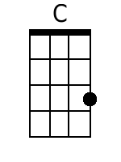 | 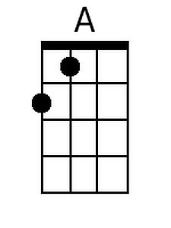 | 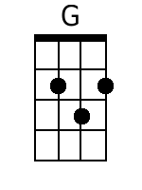 | 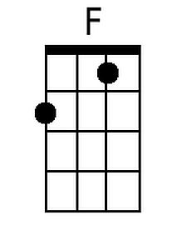 | 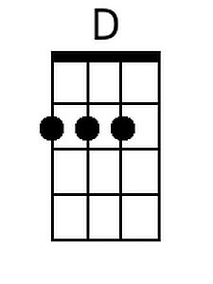 | 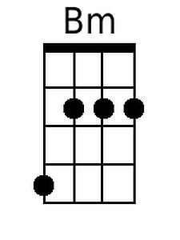
 |  | DGBE | 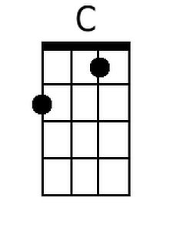 | 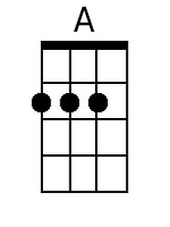 | 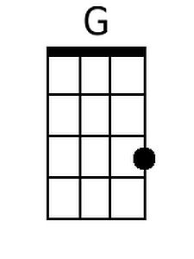 | 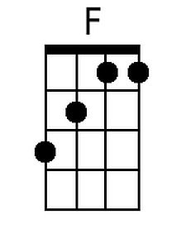 | 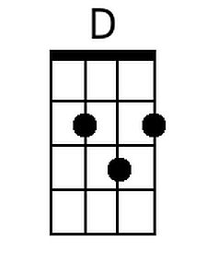 | 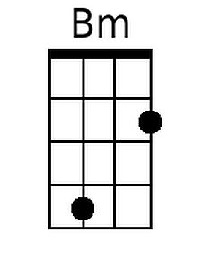


Proud Mary (John Fogerty, 1968) (G)

Intro:| F D | F D | F D C Bb | Bb G | G | G |

G
Left a good job in the city, working for the man every night and day,
And I never lost one minute of sleeping, worrying about the way things might have been.
D Em
Big wheel keep on turning, proud Mary keep on burning.
G
Rolling, rolling, rolling on the river.

G
Cleaned a lot of plates in Memphis, pumped a lot of pain down in New Orleans.
But I never saw the good side of the city. 'till I hitched a ride on a river boat queen.
D Em
Big wheel keep on turning, proud Mary keep on burning.
G
Rolling, rolling, rolling on the river.

F D | F D | F D C Bb | Bb G | G | G |
G | G | G | G | G | G | G | G |
D | D | Em | Em |

G
Rolling, rolling, rolling on the river
F D | F D | F D C Bb | Bb G | G | G |
G
If you come down to the river, bet you’re gonna find some people who live.
You don't have to worry if you got no money, people on the river are happy to give.

D Em
Big wheel keep on turning, proud Mary keep on burning.
G
Rolling, rolling, rolling on the river. (4x)

Distinctive Strum Pattern |  | GCEA |  |  |  | 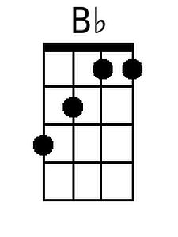 |  | 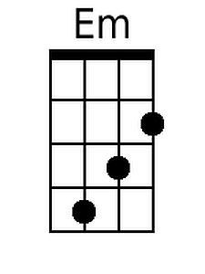
 |  | DGBE |  |  |  | 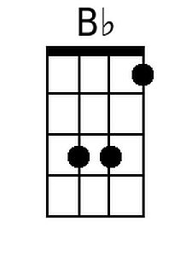 |  | 