**Proud Mary (John Fogerty) Key of G**

**Intro:| F D | F D | F D C Bb | Bb G | G | G |**

**G**

Left a good job in the city

Working for the man every night and d ay

And I never lost one minute of sleeping

Worrying about the way things might have been

**D Em**

Big wheel keep on turning, proud Mary keep on burning

**G**

Rolling, rolling, rolling on the river

**G**

F



Cleaned a lot of plates in Memphis

Pumped a lot of pain down in New Orleans

But I never saw the good side of the city

'Till I hitched a ride on a river boat queen

**D Em**

Big wheel keep on turning, proud Mary keep on burning

**G**

Rolling, rolling, rolling on the river

**F D | F D | F D C Bb | Bb G | G | G |**

**G | G | G | G | G | G | G | G |**

**D | D | Em | Em |**

**G**

Rolling, rolling, rolling on the river

**BARITONE**

**F D | F D | F D C Bb | Bb G | G | G |**



F

**G**

If you come down to the river

Bet you’re gonna find some people who live

You don't have to worry if you got no money

People on the river are happy to give

**D Em**

Big wheel keep on turning, proud Mary keep on burning

**G**

Rolling, rolling, rolling on the river

**G**

Rolling, rolling, rolling on the river

**G**

Rolling, rolling, rolling on the river

**G**

Rolling, rolling, rolling on the river



G

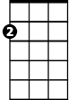

Em



D

C

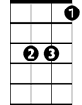

Bb

Em

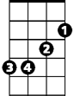

G



Bb



C

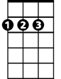

D