Psycho Killer (David Byrne, Chris Frantz & Tina Weymouth) (C)
Psycho Killer by the Talking Heads

Intro: C C Bb (2x)  C C - Bb  I can't seem to face up to the facts  C C - Bb  I'm tense and nervous and I can't relax  C C - Bb  I can't sleep cause my bed's on fire  C C - Bb  Don't touch me I'm a real live wire  Chorus  Ab Bb  Psycho kil-ler qu'est-ce que c'est  Cm  Fa fa fa fa fa fa fa fa fa fa, better  Ab Bb Eb  Run run run run run run run a-way. (Repeat)  Ab Bb - C Bb C Bb  Ooooohhh ayayayay!  C C - Bb  You start a conversation you can’t even finish it  C C - Bb  You're talking a lot, but you're not saying anything  C C - Bb  When I have nothing to say, my lips are sealed  C C - Bb  Say something once, why say it again? Chorus  Dm Eb Dm Eb  Ce que j'ai fait, ce soir la Ce qu'elle a dit, ce soir la  C Bb  Realisant mon espoir, Je me lance, vers la gloire  C C Bb C C - Bb  Okay Ay ay ay ay ay ay ay ay  C C - Bb  We are vain and we are blind  C C - Bb  I hate people when they're not polite Chorus  Outro: C Bb C Bb C C Bb C C Bb | 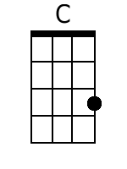 | 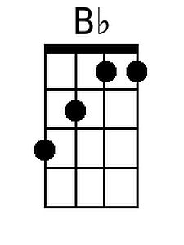
 | 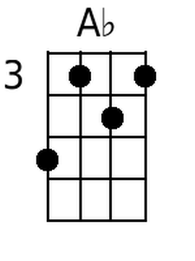 | 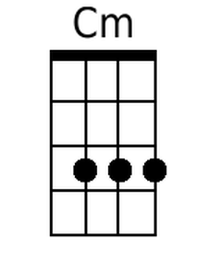
 | 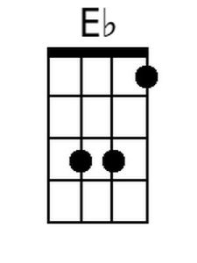 | 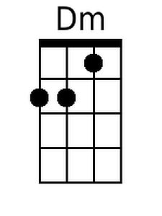
 | Baritone
 | 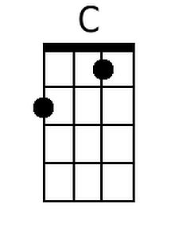 | 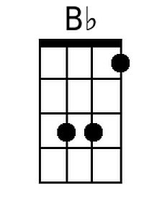
 | 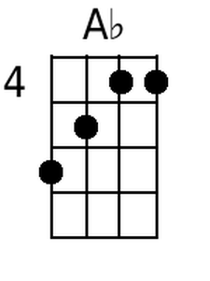 | 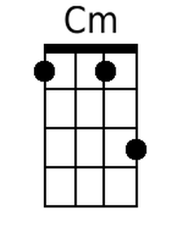
 | 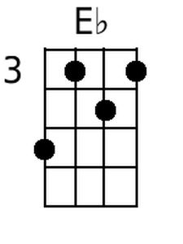 | 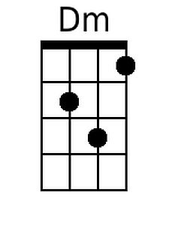

Psycho Killer (David Byrne, Chris Frantz & Tina Weymouth) (G)
Psycho Killer by the Talking Heads

Intro: G G F# (2x)  G G - F  I can't seem to face up to the facts  G G - F  I'm tense and nervous and I can't relax  G G - F  I can't sleep cause my bed's on fire  G G - F  Don't touch me I'm a real live wire  Chorus  Eb F  Psycho kil-ler qu'est-ce que c'est  Gm  Fa fa fa fa fa fa fa fa fa fa, better  Eb F Bb  Run run run run run run run a-way. (Repeat)  Eb F - G F G F  Ooooohhh ayayayay!  G G - F  You start a conversation you can't even finish it  G G - F  You're talking a lot, but you're not saying anything  G G - F  When I have nothing to say, my lips are sealed  G G - F  Say something once, why say it again? Chorus  Am Bb Am Bb  Ce que j'ai fait, ce soir la Ce qu'elle a dit, ce soir la  G F  Realisant mon espoir, Je me lance, vers la gloire  G G F G G - F  Okay Ay ay ay ay ay ay ay ay  G G - F  We are vain and we are blind  G G - F  I hate people when they're not polite Chorus  Outro: G F# G F# G G F# G G F# | 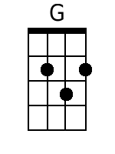 | 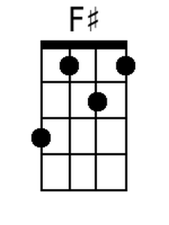
 |  | 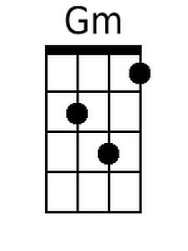
 |  | 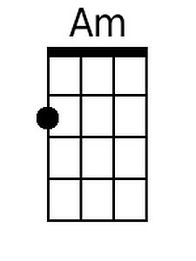
 | Baritone
 | 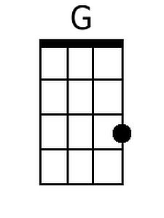 | 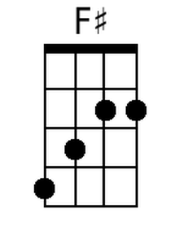
 |  | 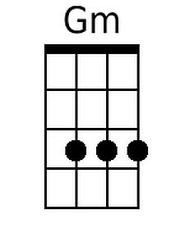
 |  | 