Purple People Eater (Sheb Wooley) (C)
Purple People Eater by Sheb Wooley

Intro: G7 G C  C  Well, I saw the thing comin' out of the sky  G C  It had the one long horn, one big eye  F  I commenced to shakin' and I said "ooh-eee"  G C  It looks like a purple eater to me  Chorus  C  It was a one-eyed, one-horned, flyin' purple people eater  G  One-eyed, one-horned, flyin' purple people eater  C  A one-eyed, one-horned, flyin' purple people eater  G7 C  Sure looks strange to me (one eye? / 2nd time: one horn?)  C  Well he came down to earth and he lit in a tree  G C  I said Mr. Purple People Eater, don't eat me  C7 F  I heard him say in a voice so gruff  G  "I wouldn't eat you 'cause you're so tough." Chorus |  |  |  |  |  |  | 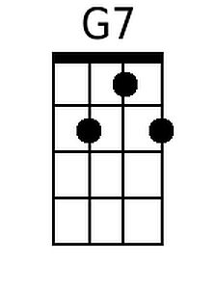 |  | 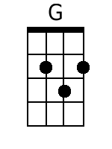
 |  |  |  |  |  |  | 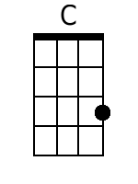 |  | 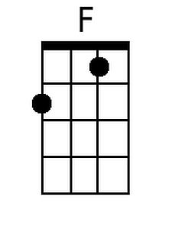
 |  |  |  |  |  |  | 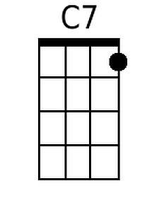 |  | 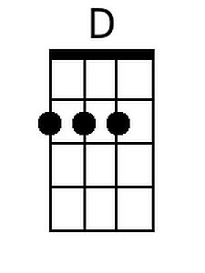
 |  |  |  |  |  |  | 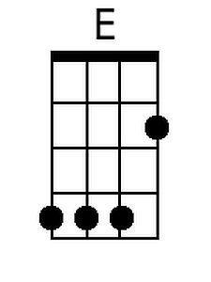 |  | 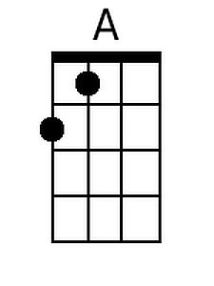
 |  |  |  |  |  |  | 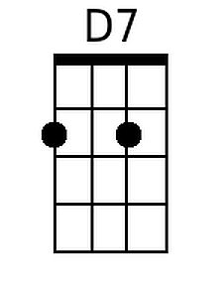 |  | 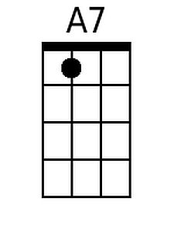
Baritone
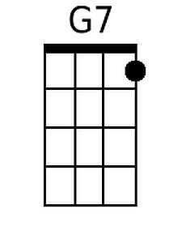 | 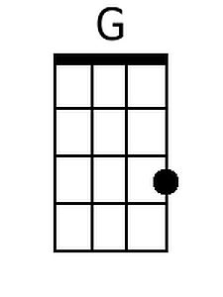 | 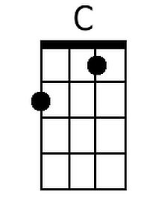 | 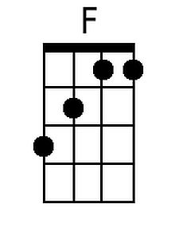 | 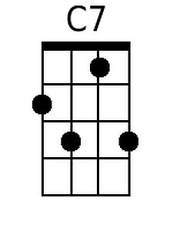
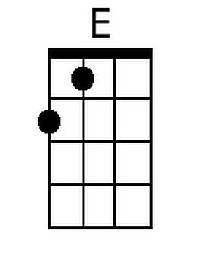 | 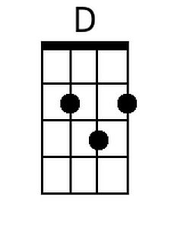 | 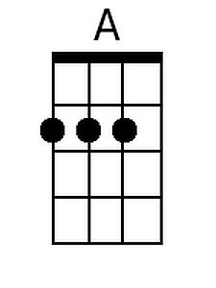 | 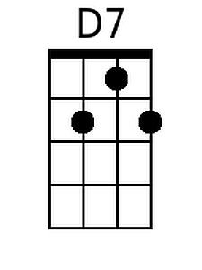 | 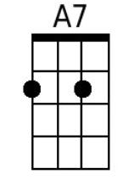

Purple People Eater (C) – Page 2
C
I said Mr. Purple People Eater, what's your line?
G C
He said “eatin' purple people and it sure is fine
C7 F
But that's not the reason that I came to land
G
I want to get a job in a rock and roll band"

C
Well bless my soul, rock and roll, flyin' purple people eater
G
Pigeon-toed, under-growed, flyin' purple people eater
C
"We wear short shorts" friendly little people eater
G7 C E
What a sight to see ( oh )

D
And then he swung from the tree and he lit on the ground
A D
And he started to rock, really rockin' around
D7 G
It was a crazy ditty with a swingin' tune
A7
“Singin' bop-bop, a-boopa lopa lum bam boom" well ….

D
Well, bless my soul, rock and roll, flyin' purple people eater
A
Pigeon-toed, under growed, flyin' purple people eater
D
"I like short shorts!" flyin' purple people eater
A7 D
What a sight to see (purple people?)

D
Well, he went on his way, and then what do ya know?
A D
I saw him last night on a TV show
D7 G
He was blowing it out, really knockin' em dead
A7 D G7 D G7 D D (Hold)
Playin' rock and roll music through the horn in his head.

"Tequila!"
Purple People Eater (Sheb Wooley) (G)
Purple People Eater by Sheb Wooley

Intro: D7 D G

G
Well, I saw the thing comin' out of the sky
D G
It had the one long horn, one big eye
C
I commenced to shakin' and I said "ooh-eee"
D G
It looks like a purple eater to me.

Chorus
G
It was a one-eyed, one-horned, flyin' purple people eater
D
One-eyed, one-horned, flyin' purple people eater
G
A one-eyed, one-horned, flyin' purple people eater
D7 G
Sure looks strange to me (one eye? / 2nd time: one horn?)

G
Well he came down to earth and he lit in a tree
D G
I said Mr. Purple People Eater, don't eat me
G7 C
I heard him say in a voice so gruff
D
"I wouldn't eat you 'cause you're so tough" Chorus

 |  |  |  |  |  |  |  | 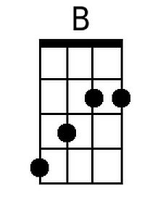
 |  |  |  |  |  |  |  | 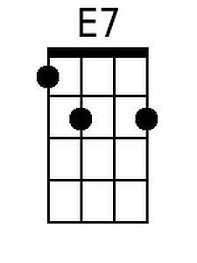
Baritone
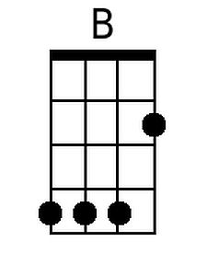 |  |  |  | 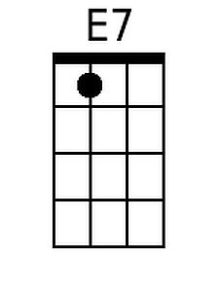

Purple People Eater (G) – Page 2
G
I said Mr. Purple People Eater, what's your line?
D G
He said "eatin' purple people and it sure is fine
G7 C
But that's not the reason that I came to land
D
I want to get a job in a rock and roll band"

G
Well bless my soul, rock and roll, flyin' purple people eater
D
Pigeon-toed, under-growed, flyin' purple people eater
G
"We wear short shorts" friendly little people eater
D7 G B
What a sight to see ( oh )

A
And then he swung from the tree and he lit on the ground
E A
And he started to rock, really rockin' around
A7 D
It was a crazy ditty with a swingin' tune
E7
"Singin' bop-bop, a-boopa lopa lum bam boom," well ….

A
Pigeon-toed, under growed, flyin' purple people eater
E
Pigeon-toed, under growed, flyin' purple people eater
A
"I like short shorts!" flyin' purple people eater
E7 A
What a sight to see (purple people?)

A
Well, he went on his way, and then what do ya know?
E A
I saw him last night on a TV show
A7 D
He was blowing it out, really knockin' em dead
E7 A D7 A D7 A A (Hold)
Playin' rock and roll music through the horn in his head.

"Tequila!"

