**Radio Ga Ga (Roger Taylor)**

**G Am C Am C G x2**

**C G**

Radio



G

**G**

I'd sit alone and watch your light

**Am**

My only friend through teenage nights

**C**

And everything I had to know

**Am C G**

I heard it on my ra - dio

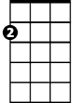

Am

**G**

You gave them all those old time stars

**Am**

Through wars of worlds, invaded by Mars

**C**

You made 'em laugh, you made 'em cry

**Am C G C G**

You made us feel like we could fly - Ra - dio



C

**G**

So don't become some background noise

**Am**

A backdrop for the girls and boys

**C**

Who just don't know or just don't care

**Dbdim**

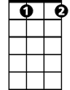

Dbdim

And just complain when you're not there

**G**

You had your time, you had the power

**D**

You've yet to have your finest hour

**C G C G**

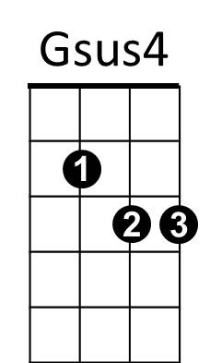Ra - dio Ra - dio

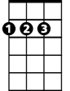

D

Em

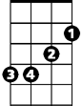

**Gsus4 C G**

All we hear is, radio ga ga,

**C G C G**

Radio goo goo, radio ga ga

**Gsus4 C G**

All we hear is, radio ga ga

**C G**

Radio blah blah

**Am C D**

Radio what's new

**Em D G**

Radio, someone still loves you

**G Am C Am C G**

**G**

We watch the shows, we watch the stars



G

**Am**

On videos for hours and hours

**C**

We hardly need to use our ears

**Am C G**

How music changes through the years

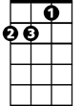

Am

**G**

Let's hope you never leave old friend

**Am**

Like all good things on you we depend

**C**

So stick around cos we might miss you

C



**Dbdim**

When we grow tired of all this visual

**G**

You had your time, you had the power

**D**

You've yet to have your finest hour

**C G C G**

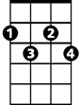

Dbdim



D

Ra - dio Ra - dio

**N.C.**

All we hear is radio ga ga

Radio goo goo radio ga ga

All we hear is radio ga ga

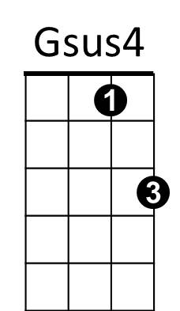Radio goo goo radio ga ga



Em

**Gsus4 C G**

All we hear is, radio ga ga

**C G**

Radio blah blah

**Am C D**

Radio what's new

**Em D G**

Someone still loves you

**G Am C Am C G / G Am C Dbdim**

**G**

You had your time, you had the power

**D**

You've yet to have your finest hour

**C G**

Ra – dio

**G Am / C Dbdim / G D**