Rain (John Lennon / Paul McCartney) (C)

C  If the rain comes  F G C  They run and hide their heads  F G C  They might as well be dead  F C  If the rain comes - if the rain comes  C  When the sun shines  F G C  They slip into the shade  (when the sun shines down)  F G C  And sip their lemonade  (when the sun shines down)  F  When the sun shines -  C  When the sun shines  Refrain:  C F C  Rrrraaaaaiiiinnnnnn - I don't mind  C F C  Shhhiiiiiiinnnnnee - the weather's fine  C F G C  I can show you that when it starts to rain,  (when the rain comes down)  F G C  Everything looks the same.  (when the rain comes down)  F C  I can show you, I can show you. Refrain | C  Can you hear me,  F G C  That when it rains and shines,  (when it rains and shines)  F G C  It's just a state of mind?  (when it rains and shines)  F C  Can you hear me, can you hear me?  C  When the rain comes  F G C  We run and hide our heads  F G C  We might as well be dead  F  When the rain comes -  C  When the rain comes
 | 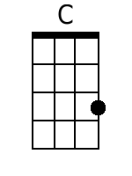 | 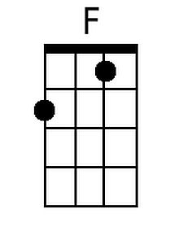 | 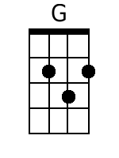
 |  | Bari
 | 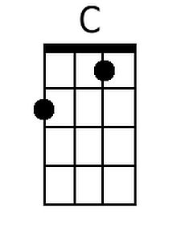 | 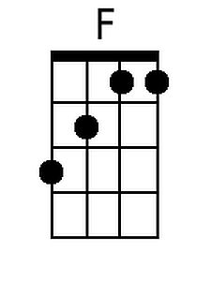 | 