**Raindrops (Dee Clark)**

**Intro: C**

**C Am Dm G7 C Am Dm**



C

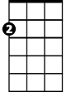

Am

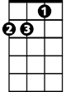

Dm

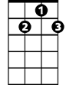

G7

Ah rain-drops, so many raindrops

**G7 C Am Dm**

It feels like ra-in drops

**G7 C Am Dm**

Falling from my eye, eyes

**G7 C G7**

Falling from my eyes

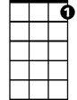

C7



G

Em

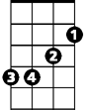

F



**C Am Dm**

Since my love has left me –

**G7 C Am Dm**

I'm so all alone

**G7 C Am Dm**

I would bring her back to me

**G7 C Am Dm**

But I don't know where she's gone

**G7 C C7**

I don't know where she's gone

**Reprise:**

**F Em Am**

There must be a cloud in my head

**Dm C Am**

Rain keeps falling from my eye, eyes

**Em Am**

Oh no, it can't be teardrops

**F G G7**

For a man ain't supposed to cry

**C Am Dm G7 C Am Dm**

So it must be rain-drops, so many rain-drops

**G7 C Am Dm**

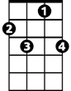

C7



G7

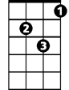

Dm



Am

C



G



Em

**BARITONE**



F

It feels like ra-in drops

**G7 C Am Dm**

Falling from my eye, eyes

**G7 C**

Falling from my eyes

**(Repeat from Reprise)**

**Outro:**

**Am Dm G7 C**

It keeps on falling - Falling from my eyes

**Am Dm G7 C (3x)**

- Falling from my eyes