Raindrops (Dee Clark) (G)

Intro: G  G Em Am D7 G Em Am  Ah rain-drops, so many raindrops  D7 G Em Am  It feels like ra-in drops  D7 G Em Am D7 G D7  Falling from my eye, eyes Falling from my eyes  G Em Am D7 G Em Am  Since my love has left me, I'm so all alone.  D7 G Em Am  I would bring her back to me  D7 G Em Am  But I don't know where she's gone  D7 G G7  I don't know where she's gone  Reprise:  C Bm Em  There must be a cloud in my head  Am G Em  Rain keeps falling from my eye, eyes  Bm Em  Oh no, it can't be teardrops  C D D7  For a man ain't supposed to cry  G Em Am D7 G Em Am  So it must be rain-drops, so many rain-drops  D7 G Em Am  It feels like ra-in drops  D7 G Em Am D7 G  Falling from my eye, eyes Falling from my eyes  (Repeat from Reprise)  Outro:  Em Am D7 G  It keeps on falling - Falling from my eyes  Em Am D7 G (3x)  - Falling from my eyes | 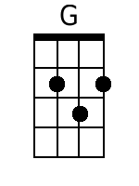 | 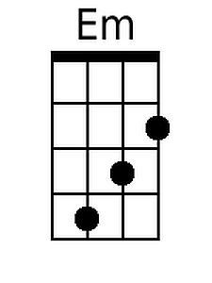 | 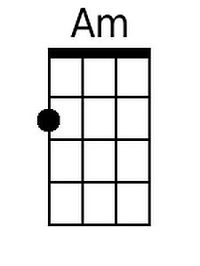
 | 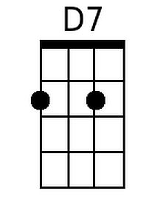 | 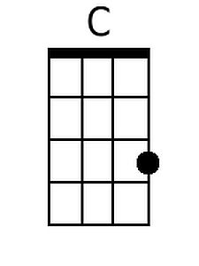 | 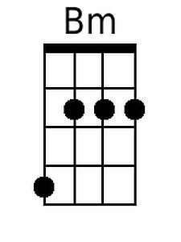
 | 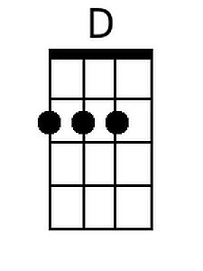 | 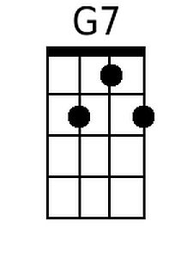
 | Bari
 | 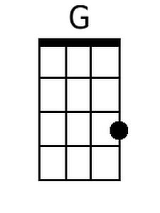 | 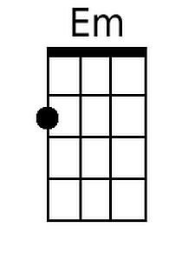 | 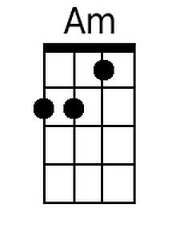
 | 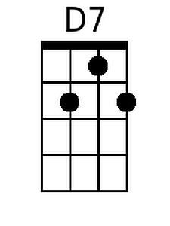 | 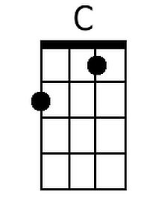 | 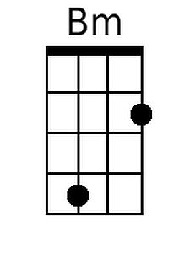
 | 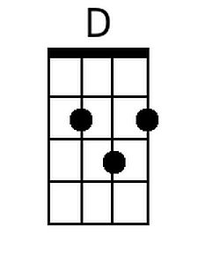 | 