Raindrops Keep Fallin' On My Head (Burt Bacharach / Hal David) (G)

Intro: G D C D (2X)  G Gmaj7  Raindrops keep fallin' on my head  G7 C Bm7  And just like the guy whose feet are too big for his bed  E7 Bm7 E7 Am D7  Nothing seems to fit - those raindrops are fallin' on my head  TACET C Cmaj7  They keep fallin' - so I just did me some talking to the sun  G7 C Bm7  And I said I didn't like the way he got things done  E7 Bm7 E7 Am D7  Sleeping on the job - those raindrops are fallin' on my head  They keep fallin' - (PAUSE)  Reprise:  TACET C Em7  But there's one thing - I know  C D7 Bm7  The blues they send to meet me won't defeat me  Bm6 Am D7 C D C D  It won't be long till happiness steps up to greet me  G Gmaj7  Raindrops keep fallin' on my head  G7 C Bm7  But that doesn't mean my eyes will soon be turning red  E7 Bm7 E7 Am D7  Crying's not for me - cause I'm never gonna stop the rain by complaining  G C D7 G  Because I'm free - nothings worrying me  (Instrumental Reprise, start at "thing" - sing last line)  Last verse - extend last line |  |  |  |  |  |  | 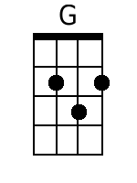 | 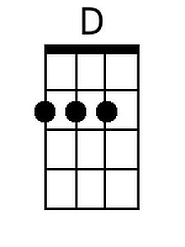
 |  |  |  |  |  |  | 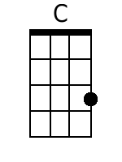 | 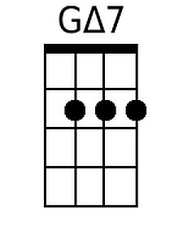
 |  |  |  |  |  |  | 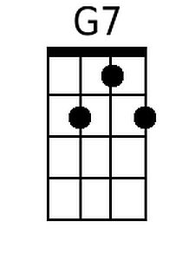 | 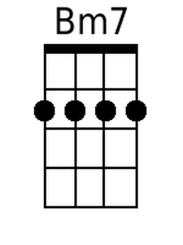
 |  |  |  |  |  |  | 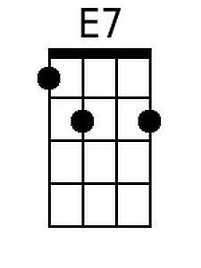 | 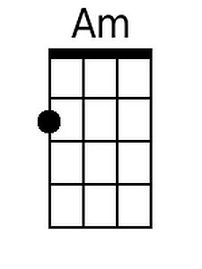
 |  |  |  |  |  |  | 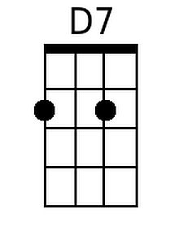 | 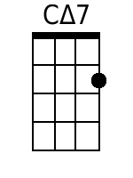
Bari | 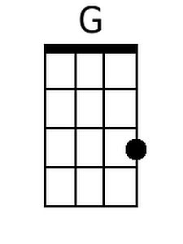 | 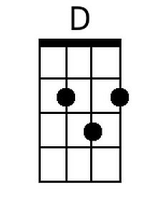 | 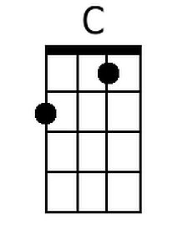 | 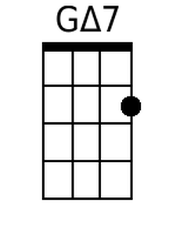 | 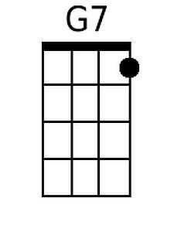
 | 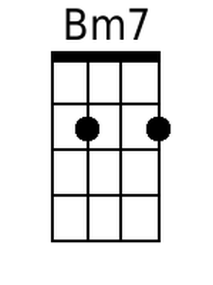 | 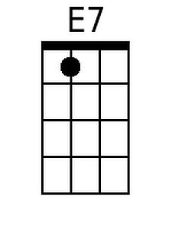 | 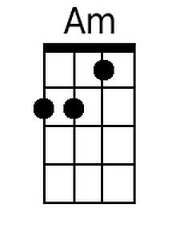 | 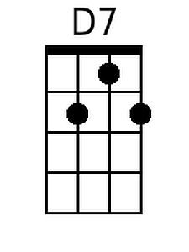 | 