Raindrops Keep Falling On My Head (Burt Bacharach & Hal David, 1969) (C)
Raindrops Keep Falling On My Head by B. J. Thomas (F)
4/4 Time – Tempo 104 bpm

Intro (4 Measures) | C G | F G | (2x) (Pattern: ↓_↓↑↓↑ ↓_↓↑↓↑ ↓_↓↑↓↑ ↓___)

C Cmaj7
Raindrops keep falling on my head
C7 F Em7
And just like the guy whose feet are too big for his bed
A7 Em7 A7 Dm7 G7
Nothing seems to fit _ those _ raindrops are falling on my head
Tacet C Cmaj7
They keep falling _ so I just did me some talking to the sun
C7 F Em7
And I said I didn't like the way he got things done
A7 Em7 A7 Dm7 G7
Sleeping on the job _ those _ raindrops are falling on my head
They keep falling _ ( Pause – Palm Mute or Hold )

Reprise
Tacet C Cmaj7
But there's one thing _ I know,
F G7 Em7
The blues they send to meet me won't de-feat me
A7 Dm7 | F F G _ | (2x) ( ↓↑↓ ↑_)
It won't be long till happiness steps up to greet me.

 | 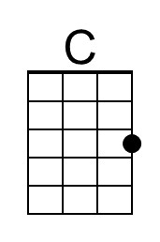 | 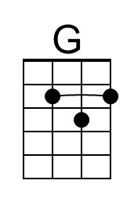 | 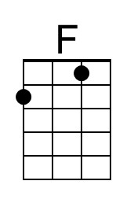 | 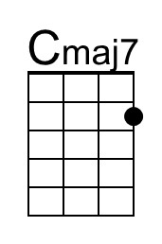 | 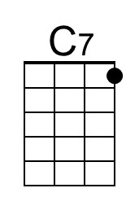
 | 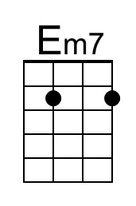 | 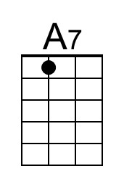 | 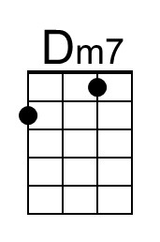 | 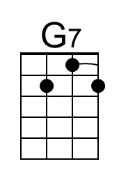

Raindrops Keep Falling On My Head (C) – Page 2

C Cmaj7
Raindrops keep falling on my head.
C7 F Em7
But that doesn't mean my eyes will soon be turning red
A7 Em7 A7 Dm7 G7
Crying's not for me _ cause _ I'm never gonna stop the rain by complaining
C F G7 C
Because I'm free __ nothing’s worrying me. (Join Reprise at “thing;”)

Reprise (First 2 lines Instrumental; sing last line)
Tacet C Cmaj7
………….. thing _ I know,
F G7 Em7
The blues they send to meet me won't de-feat me
[Sing] A7 Dm7 | F F G _ | (2x) ( ↓↑↓ ↑_)
It won't be long till happiness steps up to greet me

C Cmaj7
Raindrops keep falling on my head.
C7 F Em7
But that doesn't mean my eyes will soon be turning red
A7 Em7 A7 Dm7 G7
Crying's not for me _ cause _ I'm never gonna stop the rain by complaining
C | [ Ritard ] F G7 C [Hold]
Because I'm free . . . __ nothing’s . . . worrying . . . me.

 |  | Bari | 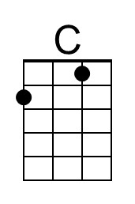 | 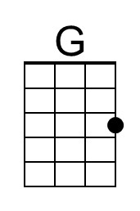 | 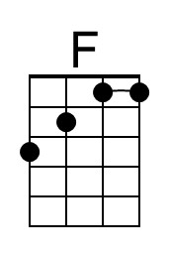 | 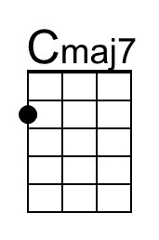 | 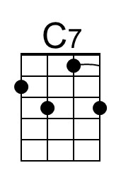
 |  |  | 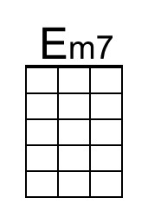 | 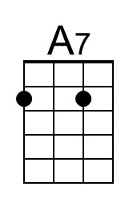 | 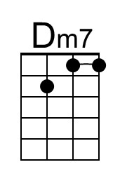 | 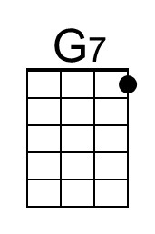

Raindrops Keep Falling On My Head (Burt Bacharach & Hal David, 1969) (F)
Raindrops Keep Falling On My Head by B. J. Thomas (F)
4/4 Time – Tempo 104 bpm

Intro (4 Measures) | F C | Bb C | (2x) (Pattern: ↓_↓↑↓↑ ↓_↓↑↓↑ ↓_↓↑↓↑ ↓___)

F Fmaj7
Raindrops keep falling on my head
F7 Bb Am7
And just like the guy whose feet are too big for his bed
D7 Am7 D7 Gm7 C7
Nothing seems to fit _ those _ raindrops are falling on my head
F Fmaj7
They keep falling _ so I just did me some talking to the sun
F7 Bb Am7
And I said I didn't like the way he got things done
D7 Am7 D7 Gm7 C7
Sleeping on the job _ those _ raindrops are falling on my head,
They keep falling _ ( Pause – Palm Mute or Hold )

Reprise
Tacet F Fmaj7
But there's one thing _ I know,
Bb C7 Am7
The blues they send to meet me won't de-feat me
D7 Gm7 | Bb Bb C | (2x) ( ↓↑↓ ↑_)
It won't be long till happiness steps up to greet me.

 |  |  | 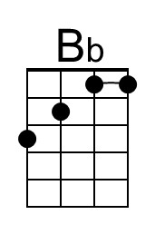 | 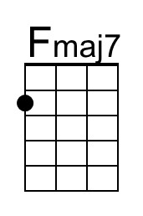 | 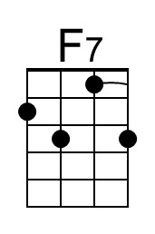
 | 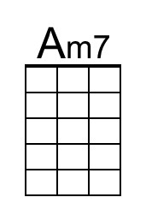 | 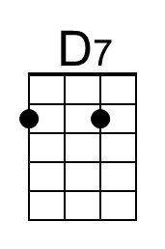 | 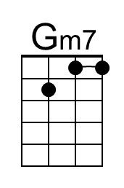

Raindrops Keep Falling On My Head (F) – Page 2

F Fmaj7
Raindrops keep falling on my head.
F7 Bb Am7
But that doesn't mean my eyes will soon be turning red
D7 Am7 D7 Gm7 C7
Crying's not for me _ cause _ I'm never gonna stop the rain by complaining
F Bb C7 F
Because I'm free __ nothing’s worrying me. (Join Reprise at “thing;”)

Reprise (First 2 lines Instrumental; sing last line)
Tacet F Fmaj7
………….. thing _ I know,
Bb C7 Am7
The blues they send to meet me won't de-feat me
[Sing] D7 Gm7 | Bb Bb C | (2x)
It won't be long till happiness steps up to greet me. ( ↓↑↓ ↑_)

F Fmaj7
Raindrops keep falling on my head.
F7 Bb Am7
But that doesn't mean my eyes will soon be turning red
D7 Am7 D7 Gm7 C7
Crying's not for me _ cause _ I'm never gonna stop the rain by complaining
F | [ Ritard ] Bb C7 F [Hold]
Because I'm free . . . __ nothing’s . . . worrying . . . me.

 |  | Bari |  |  | 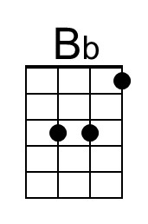 | 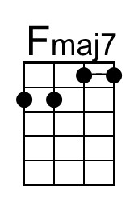 | 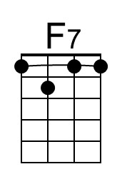
 |  |  | 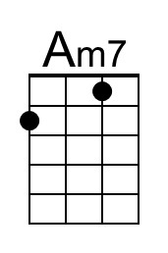 | 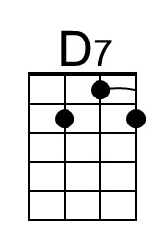 | 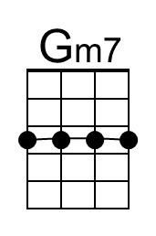 |  | 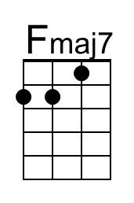

Raindrops Keep Falling On My Head (Burt Bacharach & Hal David, 1969) (G)
Raindrops Keep Falling On My Head by B. J. Thomas (F)
4/4 Time – Tempo 104 bpm

Intro (4 Measures) | G D | C D | (2x) (Pattern: ↓_↓↑↓↑ ↓_↓↑↓↑ ↓_↓↑↓↑ ↓___)

G Gmaj7
Raindrops keep falling on my head
G7 C Bm7
And just like the guy whose feet are too big for his bed
E7 Bm7 E7 Am7 D7
Nothing seems to fit _ those _ raindrops are falling on my head
G Gmaj7
They keep falling _ so I just did me some talking to the sun
G7 C Bm7
And I said I didn't like the way he got things done
E7 Bm7 E7 Am7 D7
Sleeping on the job _ those _ raindrops are falling on my head,
They keep falling _ ( Pause – Palm Mute or Hold )

Reprise
Tacet G Gmaj7
But there's one thing _ I know,
C D7 Bm7
The blues they send to meet me won't de-feat me
E7 Am7 | C C D | (2x) ( ↓↑↓ ↑_)
It won't be long till happiness steps up to greet me.

 |  | 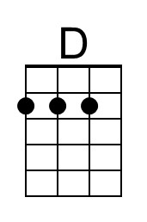 |  | 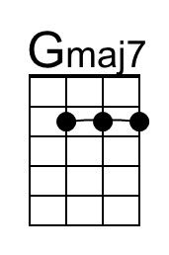
 | 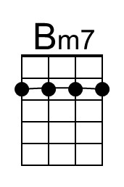 | 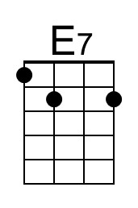

Raindrops Keep Falling On My Head (G) – Page 2

G Gmaj7
Raindrops keep falling on my head.
G7 C Bm7
But that doesn't mean my eyes will soon be turning red
E7 Bm7 E7 Am7 D7
Crying's not for me _ cause _ I'm never gonna stop the rain by complaining
G C D7 G
Because I'm free __ nothing’s worrying me. (Join Reprise at “thing;”)

Reprise (First 2 lines Instrumental; sing last line)
G Gmaj7
………….. thing _ I know, Tacet
C D7 Bm7
The blues they send to meet me won't de-feat me
[Sing] E7 Am7 | C C D | (2x)
It won't be long till happiness steps up to greet me. ( ↓↑↓ ↑_)

G Gmaj7
Raindrops keep falling on my head.
G7 C Bm7
But that doesn't mean my eyes will soon be turning red
E7 Bm7 E7 Am7 D7
Crying's not for me _ cause _ I'm never gonna stop the rain by complaining
G | C D7 G [Hold]
Because I'm free . . . [ Ritard ] __ nothing’s . . . worrying . . . me.

 |  | Bari |  | 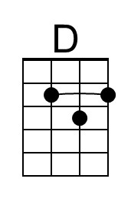 |  | 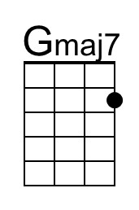
 |  |  | 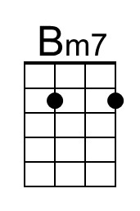 | 