Raindrops Keep Falling On My Head (Burt Bacharach & Hal David, 1969) (F)
Raindrops Keep Falling On My Head by B. J. Thomas (F)
4/4 Time – Tempo 104 bpm

Intro (4 Measures) | F C | Bb C | (2x) (Pattern: ↓_↓↑↓↑ ↓_↓↑↓↑ ↓_↓↑↓↑ ↓___)

F Fmaj7
Raindrops keep falling on my head
F7 Bb Am7
And just like the guy whose feet are too big for his bed
D7 Am7 D7 Gm7 C7
Nothing seems to fit _ those _ raindrops are falling on my head
F Fmaj7
They keep falling _ so I just did me some talking to the sun
F7 Bb Am7
And I said I didn't like the way he got things done
D7 Am7 D7 Gm7 C7
Sleeping on the job _ those _ raindrops are falling on my head,
They keep falling _ ( Pause – Palm Mute or Hold )

Reprise
Tacet F Fmaj7
But there's one thing _ I know,
Bb C7 Am7
The blues they send to meet me won't de-feat me
D7 Gm7 | Bb Bb C | (2x) ( ↓↑↓ ↑_)
It won't be long till happiness steps up to greet me.

 | 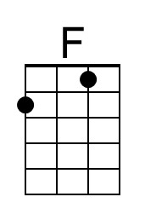 | 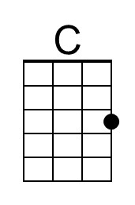 | 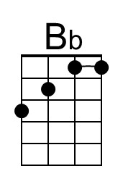 | 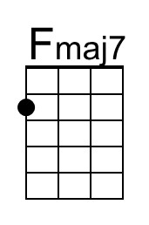 | 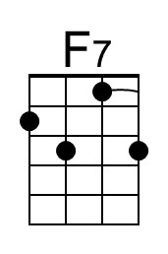
 | 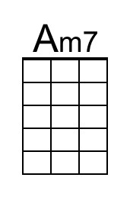 | 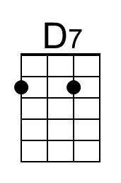 | 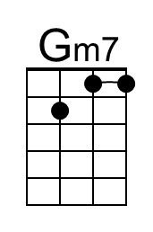 | 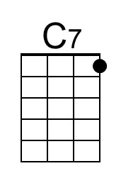

Raindrops Keep Falling On My Head (F) – Page 2

F Fmaj7
Raindrops keep falling on my head.
F7 Bb Am7
But that doesn't mean my eyes will soon be turning red
D7 Am7 D7 Gm7 C7
Crying's not for me _ cause _ I'm never gonna stop the rain by complaining
F Bb C7 F
Because I'm free __ nothing’s worrying me. (Join Reprise at “thing;”)

Reprise (First 2 lines Instrumental; sing last line)
Tacet F Fmaj7
………….. thing _ I know,
Bb C7 Am7
The blues they send to meet me won't de-feat me
[Sing] D7 Gm7 | Bb Bb C _ | (2x)
It won't be long till happiness steps up to greet me. ( ↓↑↓ ↑_)

F Fmaj7
Raindrops keep falling on my head.
F7 Bb Am7
But that doesn't mean my eyes will soon be turning red
D7 Am7 D7 Gm7 C7
Crying's not for me _ cause _ I'm never gonna stop the rain by complaining
F | [ Ritard ] Bb C7 F [Hold]
Because I'm free . . . __ nothing’s . . . worrying . . . me.

 |  | Bari | 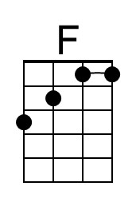 | 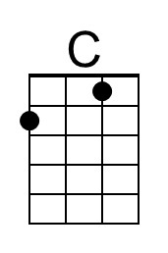 | 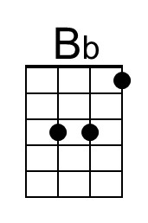 | 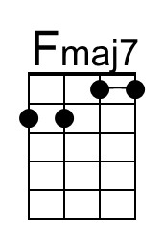 | 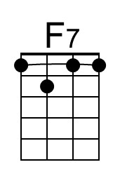
 |  |  | 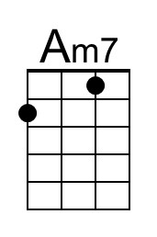 | 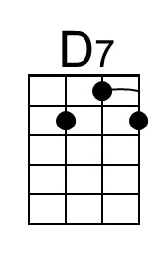 | 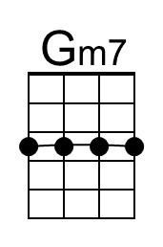 | 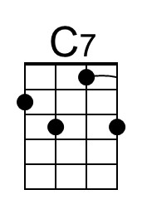 | 