**Raindrops Keep Falling On My Head (Bacharach / Hal David)**

**Intro: C G F G (2X)**

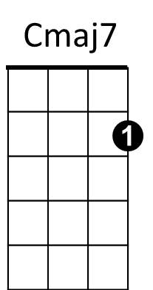**C Cmaj7**

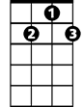

G7



C

F



Raindrops keep falling on my head

**C7 F Em7**

And just like the guy whose feet are too big for his bed

**A7 Em7 A7 Dm G7**

Nothing seems to fit - those raindrops are falling on my head

**TACET C** **Cmaj7**

They keep falling - so I just did me some talking to the sun

**C7 F Em7**

And I said I didn't like the way he got things done

**A7 Em7 A7 Dm G7**

Sleeping on the job - those raindrops are falling on my head

They keep falling – **(PAUSE)**

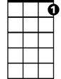

C7

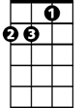

Dm



G

Em7

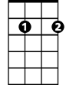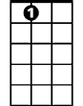

A7

**Reprise:**

**TACET C Em7**

But there's one thing - I know

**F G7 Em7**

The blues they send to meet me won't defeat me

**Em6 Dm G7 F G F G**

It won't be long till happiness steps up to greet me

**C Cmaj7**

Raindrops keep falling on my head

**C7 F Em7**

But that doesn't mean my eyes will soon be turning red

**A7 Em7 A7 Dm G7**

Crying's not for me - cause I'm never gonna stop the rain by complaining

**C F G7 C**

Because I'm free - nothings worrying me

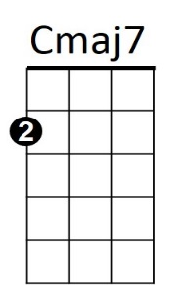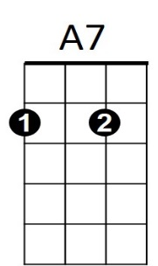**(Instrumental (kazoos?) Reprise, sing last line) Last verse - extend last line**

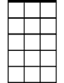

Em7

C



G



F

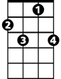

C7

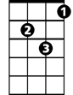

Dm



G7

**BARITONE**