GCEA  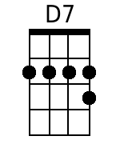  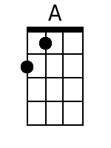  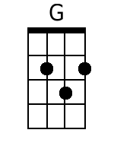  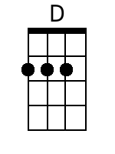  Bari  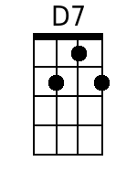  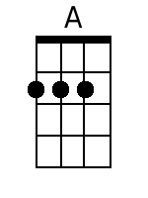  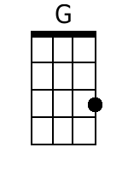  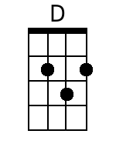 | Ramblin'  Randy Sparks  4/4 Time; Original Key of D (2 Sharps); “Driving Blues Tempo”; Ukulele  Recorded by The New Christy Minstrels on their 1963 album Ramblin'  Four measure instrumental introduction, then five measures:  D7  I've been a-ramblin', oo, I've been a-ramblin', oo,  D7  I've been ramblin'; Lawd, I've been ramblin'!  I've been north, south, east, west, all up and down the line;  A G  I've been waitin', anticipat-in'  D D7  Lookin' for the sun to shine.  I've been a-ramblin', oo, I've been a-ramblin', oo,  D7  Kansas City, New Orleans;  Just like an old muddy river, I gotta roll along.  A G  I gotta ramble, I gotta ramble,  D D7  I gotta sing my lonely song.  I've been a-ramblin', oo, I've been a-ramblin', oo,  D7  I had a woman, once I had a woman;  She was the truest woman this world will ever see.  A G  Oh well, I loved her; yes I loved her;  D D7  And she was true to everyone ... but me. (Poor boy!)  I've been a-ramblin', oo, I've been a-ramblin', oo,  D7  Train's a comin'; my train's a-comin',  Can't you hear that lonesome whistle .. moanin' down the track?  A G  I gotta ramble, I gotta ramble;  D D7  I got a feelin' that I won't be back.  I've been a-ramblin', oo, poor boy,  D7  I gotta ramble, Lawd;  I'm movin' North and South, all up and down the line.  Yes, I'm ramblin' ...  (Repeat as needed for fade out)

