Key C RAPID ROY (Jim Croce)
CHORUS

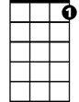

C C7 F C
F
C7
C
Oh Rapid Roy that stock car boy, he too much to believe
F C
You know he always got an extra pack of cigarettes
D G
Rolled up in his t-shirt sleeve
C C7
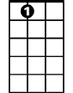
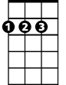

He got a tattoo on his arm that say “Baby”
A7
D
G
F D
He got another one that just say, “Hey”
C A7
But every Sunday afternoon he is a dirt track demon
D G C
In a '57 Chevro-let

C C7 F C
Oh Rapid Roy that stock car boy, he's the best driver in the land
F C
He say that he learned to race a stock car
D G
By runnin' ‘shine outta Alabam'
C C7
Oh the demolition derby and the figure eight
F D
Is easy money in the bank
C Am
Compared to runnin' from the man in Oklahoma City
D G C
With a 500 gallon tank

(Chorus)
BARITONE
C C7 F C
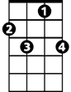

Yeah, Roy so cool, that racin' fool, he don't know what fear's about
C
C7
F
F C
He do a hundred thirty mile an hour, smilin' at the camera
D G
With a toothpick in his mouth
C C7
He got a girl back home name of Dixie Dawn
F D
But he got honeys all along the way
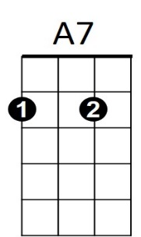
C Am
G
D
And you oughta hear 'em screamin' for that dirt track demon
D G C
In a '57 Chevro - let

CHORUS (2X)

C Am
But every Sunday afternoon he is a dirt track demon
D G C
In a '57 Chevro-let
Key G RAPID ROY (Jim Croce)
CHORUS
G
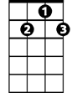
G G7 C G
G7
C
Oh Rapid Roy that stock car boy, he too much to believe
C G
You kn ow he always got an extra pack of cigarettes
A D
Rolled up in his t-shirt sleeve
G G7
He got a tattoo on his arm that say “Baby”
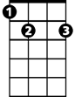
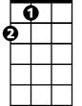
C A
E7
A
D
He got another one that just say, “Hey”
G E7
But every Sunday afternoon he is a dirt track demon
A D G
In a '57 Chevro-let

G G7 C G
Oh Rapid Roy that stock car boy, he's the best driver in the land
C G
He say that he learned to race a stock car
A D
By runnin' ‘shine outta Alabam'
G G7
Oh the demolition derby and the figure eight
C A
Is easy money in the bank
G Em
Compared to runnin' from the man in Oklahoma City
A D G
BARITONE
With a 500 gallon tank
G7
C
G

(Chorus)

G G7 C G
Yeah, Roy so cool, that racin' fool, he don't know what fear's about
C G
He do a hundred thirty mile an hour, smilin' at the camera
A D
E7
D
A
With a toothpick in his mouth
G G7
He got a girl back home name of Dixie Dawn
C A
But he got honeys all along the way
G Em
And you oughta hear 'em screamin' for that dirt track demon
A D G
In a '57 Chevro - let

CHORUS (2X)

G Em
But every Sunday afternoon he is a dirt track demon
A D G
In a '57 Chevro-let

