**Key C RAPID ROY (Jim Croce)**

**CHORUS**

**C C7 F C**

F

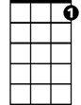

C7



C

Oh Rapid Roy that stock car boy, he too much to believe

**F C**

You know he always got an extra pack of cigarettes

**D G**

Rolled up in his t-shirt sleeve

**C C7**

He got a tattoo on his arm that say “Baby”

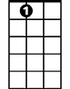

A7

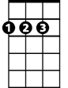

D



G

**F D**

He got another one that just say, “Hey”

**C A7**

But every Sunday afternoon he is a dirt track demon

**D G C**

In a '57 Chevro-let

**C C7 F C**

Oh Rapid Roy that stock car boy, he's the best driver in the land

**F C**

He say that he learned to race a stock car

**D G**

By runnin' ‘shine outta Alabam'

**C C7**

Oh the demolition derby and the figure eight

**F D**

Is easy money in the bank

**C Am**

Compared to runnin' from the man in Oklahoma City

**D G C**

With a 500 gallon tank

**(Chorus)**

**BARITONE**

**C C7 F C**

Yeah, Roy so cool, that racin' fool, he don't know what fear's about

C

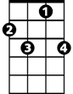

C7



F

**F C**

He do a hundred thirty mile an hour, smilin' at the camera

**D G**

With a toothpick in his mouth

**C C7**

He got a girl back home name of Dixie Dawn

**F D**

But he got honeys all along the way

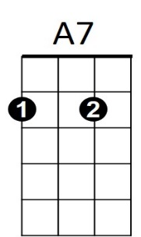 **C Am**



G



D

And you oughta hear 'em screamin' for that dirt track demon

**D G C**

In a '57 Chevro - let

**CHORUS (2X)**

**C Am**

But every Sunday afternoon he is a dirt track demon

**D G C**

In a '57 Chevro-let

**Key G RAPID ROY (Jim Croce)**

**CHORUS**



G

**G G7 C G**

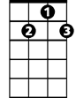

G7



C

Oh Rapid Roy that stock car boy, he too much to believe

**C G**

You kn ow he always got an extra pack of cigarettes

**A**  **D**

Rolled up in his t-shirt sleeve

**G G7**

He got a tattoo on his arm that say “Baby”

**C A**

E7

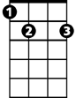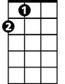

A



D

He got another one that just say, “Hey”

**G E7**

But every Sunday afternoon he is a dirt track demon

**A D G**

In a '57 Chevro-let

**G G7 C G**

Oh Rapid Roy that stock car boy, he's the best driver in the land

**C G**

He say that he learned to race a stock car

**A D**

By runnin' ‘shine outta Alabam'

**G G7**

Oh the demolition derby and the figure eight

**C A**

Is easy money in the bank

**G Em**

Compared to runnin' from the man in Oklahoma City

**A D G**

**BARITONE**

With a 500 gallon tank



G7

C



G

**(Chorus)**

**G G7 C G**

Yeah, Roy so cool, that racin' fool, he don't know what fear's about

**C G**

He do a hundred thirty mile an hour, smilin' at the camera

**A D**



E7



D



A

With a toothpick in his mouth

**G G7**

He got a girl back home name of Dixie Dawn

**C A**

But he got honeys all along the way

**G Em**

And you oughta hear 'em screamin' for that dirt track demon

**A D G**

In a '57 Chevro - let

**CHORUS (2X)**

**G Em**

But every Sunday afternoon he is a dirt track demon

**A D G**

In a '57 Chevro-let