
Red River Valley (Traditional, late 1800s)
418C
Red River Valley by Marty Robbins (1960) (G @ 118 BPM)

Intro Last two lines of chorus  Chorus  C G7 C  Come and sit by my side if you love me  G7  Do not hasten to bid me adieu  C C7 F  Just remember the Red River Valley  G7 C  And the cowboy that loved you so true  C G7 C  From this valley they say you are leaving  G7  We shall miss your bright eyes and sweet smile  C C7 F  For you take with you all of the sunshine  G7 C  That has brightened our pathway a while. Chorus  C G7 C  When you go to your home by the ocean  G7  May you never forget those sweet hours  C C7 F  That we spent in that Red River Valley  G7 C  And the love we exchanged with the flowers. Chorus  C G7 C  I have waited a long time my darling  G7  For those words that you never would say  C C7 F  Till at last now my poor heart is breaking  G7 C  For they tell me you're going away. Chorus | 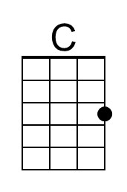 | 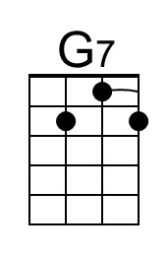
 | 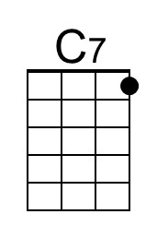 | 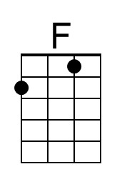
 | Bari
 | 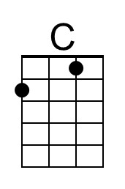 | 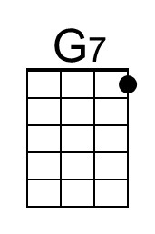
 | 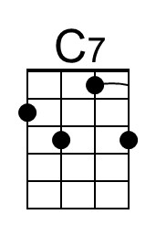 | 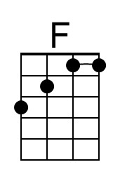

Red River Valley (Traditional, late 1800s)
418G
Red River Valley by Marty Robbins (1960) (G @ 118 BPM)

Intro Last two lines of chorus  Chorus  G D7 G  Come and sit by my side if you love me  D7  Do not hasten to bid me adieu  G G7 C  Just remember the Red River Valley  D7 G  And the cowboy that loved you so true.  G D7 G  From this valley they say you are leaving  D7  We shall miss your bright eyes and sweet smile  G G7 C  For you take with you all of the sunshine  D7 G  That has brightened our pathway a while. Chorus  G D7 G  When you go to your home by the ocean  D7  May you never forget those sweet hours  G G7 C  That we spent in that Red River Valley  D7 G  And the love we exchanged with the flowers. Chorus  G D7 G  I have waited a long time my darling  D7  For those words that you never would say  G G7 C  Till at last now my poor heart is breaking  D7 G  For they tell me you're going away. Chorus | 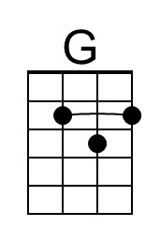 | 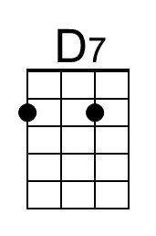
 | Bari
 | 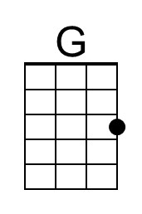 | 