**Red River Valley (Marty Robbins)**

**Chorus:**

**C G7 C**

Come and sit by my side if you love me

**G7**

Do not hasten to bid me adieu

F

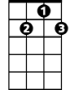

G7



C

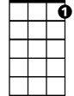

C7

**C C7 F**

Just remember the Red River Valley

**G7 C**

And the cowboy that loved you so true

**C G7 C**

From this valley they say you are leaving

**G7**

We shall miss your bright eyes and sweet smile

**C C7 F**

For you take with you all of the sunshine

**G7 C**

That has brightened our pathway a while

**(CHORUS)**

**C G7 C**

**BARITONE**

When you go to your home by the ocean



G7

C



**G7**

May you never forget those sweet hours

**C C7 F**

That we spent in that Red River Valley

**G7 C**

And the love we exchanged with the flowers



F

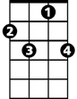

C7

**(CHORUS)**

**C G7 C**

I have waited a long time my darling

**G7**

For those words that you never would say

**C C7 F**

Till at last now my poor heart is breaking

**G7 C**

For they tell me you're going away

**(CHORUS)**

F

