**Red Roses for a Blue Lady (Sid Tepper / Roy C. Bennett)**

**C G7 C B7**

I - want - some red roses for a blue lady

**E7 A7**

Mister florist take my order please

**Dm G7 Em Am**

We had a silly quarrel the oth-er day

**D7 G7**

I hope these pretty flowers chase her blues away

**C G7**  **C B7**

Wrap up some red roses for a blue lady

**E7 A7**

Send them to the sweetest gal in town

**Dm Em B**

And if they do the trick I'll hurry back to pick

**Dm G7 C**

Your best white orchid for her wedding gown

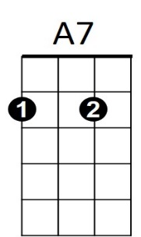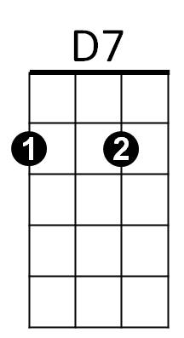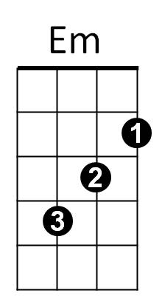**REPEAT ENTIRE SONG**

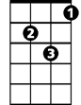

Dm

B

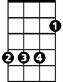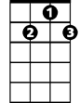

D7

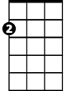

Em

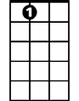

E7

B7

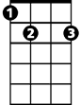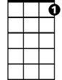

G7

C



**BARITONE**

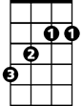

B



A7

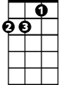

Dm

E7



C



G7