**Rhythm of the Rain (John C. Gummoe, 1962) Key C**

**Intro: C Am C G7**



C

F

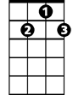

G7

**C F**

Listen to the rhythm of the falling rain

**C G7**

Telling me just what a fool I've been

**C F**

I wish that it would go and let me cry in vain

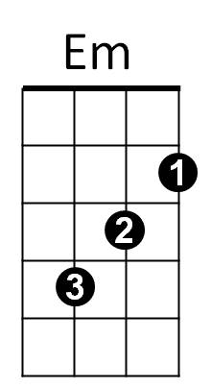 **C G7 C G7**

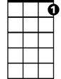

C7

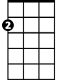

Am

And let me be alone again

**Chorus:**

**C F**

The only girl I care about has gone away

**C G7**

Looking for a brand new start

**C F**

But little does she know that when she left that day

**C G7 C C7**

Along with her she took my heart

**BARITONE**

**F Em**



F

C



Rain please tell me now does that seem fair

**F C**

For her to steal my heart away when she don't care

**Am F G7 C G7**

I can't love another when my heart's somewhere far away

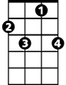

C7

**(Chorus)**



G7



Em

**Instrumental verse.**

**F Em**

Rain won’t you tell her that I love her so

**F C**

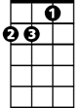

Am

Please ask the sun to set her heart aglow

**Am F G7 C G7**

Rain in her heart and let the love we knew start to grow.

**(First Verse)**

**Outro: (repeat to fade)**

**C F C G7**

Oh listen to the falling rain, pitter patter, pitter patter, oh oh oh.

**C F C G7**

Listen, listen to the falling rain, pitter patter, pitter patter, oh oh oh.

**Rhythm of the Rain (John C. Gummoe, 1962) Key G**

**Intro: G Em G D7**

**G C**

Listen to the rhythm of the falling rain

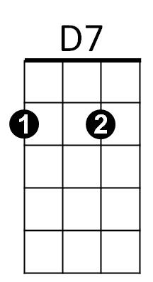**G D7**



C



G

Telling me just what a fool I've been

**G C**

I wish that it would go and let me cry in vain

**G D7 G D7**

And let me be alone again

**Chorus:**

**G C**

The only girl I care about has gone away



G7

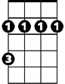

Bm

Em

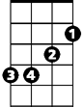

**G D7**

Looking for a brand new start

**G C**

Little does she know that when she left that day

**G D7 G G7**

Along with her she took my heart

**C Bm**

**BARITONE**

Rain please tell me now does that seem fair



G

C



**C G**

For her to steal my heart away when she don't care

**Em C D7 G D7**

I can't love another when my heart's somewhere far away

**(Chorus)**



G7



D7

Bm



**Instrumental verse.**

**C Bm**

Rain won’t you tell her that I love her so

**C G**

Please ask the sun to set her heart aglow



Em

**Em C D7 G D7**

Rain in her heart and let the love we knew start to grow.

**(First Verse)**

**Outro: (repeat to fade)**

**G C G D7**

Oh listen to the falling rain, pitter patter, pitter patter, oh oh oh.

**G C G D7**

Listen, listen to the falling rain, pitter patter, pitter patter, oh oh oh.