**Rhythm of the Rain (John C. Gummoe, 1962) Key C**

**Intro: C Am C G7**

**C F**

Listen to the rhythm of the falling rain

**C G7**

Telling me just what a fool I've been

**C F**

I wish that it would go and let me cry in vain

**C G7 C G7**

And let me be alone again

**C F**

The only girl I care about has gone away

**C G7**

Looking for a brand new start

**C**

But little does she know

**F**

That when she left that day

**C G7 C C7**

Along with her she took my heart

**F Em**

Rain please tell me now does that seem fair

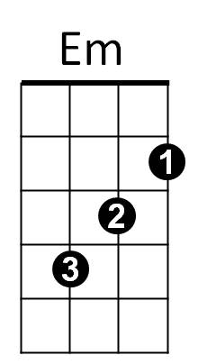 **F**

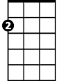

Am

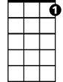

C7

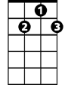

G7

F



C

For her to steal my heart away

**C**

When she don't care

**Am F**

I can't love another when my heart's

**G7 C G7**

Somewhere far away

**C F**

The only girl I care about has gone away

**C G7**

Looking for a brand new start

**C**

But little does she know

**F**

That when she left that day

**C G7 C G7**

Along with her she took my heart

**(Instrumental Second Verse)**

**F Em**

Rain won’t you tell her that I love her so

**F C**

Please ask the sun to set her heart aglow

**Am F G7**

Rain in her heart and let the love we knew

**C G7**

Start to grow.

**(First Verse )**

**Outro: (repeat to fade)**

**C F**

Oh listen to the falling rain,

**C G7**

Pitter patter, pitter patter, oh oh oh.

**C F**

Listen, listen to the falling rain,

**C G7**

Pitter patter, pitter patter, oh oh oh.

**BARITONE**

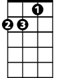

Am

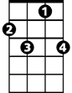

C7



G7



Em



F

C



**Rhythm of the Rain (John C. Gummoe, 1962) Key G**

**Intro: G Em G D7**

**G C**

Listen to the rhythm of the falling rain

**G D7**

Telling me just what a fool I've been

**G C**

I wish that it would go and let me cry in vain

**G D7 G D7**

And let me be alone again

**G C**

The only girl I care about has gone away

**G D7**

Looking for a brand new start

**G**

Little does she know

**C**

That when she left that day

**G D7 G G7**

Along with her she took my heart

**C Bm**

Rain please tell me now does that seem fair

**C**

For her to steal my heart away

**G**

When she don't care

**Em C**

I can't love another when my heart's

**D7 G D7**

Somewhere far away

**G C**

The only girl I care about has gone away



Em

**G D7**

Looking for a brand new start

**G**

Little does she know

**C**

That when she left that day

**G D7 G G7**

Along with her she took my heart

**(Instrumental Second Verse)**

**C Bm**

Rain won’t you tell her that I love her so

**C G**

Please ask the sun to set her heart aglow

**Em C D7**

Rain in her heart and let the love we knew

**G D7**

Start to grow.

**(First Verse)**

**Outro: (repeat to fade)**

**G C**

Oh listen to the falling rain,

**G D7**

Pitter patter, pitter patter, oh oh oh.

**G C**

Listen, listen to the falling rain,

**G D7**

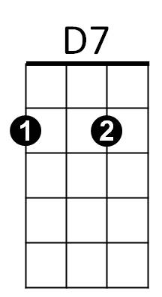Pitter patter, pitter patter, oh oh oh.

**BARITONE**



D7

C



G7



G

Bm

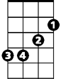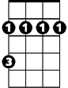

Bm



G7



C

Em



G